1. [Add product via Admin](file:///C:\Users\dell\Downloads\YSM-%20ADD%20PRODUCT%20VIA%20ADMIN.docx)

Steps—

1. Admin will login to their account.
2. Now click on “Devices” menu. 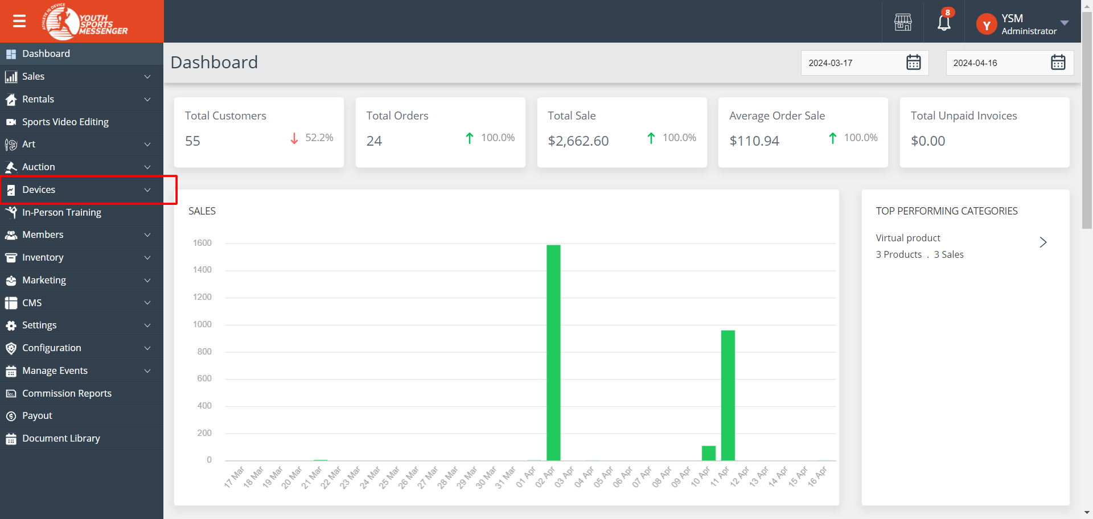
3. To add product attributes are important. Admin can add them by clicking “Attributes” menu under Devices section. Click on “Add Attribute” button.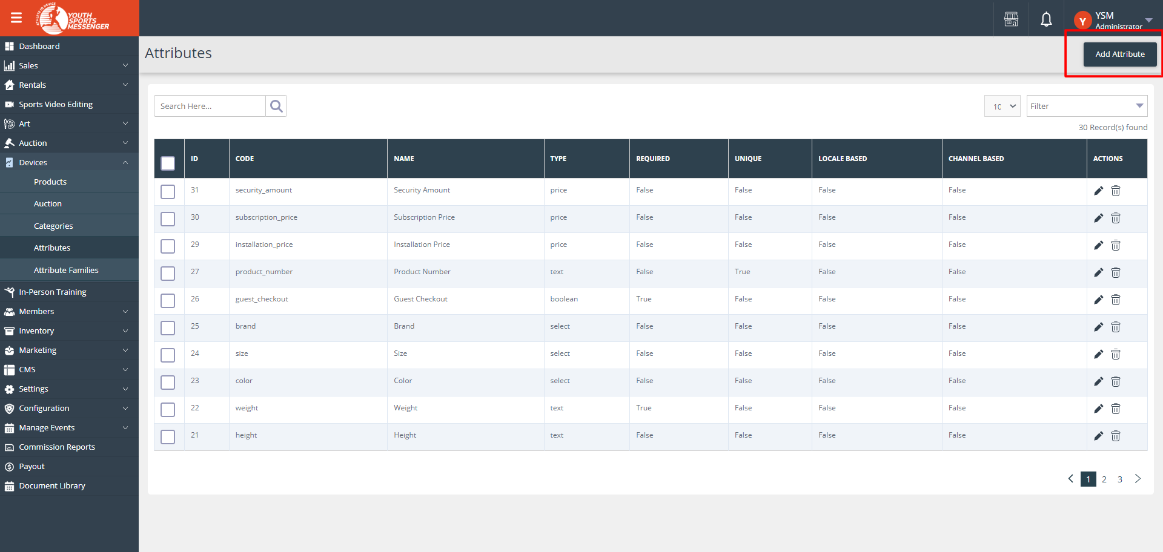
4. On clicking “Add Attribute” button form will be open. 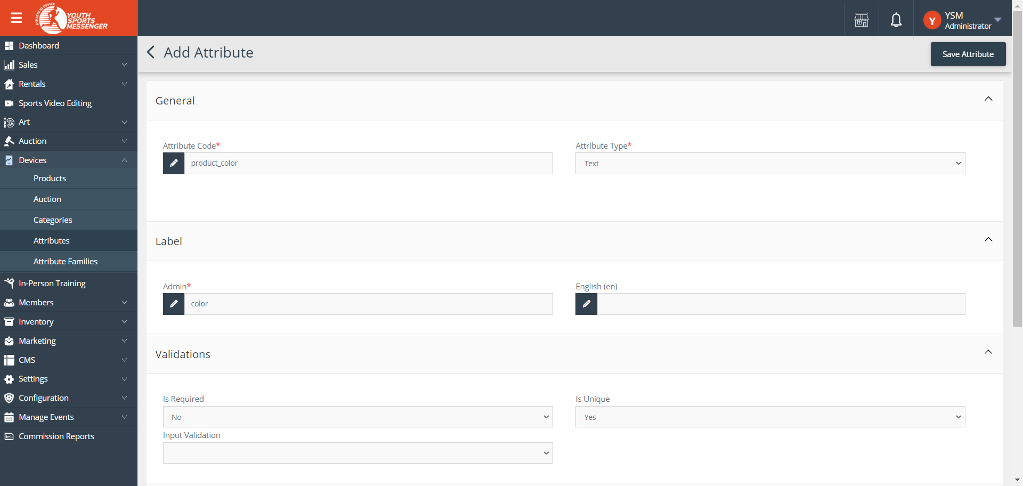
5. General field—
6. Attribute Code: This is a unique code used to identify the attribute in the system. It's typically a short, alphanumeric string without spaces or special characters.
7. Attribute Type: This defines the type of data the attribute will store. For example, it could be text, a dropdown selection, a date, etc.
8. Label field –
9. Admin: This indicates that the attribute is managed and configured by the admin of the system.
10. English (en): Specifies the language in which the attribute label and other details are displayed (in this case, English).
11. Validations field –
12. Specifies whether the attribute is required and/or unique, and may include input validation rules.
13. Configuration field –
14. Specifies settings such as whether the attribute's values are specific to different locales or channels, whether it's used for layered navigation, configurable product creation, visibility on the front-end, and storage in the product flat table.
15. Attribute is Comparable: Indicates whether this attribute can be used for product comparison purposes. 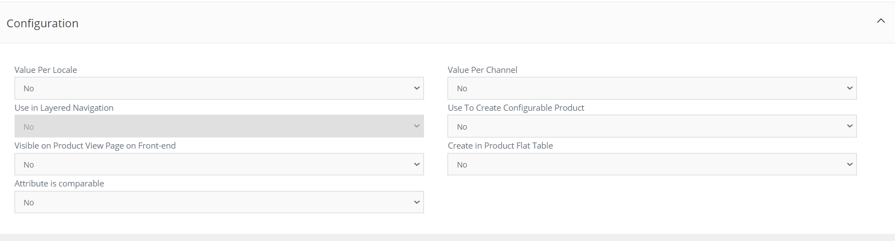
16. Added attribute will be shown on the attribute list.
17. Now Admin can make attribute family from the group of attributes. Click on “Attribute Families” menu then click on “Add Family” button.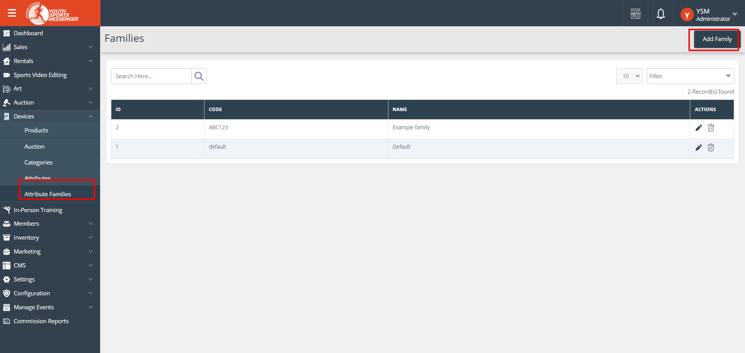
18. On clicking “Add Family” button form will be open. 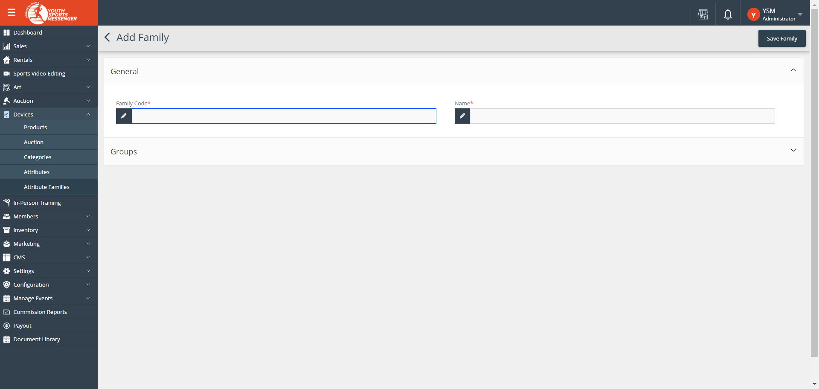
19. General field –
20. Family Code: The family code is a unique identifier assigned to each attribute family. It helps in distinguishing one attribute family from another, especially in databases or systems where multiple attribute families are managed.
21. Name: The name field is used to define the name of the attribute family, making it easier for users to identify and understand the purpose of the attributes grouped under this family.
22. User can add group by clicking “Add Group” button. 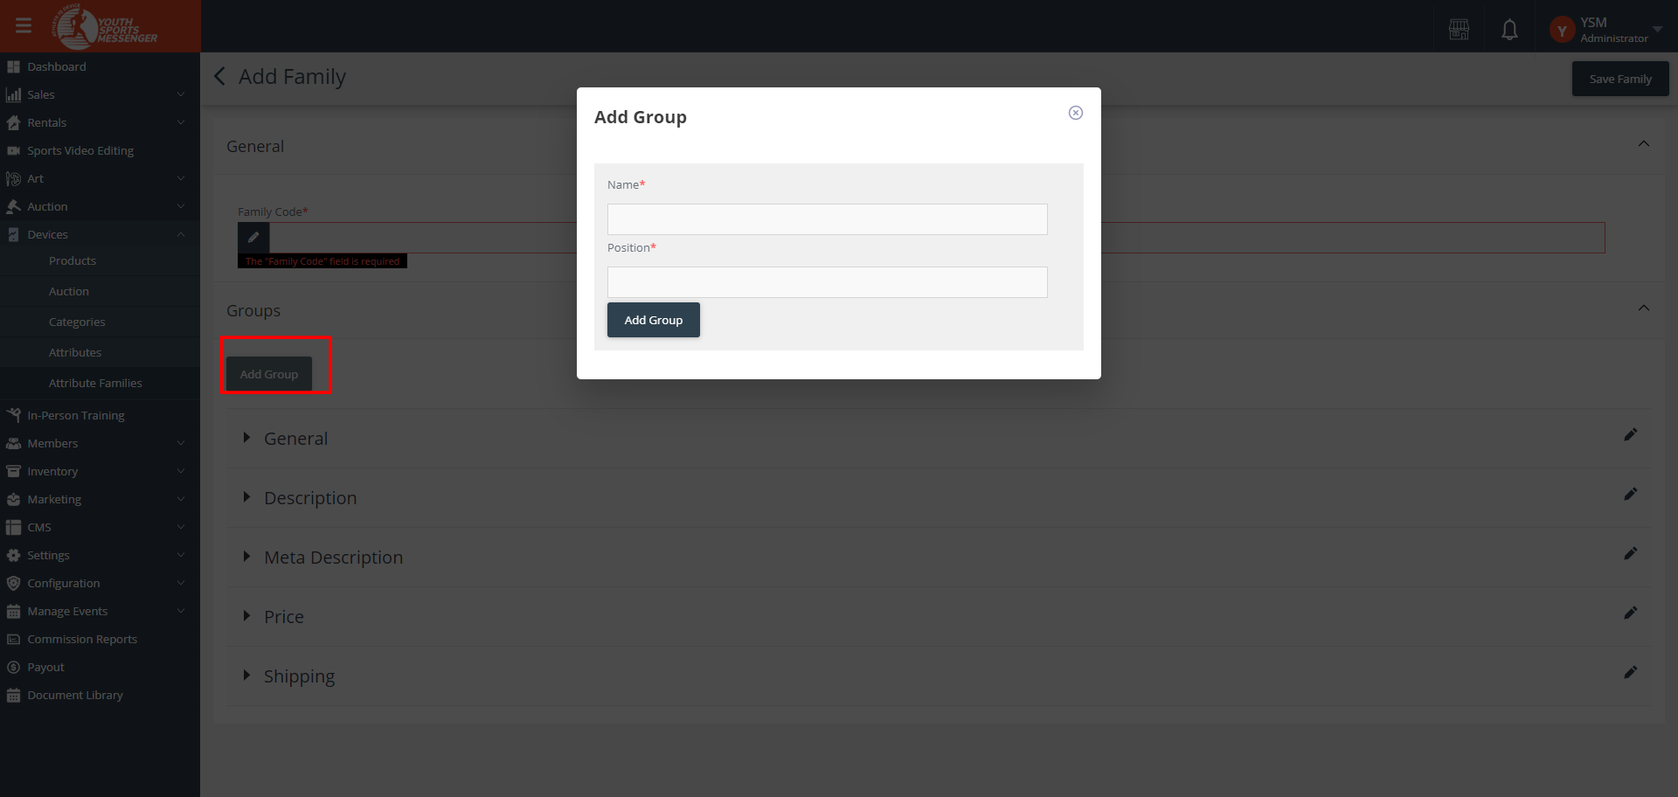

n) Groups –

1. General - This group includes attributes that provide general information about the product, such as its name, brand, manufacturer, and any other relevant identifiers. User can also add an attribute. 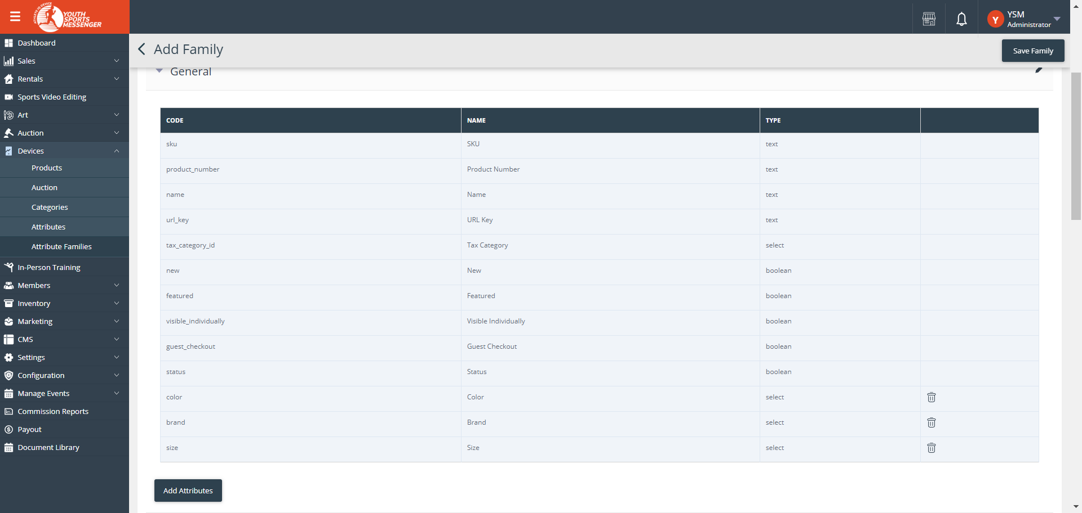

2. Description- Attributes in this group describe the product in detail, including its features, specifications, materials used, and other information that helps customers understand what the product offers. User can also add an attribute. 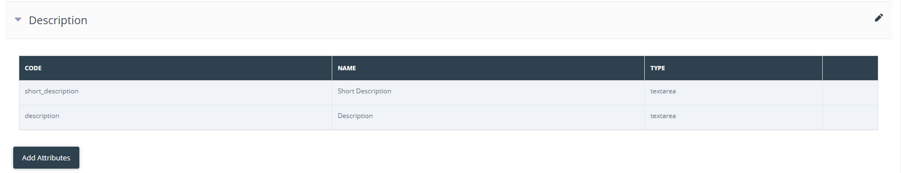

3. Meta Description - These attributes are used for SEO purposes. They include keywords and a concise description of the product that appears in search engine results, helping improve the product's visibility online. User can also add an attribute. 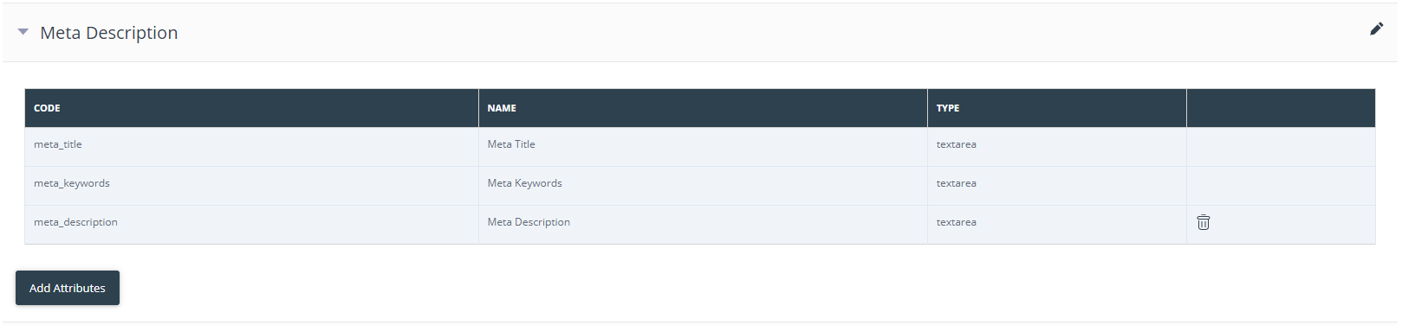

4. Price - This group includes attributes related to pricing, such as the product's base price, discounts, sale prices, and any other pricing variations or options available. User can also add an attribute. 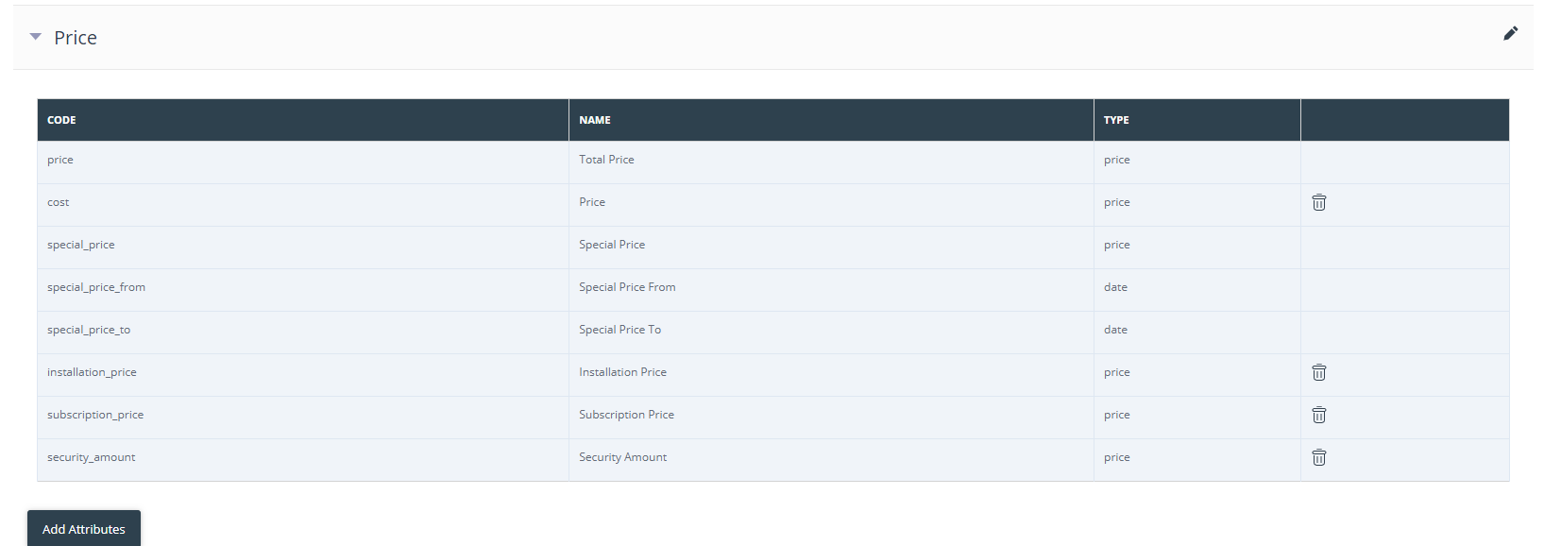

5. Shipping - Attributes in this group provide information about shipping options, costs, delivery times, available carriers, and any special shipping-related details for the product. User can also add an attribute. 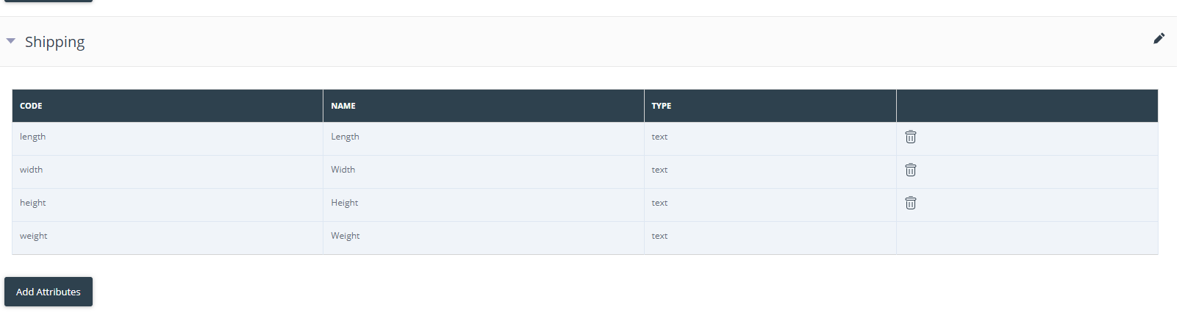

1. After saving details, attribute family will be shown on the list. 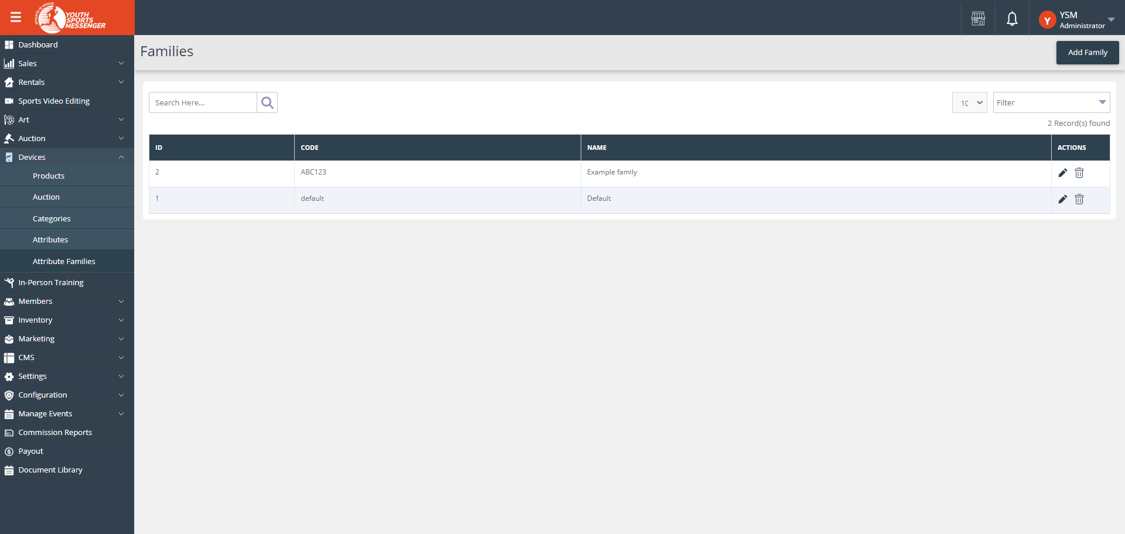
2. Go to the “Products” menu.
3. All products list will be visible. Admin can add product by clicking “Add Product” button. 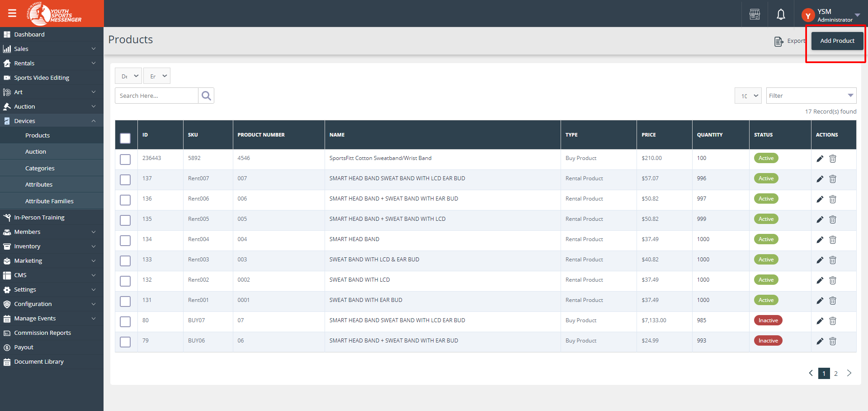
4. Saved attributes and attribute family will be shown while adding new product.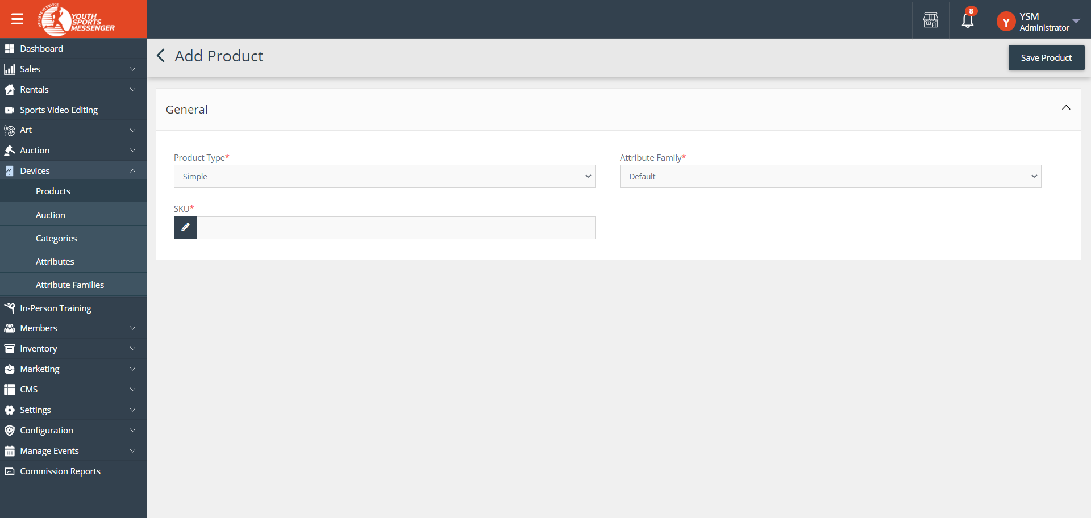
5. Fill the general details like Product Type , Attribute Family , and SKU code for the product.
6. Product Type: Specifies the category or classification of the product for organizational purposes and accurate display.
7. Attribute Family: Defines the set of attributes relevant to products within a specific category, aiding in detailed product information.
8. SKU Code: Provides a unique identifier for each product variant, facilitating inventory management and order tracking.
9. Fill all details and save then more product details will be open to be filled. 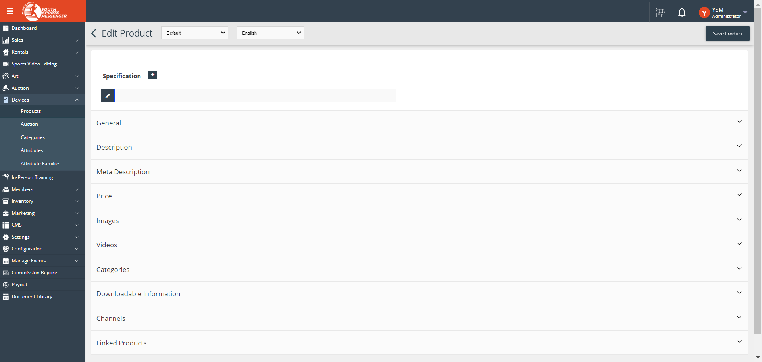
10. Fill the specification details of the product. 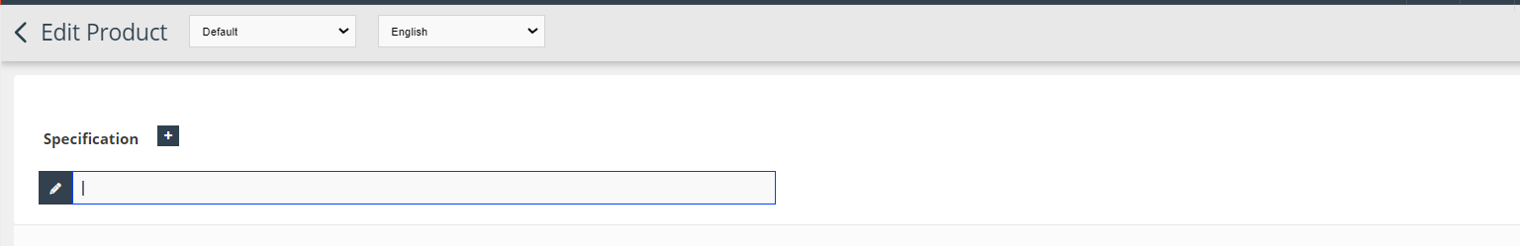
11. Then fill the General details –
12. SKU Code: Provides a unique identifier for each product variant, facilitating inventory management and order tracking.
13. Product Number: Unique identifier for internal inventory and tracking.
14. Name [default - en]: Product's primary name in the default language.
15. URL Key: SEO-friendly part of the product's URL for easy access.
16. Tax Category [default]: Specifies applicable tax category for accurate pricing.

Toggle buttons:

* New: Marks product as new, attracting attention to recent additions.
* Featured: Highlights product for increased visibility and promotion.
* Visible Individually: Determines if product appears as a standalone item.
* Guest Checkout: Enables non-registered users to buy without creating an account.
* Status: Indicates product's current availability and visibility.

1. Color: Specifies product color options for customer selection.
2. Size: Specifies product size options for customer selection.
3. Brand: Identifies product's brand or manufacturer for categorization. 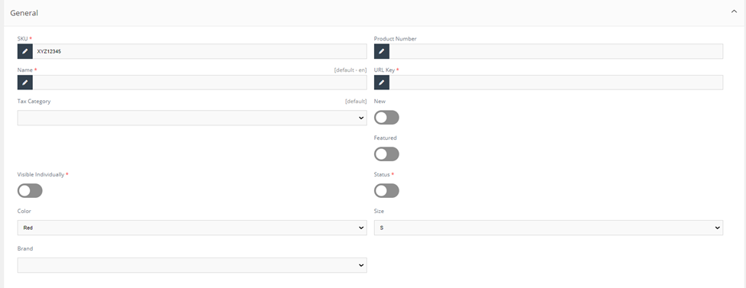
4. Then fill the Description details –
5. Description: This field allows you to provide a detailed and comprehensive description of the product. It can include information about features, specifications, benefits, usage instructions, and any other relevant details that help customers understand the product better before making a purchase.
6. Short Description: The short description field is typically used to provide a brief overview or summary of the product. It is often displayed alongside the product image on listing pages or in search results, giving customers a quick glimpse of what the product offers without going into extensive detail. 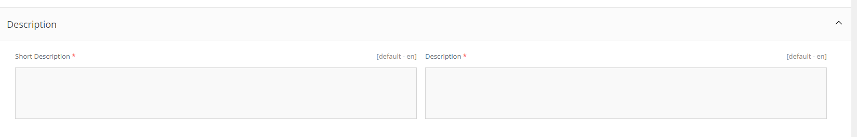
7. Then fill Meta Description details –
8. Meta Title: This field contains the title of the product's web page, which is displayed on search engine results pages (SERPs) and browser tabs. It should be concise, relevant, and include keywords to improve search engine visibility.
9. Meta Description: The Meta Description field provides a brief summary or snippet of information about the product. It appears below the Meta Title on SERPs, influencing click-through rates by enticing users to visit the page. It should be compelling, descriptive, and include relevant keywords.
10. Meta Keywords: Meta Keywords are a set of keywords or phrases related to the product that are embedded in the HTML code of the webpage. While their direct impact on search engine rankings has diminished over time, they can still help search engines understand the content and context of the page. 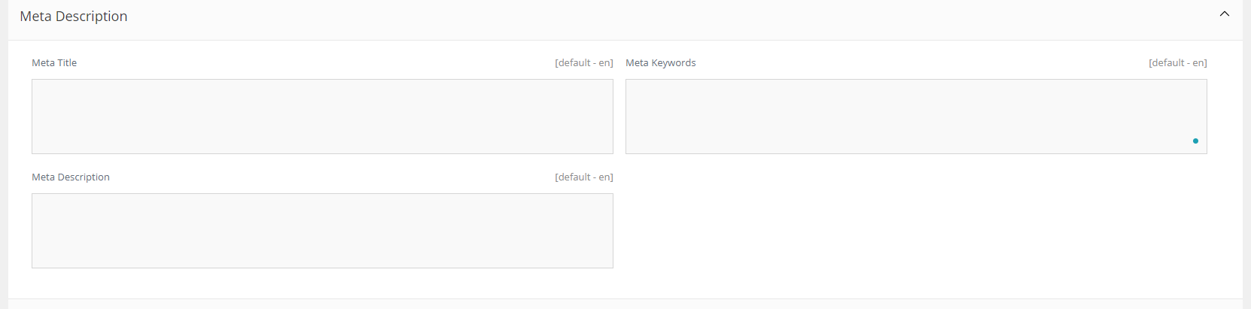
11. Then fill Price details—
12. Activation Price ($): Specifies the initial price of the product, often used for one-time purchases or activation fees.
13. Check for Wave Off: Indicates whether there's a discount or promotion that can be applied to waive off part of the price.
14. Subscription Price ($): Specifies the recurring price for subscriptions or ongoing services.
15. Customer Group - All groups dropdown: Allows you to set different prices for specific customer groups (e.g., Online Coach, Guest User, Business), providing personalized pricing.

* QTY: Specifies the quantity of the product available or purchased.
* PRICE - Fixed/Discount: Defines the pricing type as either a fixed price or a discounted price for promotions or special offers.

1. Add Customer Group Price field: Adds a field where you can set customized prices for different customer groups, further personalizing pricing strategies. 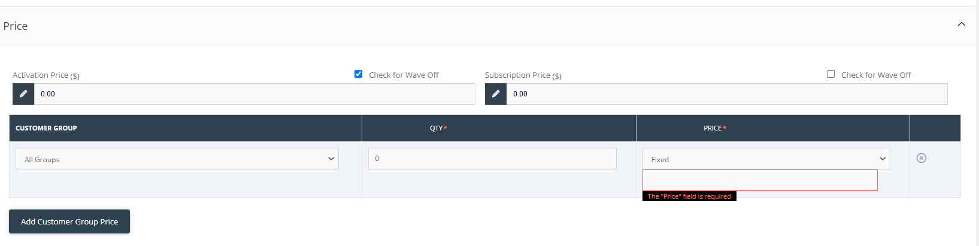
2. Then upload Product Image by clicking “Add Image” button.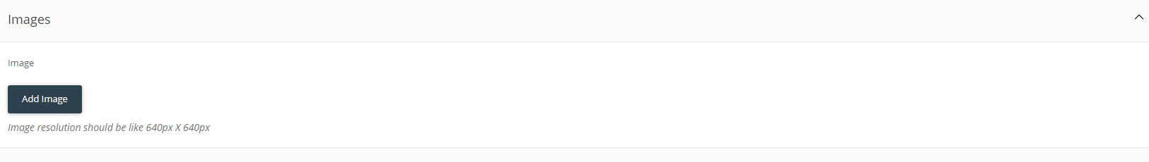
3. Then fill
4. After filling details, product will be added to Product list. Admin will make product status “Active” so that product can be visible to frontend.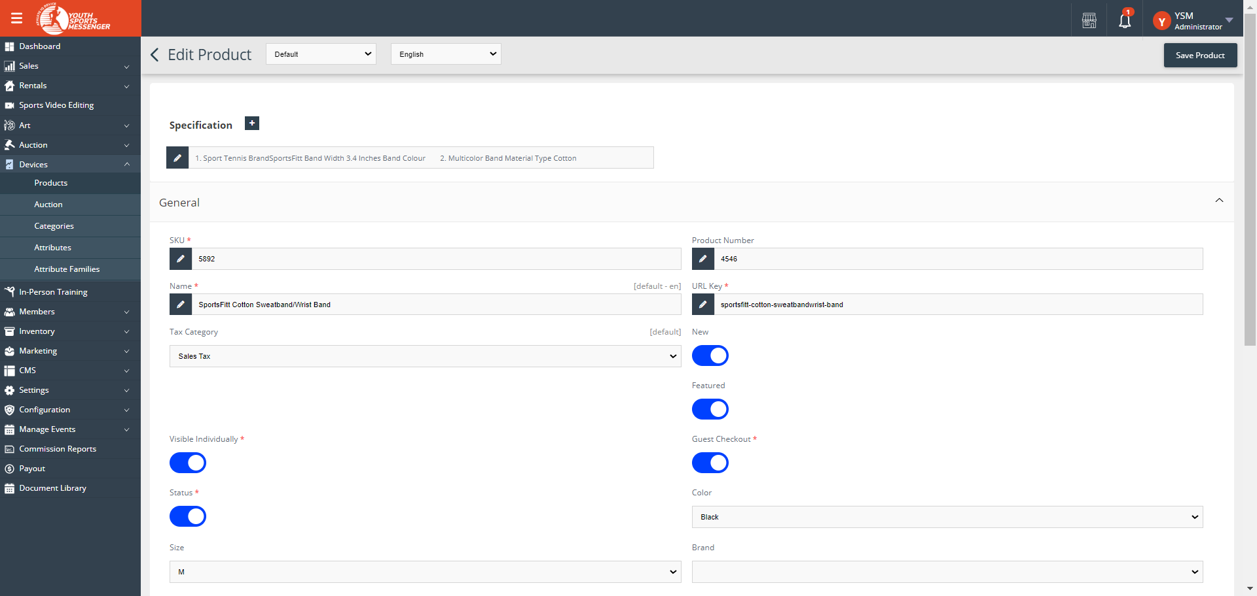
5. Admin can also add the product for auction by going to “Auction” menu under Devices. Click on “Add Auction” button. 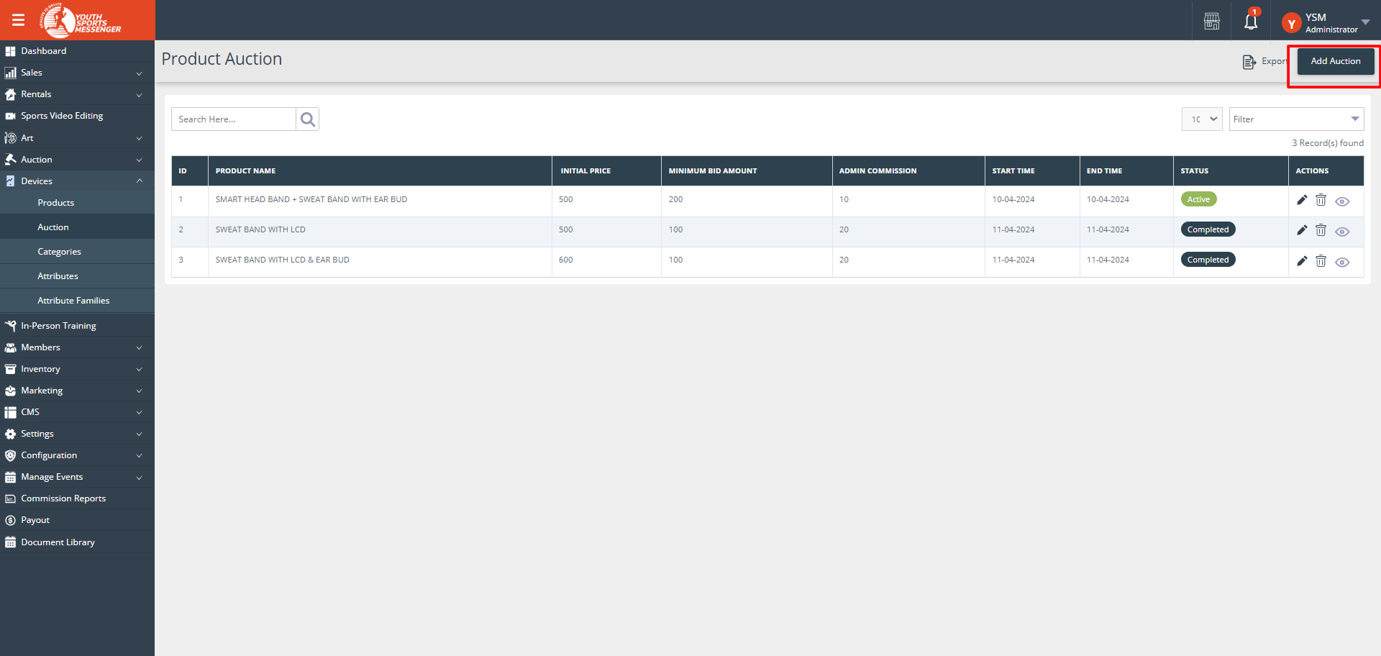
6. Admin can manage category of the product by going to “Categories” menu. Here admin can add category of the product . Added category will be show on creating new product. 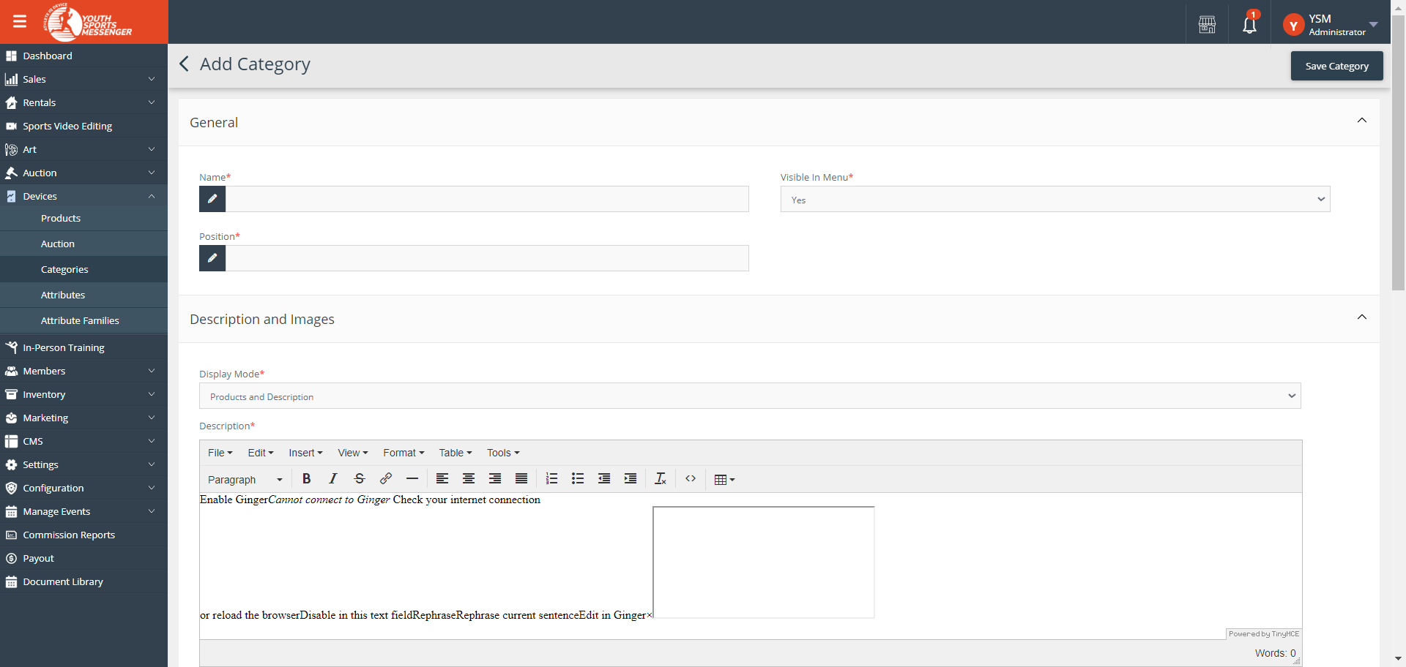
7. New product will be publish to the frontend in “Products” menu of the website. 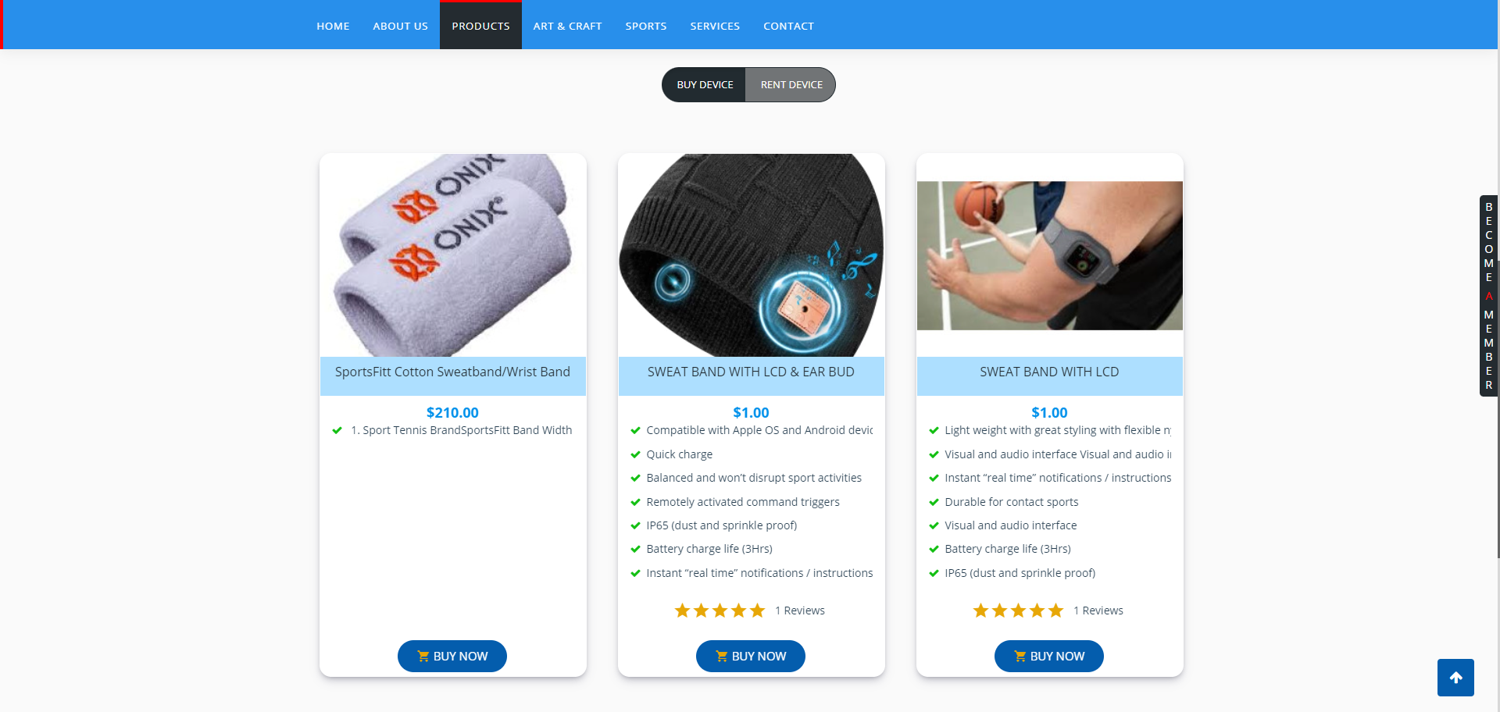
8. Now the product will be able to buy from users end.