**Updates by Jeff – dated 25-10-2022**

https://blackdiamondz.getanapp.co.in/

The test website is not working as mentioned in the video dated October 1:

1. The website in the video and the live are the same, but the contents (feature pages) does not match.

2. The banners are not moving by itself every 5 seconds, it needs to be clicked once first before it continuously shift. We want the banners to start shifting once someone lands on the website.

FREE SHIPPING should only appear when there is a Free Shipping promo.

NOTE:

Create the functionality to add a Free Shipping banner for promos on the admin.

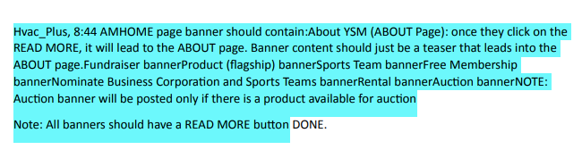

The banners mentioned here are not yet complete. Please check.

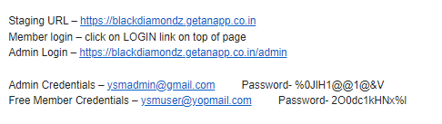

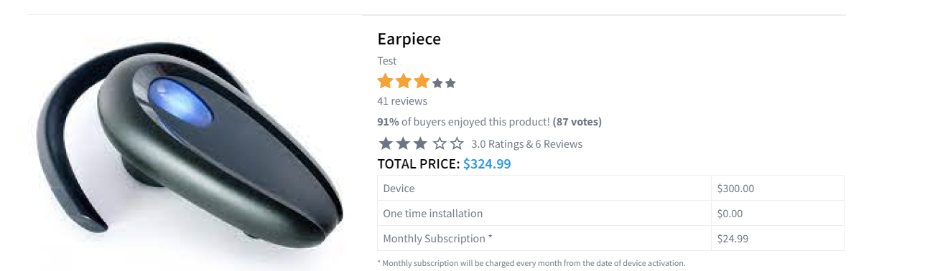

NOTE:

We need more information about the ONE TIME INSTALLATION

We need the help and energy from Restaurants and Bars. We will create a marketing template “Brochure” for Restaurants and Bars to purchase. after they purchase the Brochure the Restaurant and Bar will promote “Sit Out” the Brochure onto their Table Tops or Bar Tops at their own expense. Money from Messenger Sells and Fund Raisers will be sent to their Local Sports Teams. In return the Restaurant and Bar will receive a Promotional Space on our website per their zip code.

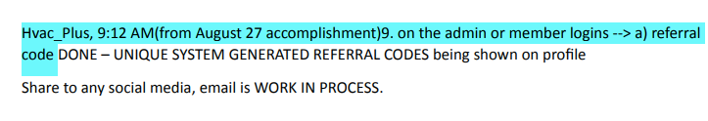

The referral code is already working, but the "Share to Social Media" is still not working.

Welcome

Jeffrey Spruel

Free Member

Ferdinand Ledesma has invited you to join YSM; one of the best Sports Coaching Technology company. We help you earn more by selling our devices to your network and also help you get more training opportunities in your area. This is a great opportunity to earn handsome margins, and by giving cutting edge technology to your sports kids.

You can login with your email and password to get the benefit of all services and update your profile as well. First, you have to click on the below link to accept this invite.

Email : mailto:jspruel123@gmail.com

Click Here To Accept

If you do not wish to accept, you can simply ignore this email. "You are nominated" "email is titled YSM"

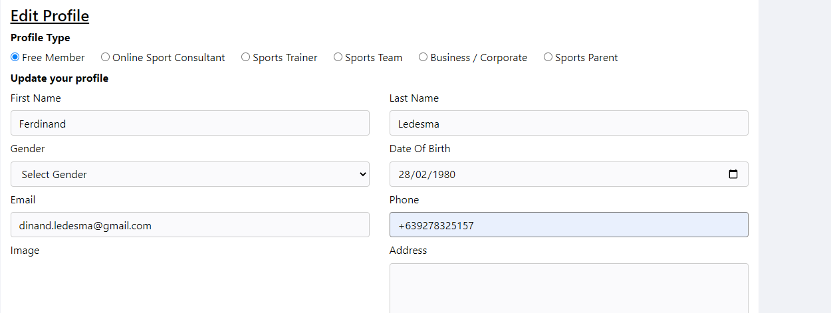

Date format should be: Month/Date/Year

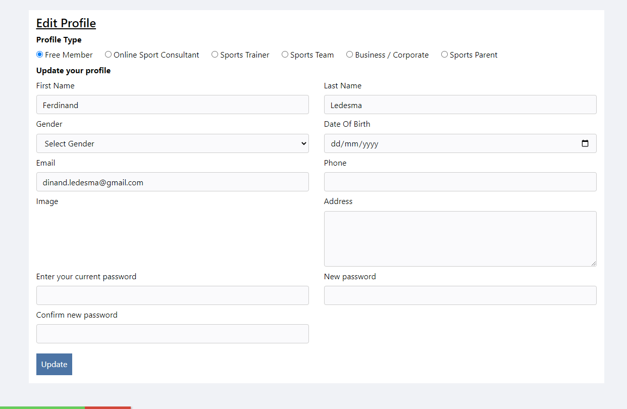

The EDIT PROFILE is not updating the profile after clicking UPDATE.

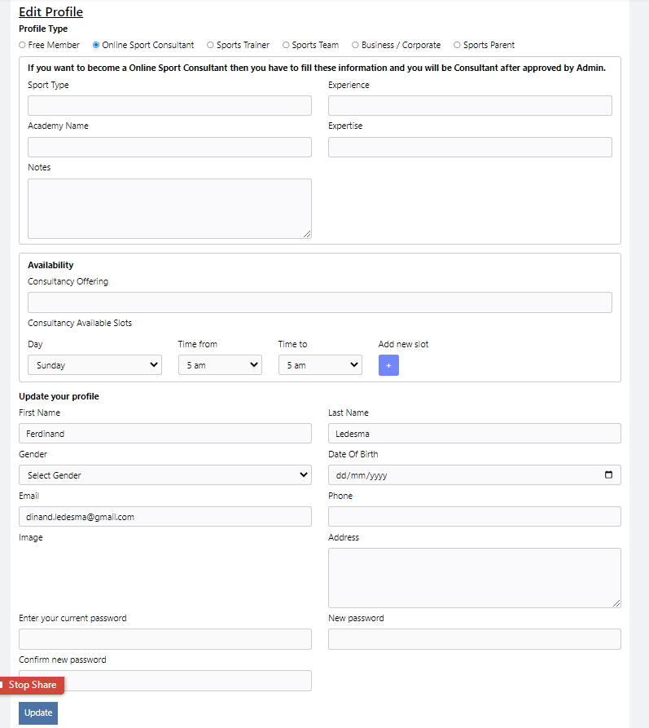The Edit page does not update the profile after adding details such as birthday, phone number etc. It also doesn't show any update after editing information or adding Sports Consultant or Sports Trainer in the profile status.

After editing the profile to become a Sports Consultant and/or a Sports Trainer, nothing happened, no changes appeared in the profile status. There should be something in the MY PROFILE that says or shows that the free member is also a Sports Consultant and a Sports Trainer.

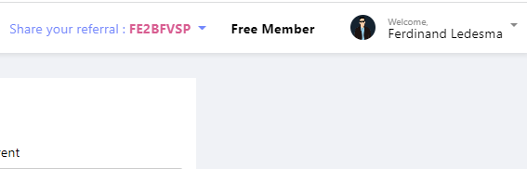

Once a free member updates his profile to Sports Trainer and/or Sports Consultant, this portion in the dashboard should also reflect the updated status in the form of a drop down.

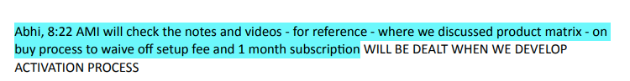

What is the latest update on this?

I was waiting for your latest updates you were telling me about

I am sending you updates, changes and fixes from your last update list.

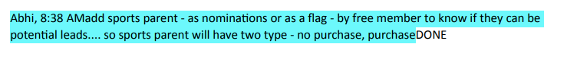

1. How does it affect the system if the Sports Parent have "purchase" or "no purchase"?

2. Where can we see the status of "purchase" or "no purchase" for the Sports Parent?

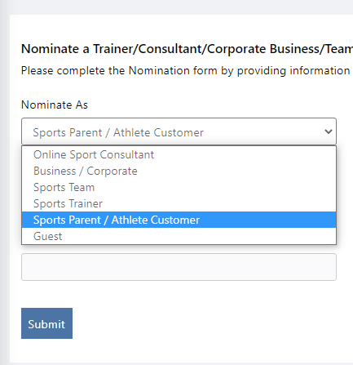

1. Remove "Athlete Customer" from Sports Parent.

2. Make a new category called "Student Athlete"

the parent will mostly purchase the the device for the youth. that is our starting mindset.

a child will hardly purchase this device so do we need to give them them a Category?

the main reason for this change is let you know to reference “Student-Athlete” whenever mentioning the Youth or Athlete.

1. Remove "Athlete Customer" from Sports Parent.

2. Make a new category called "Student Athlete"