**Step by Step process – for Purchase / Rent at Purchase Portal and API data points – for data exchange with engineer portal.**

**Points to remember –**

1. Purchase portal – will remain a key portal point for customers to browse and engage
2. Thru Purchase portal – customers / athletes / parents – can purchase / rent out devices
3. Thru purchase portal – they will be able to maintain their base profile and manage their accounts
4. Purchase portal will also keep track of monthly subscription payments

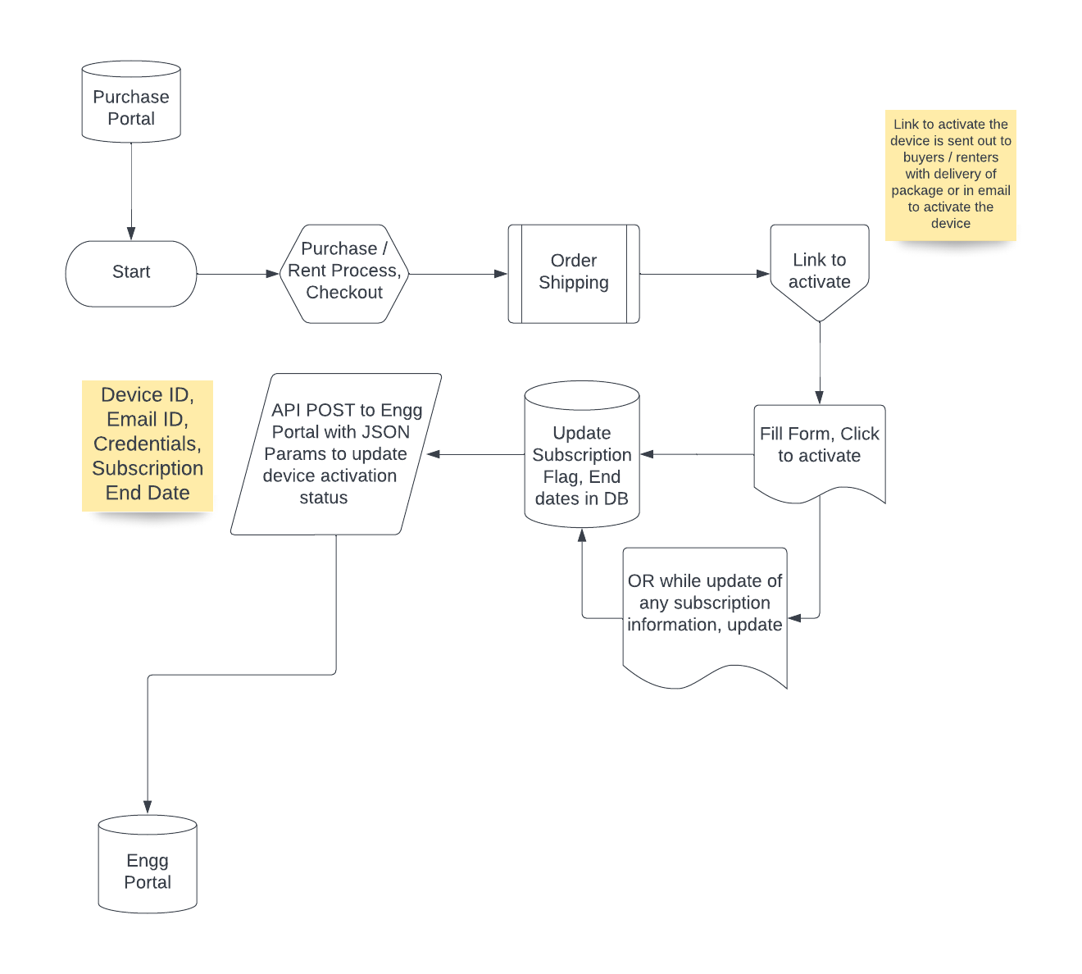

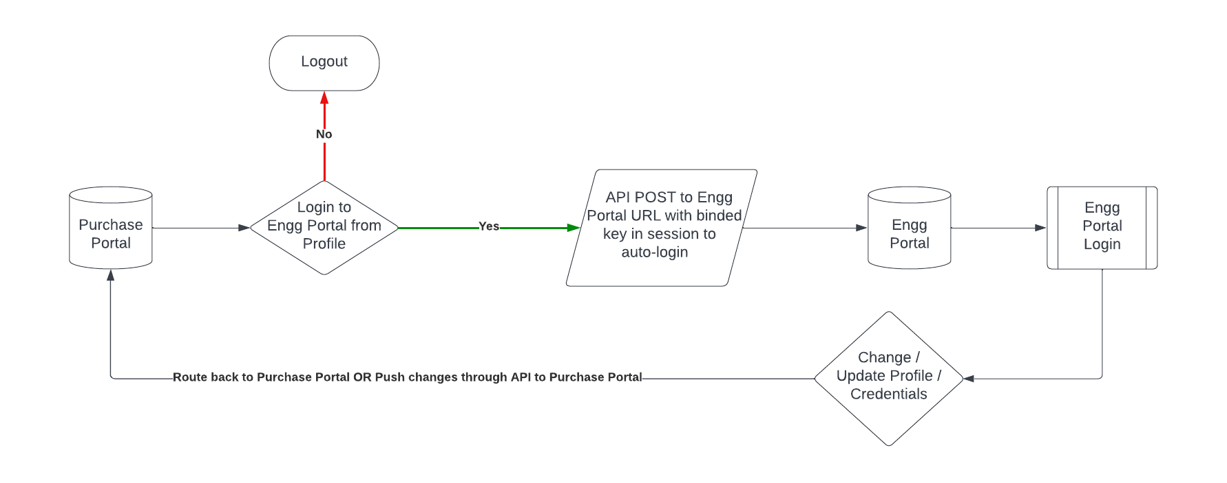

**API Points & Use Cases –**

1. **First Activation of a Device**
   1. **When user purchases a device for first time**
   2. **When user rents out a device for the first time**
2. After purchase (buy) – a device will be shipped to customer with relevant activation instructions (or an email with links, activation steps)
3. On receiving of device, customer will follow steps to activate the device
4. Copy or type or click on URL given e.g., <https://ysm.com/activate>
   1. Enter existing login credentials / email id – used while making a purchase
   2. Navigate to Profile
   3. Click on Add Device
      1. Enter Device ID
      2. Pick order ID from list (auto-populate) to indicate the purchase
      3. Enter details of athlete who will be using the device –
         1. NAME
         2. Age / DOB
         3. Gender
         4. Sports TYPE
         5. Email ID + PIN/Password for Engg portal access
   4. On SUBMIT – the given details will be saved to Purchase portal DB. Date and TIME stamp are updated in subscription details with a 30 day validity calculated Subscription End Date and 3 day grace period as Grace End Date.
   5. And, API POST will be invoked to engg portal – to save same to engg portal db for their use.

**[Engg portal – to create an API POST to seek input from purchase portal. Include data points from above details and in case you need any further – you may give/add/remove]**

**Tentative data points –**

**[***Device_id,*

*Order_id,*

*order_date,*

*Activation_date,*

*Activation_status,*

*Name,*

*dob,*

*gender,*

*sports_id,*

*email_id,*

*credential_MD5 or hash,*

*Subs_End_Date,*

*Grace_End_Date***]**

1. **De-activation of a device –** 
   1. **When user fails to pay subscription fee before End of Grace period**
   2. **When a user willingly opts for deactivation –** 
      1. **When use do not wishes to use the device temporarily for a period**
      2. **When user do not wishes to use the device henceforth and wants to return / auction**
   3. **When user fails to pay for rental fee before end of grace period**

**On Engg portal –**

During login – if any device ID End of grace period date is > current date – Engg portal will call API to check status from purchase portal to get updated status – If found ok – login , else, logout and show message to make payment

**On Purchase Portal –**

During login / profile access – during end of grace period – message will be shown for payment. After end of grace – message will be shown that the device is deactivated due to non-payment.

CRON job will update the status – after end of grace period / thru a trigger / SP – this will be updated in the db.

**GET API will be done by purchase portal – for checking any device activation status.**

**Engg portal to send 🡪 device ID to GET activation status, end of grace period date, end of subscription date to update their side of db, login**

1. **Re-activation of a Device –** 
   1. **when somebody purchases an auctioned or used device OR**
   2. **rents out a device priorly in use by someone else OR**
   3. **Pays subscription after the End of Grace Period**

On payments – the purchase portal will update their side of DB and push API to update respective status to engineer portal

**We will hit engg portal api url to update this.**

**[Engg portal to make an API for this] Data points to be – [device_id, activation_status, updated_on_timestamp, subs_end_date, grace_end_date]**