Device Activation Process

Here we are going to do the device activation, will see how user purchase product, and admin makes the shipment and delivery person deliver it to user, then finally the customer will able to do the activation of their device.

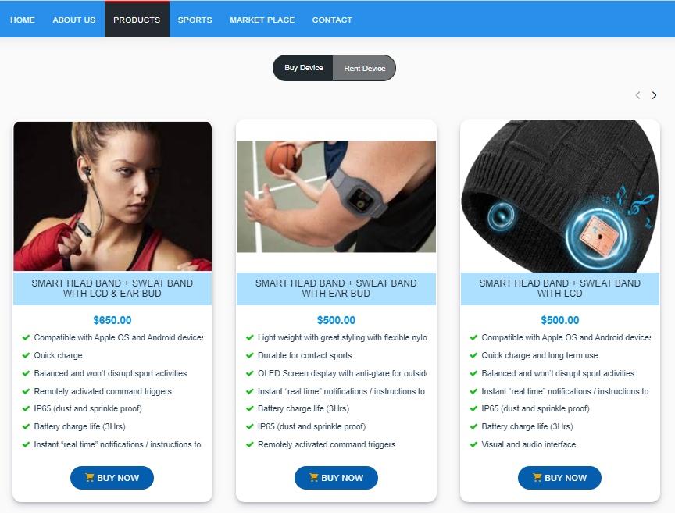

First, Customer/User will make purchase

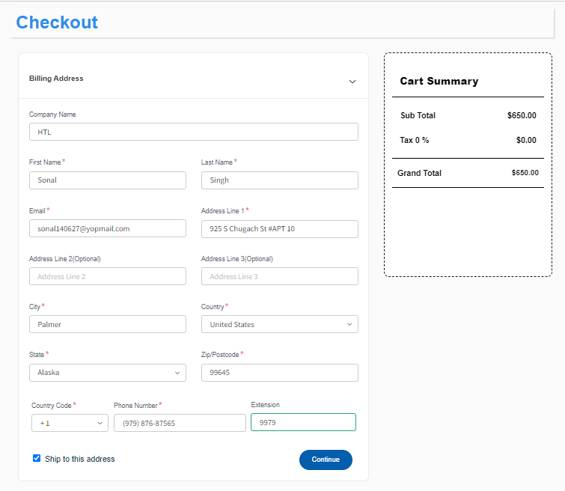

Will complete the whole registration process

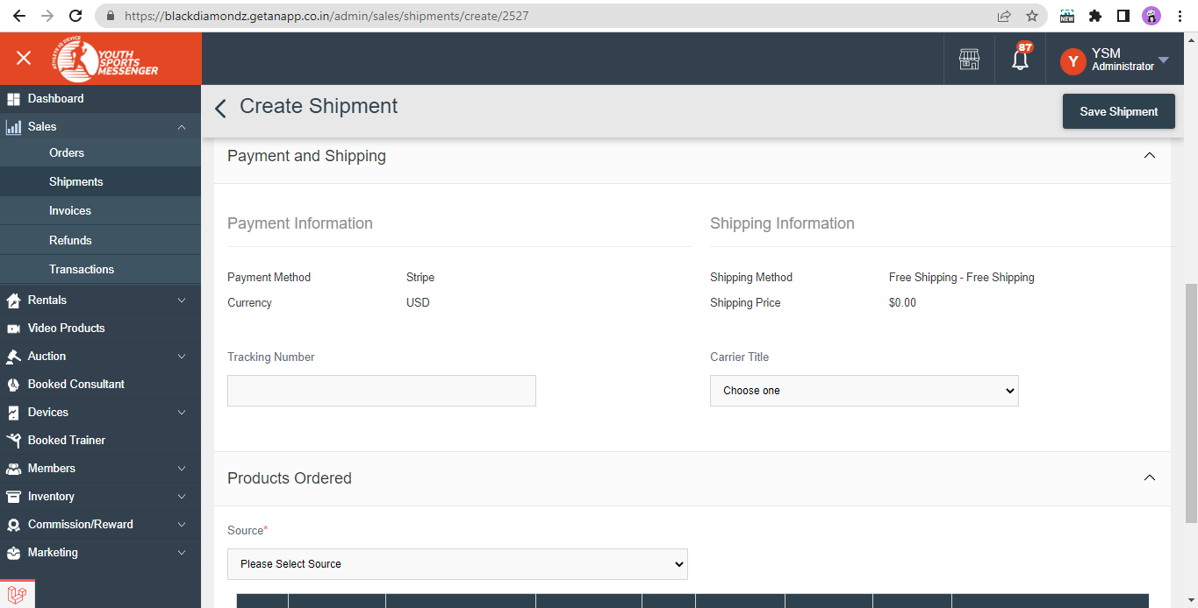

Once order is successfully placed, admin will then create shipment for that order by providing shipping method, Tracking Number

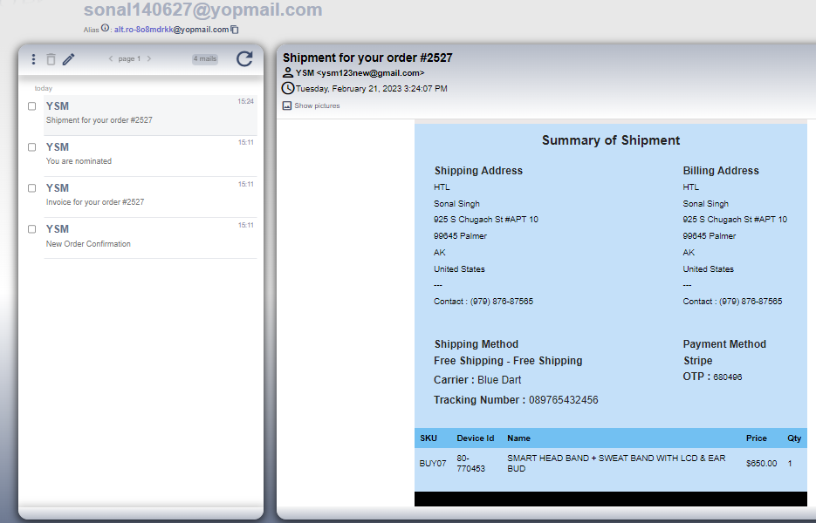

Customer/User will receive an email after shipment, with details like “Tracking Number”, “OTP” which they have provide to the delivery person to confirm their identity.

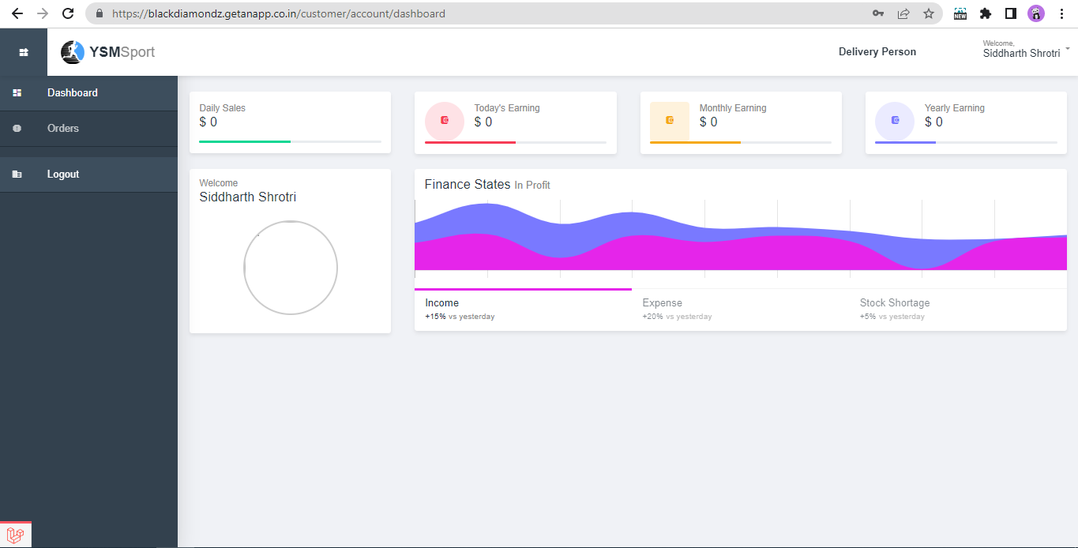

Now we logged in as a Delivery Person to deliver the order to the Customer/User

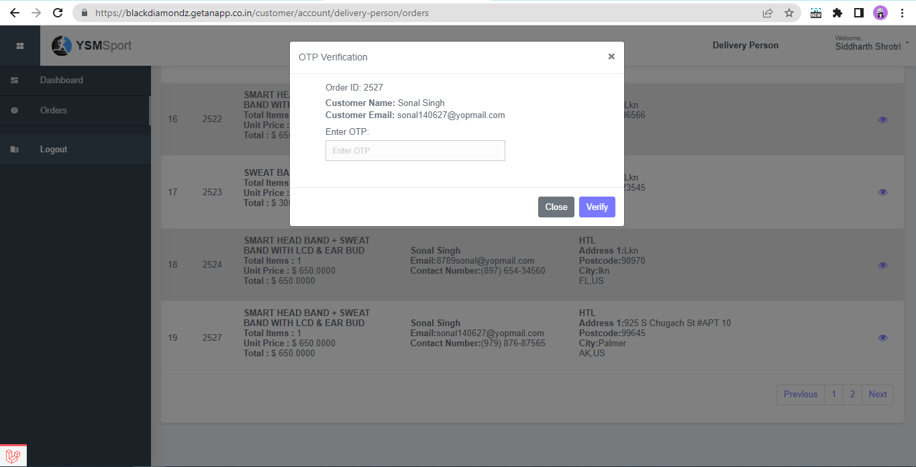

If Member received delivery on doorstep, they can also mark shipment as delivered by entering OTP through the given link on email to get your activation code and start using the device.

Now the delivery person will ask the customer/user for OTP to confirm, which they have received by email, once it is verified delivery will hand over the package/device to the customer/user

After shipment is marked delivered, member will then receive device activation code on email. Which is required while activating device for use for oneself or for other member.

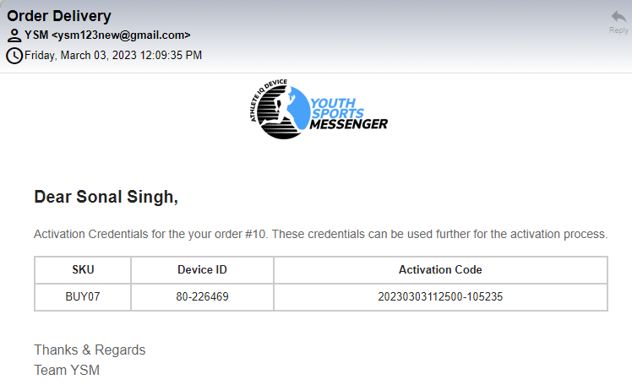

Now going to login as member who purchased the device, to activate device after it is delivered.

There are two conditions to login either user is already a member of YSM so they easily log in to their account.

If user is not registered and purchased a device they will receive an invitation on email along with order confirmation and invoice, member then accept the invite and generate their password and then can easily log in to the account and activate purchased device.



After logging in to device navigates to My Ysm menu given on left side and click on Devices.

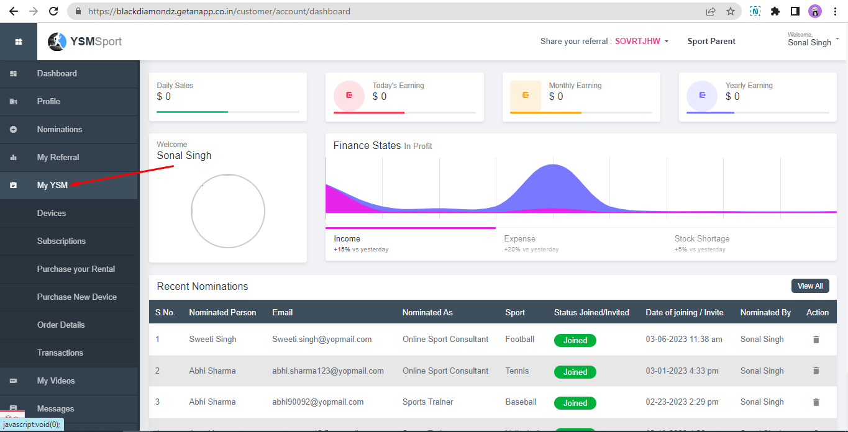

In this section member can see all his/her purchased devices, to activate device click on the arrow given under action column

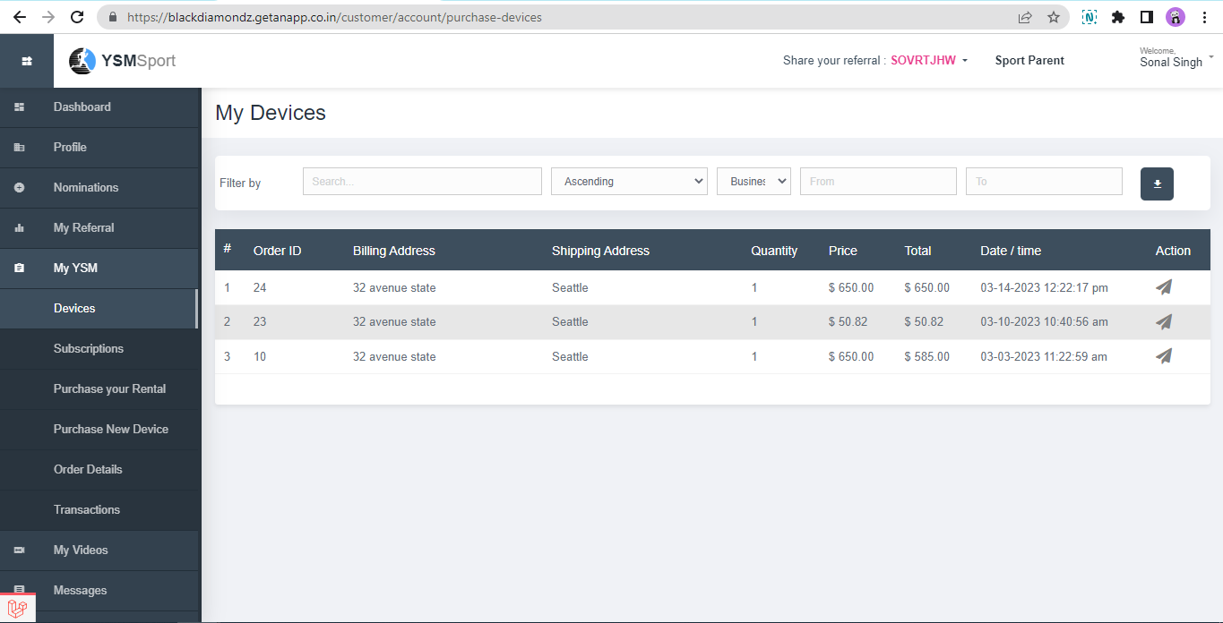

After clicking on the icon, below page will open with details of subscription.

It is NA now because we haven’t activated the device yet.

For activating device again customer needs to click on the “ACTIVATE NOW”

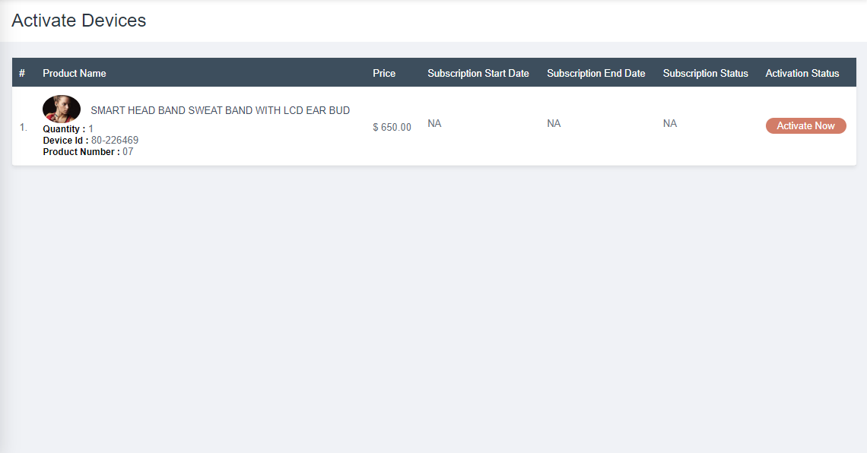

Customer can activate device for oneself and for other as well. However, activating for other member they need to enter their details with the activation code they have received on email.

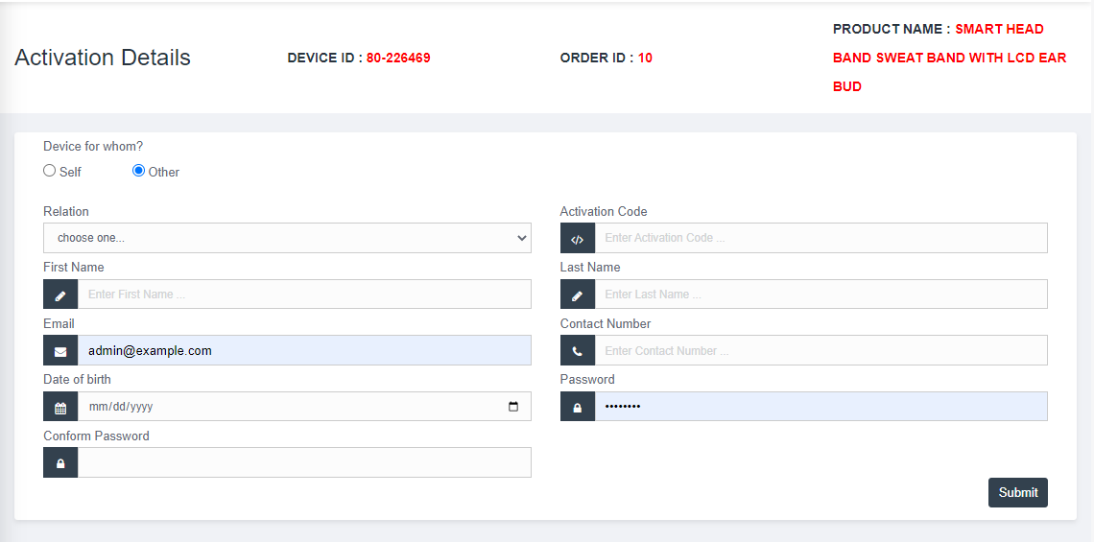

In addition, for activating for self they just need to enter only the activation code.

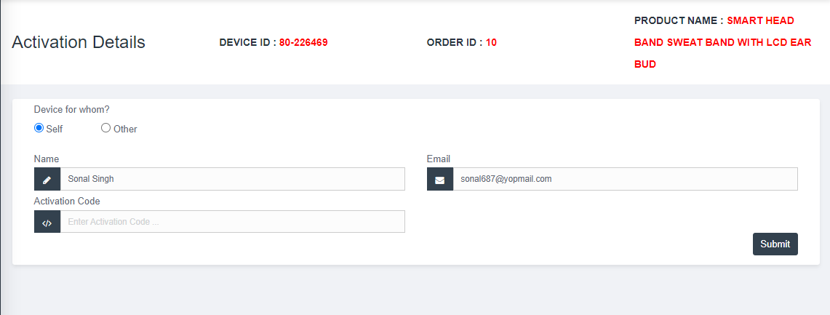

Device now activated! To see the subscription details, click on the icon to see the page with subscription details.

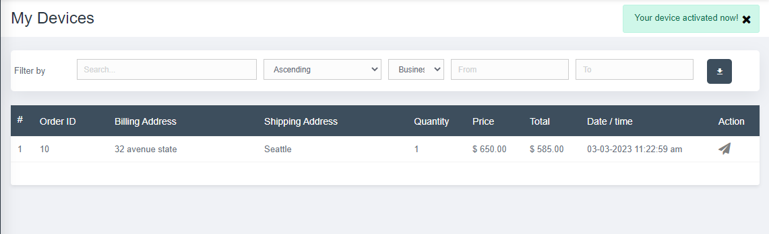

Now after activating device, customer can see subscription plan of device.

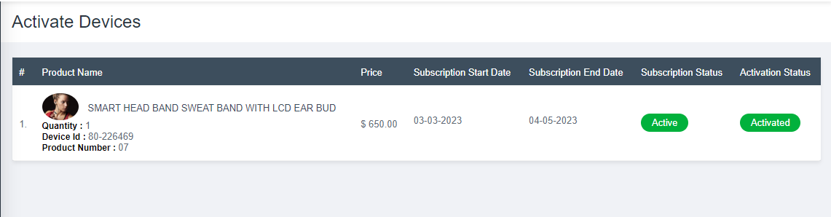

It is for one month now, before 7 days of subscription end date customer will be notified about expiration of their subscription and to renew it.

However, the device will keeps working after 3 days of subscription end date and these 3 days will be included in the next subscription plan.

And after 3 days of subscription end date the device will stops working and get inactive with a notification to renew subscription.