

Table of Contents

Youth Sports Messenger Website 3

Abbreviations: 3

Member Types: 3

1. Navigating Purchase Portal Website 4

2. Purchase or Rent a Device from Purchase Portal 5

2.1 Purchasing a Device: 5

2.2 Purchasing a Device Rental: 5

3. Cart/Checkout Process 6

Marketplace Offerings 7

4. Booking a Sports Trainer 7

5. Booking a Sports Consultation Service 9

6. Booking a Video Editing Service 10

7. Registration/Login/Forgot Password 11

Member Portal 12

1. Dashboard 13

2. My Profile 14

2.1 My Profile- 14

2.2 Edit Profile- 14

2.3 Bank Details- 15

2.4 Manage address- 15

3. Nominate a Member 16

4. Referrals, Referral Code, Earnings 22

**Share Referral Code- 22**

**Referred Members- 23**

**Manage Discount- 24**

**My Earnings 25**

5. My YSM (Member’s YSM – all services from Member context) 26

**Devices 26**

**Subscription 27**

**Purchase your Rental 28**

**Purchase New device 29**

**Order Details 30**

**Transactions 31**

6. My Videos 32

7. Messages 36

**Chat among Nominated users: Send message to nominated member 37**

**Against support ticket 38**

**Chat with Sports Consultant 39**

8. Support Tickets 40

**Select category, title and description of your problem. 41**

**Title – are mapped frequently asked queries 42**

**Unique Support ticket ID: 43**

**9. Events/Events List 45**

10. Ratings & Reviews 49

11. Sports Consultant Booking 50

12. Trainer Booking 51

13. LogOut 52

SUPER ADMIN / ADMIN AREA 53

Manage Members 53

**Nominations 58**

Manage Orders 59

**ADDING “BUY” PRODUCT & ORDERS 59**

ADDING “RENTAL” PRODUCT & ORDERS 63

Manage/View Marketplace order listings 66

**Trainer booking orders 66**

**Consultancy booking orders 67**

Manage Video editing booking orders 68

Earnings, Commissions 70

**Referral Commission 70**

**Event Commissions- 71**

Support Tickets 73

# Youth Sports Messenger Website

The YSM Website is essentially the purchase portal. The system comprises a Purchase portal (which is described under this document) and an Engineer Portal – which is a separate portal that takes care of the device based training part.

The YSM portal (purchase portal) will be discussed here and it has many stakeholders, users and use cases. All the important use cases, member types and user scenarios are discussed in the help document.

### Abbreviations:

* YSM: Youth Sports Messenger
* EP: Engineer Portal
* PP: Purchase Portal

### Member Types:

* Free Member
* Sports Parent / Athlete
* Sports Trainer
* Sports Consultant
* Business
* Sports Team
* Super Admin
* Sub-Admin
* Account Manager
* Supporter
* Delivery/Courier Agent

Live URL - <https://youthsportsmessenger.com>

Live URL - Admin panel - <https://youthsportsmessenger.com/admin>

Generic URL Structure - https://URL/<pagename>

## Navigating Purchase Portal Website

The website can be accessed using URL: <https://ysm.com>

The following document briefs about how to navigate the website and what is where. Gives brief understanding to the user – where to get what. The document below describes how to use and navigate the website.

<https://docs.google.com/document/d/1DFwn3mV0_GfkbOWEGJL0Gub5zFBlNL95/edit?usp=share_link&ouid=111670019116578694944&rtpof=true&sd=true>

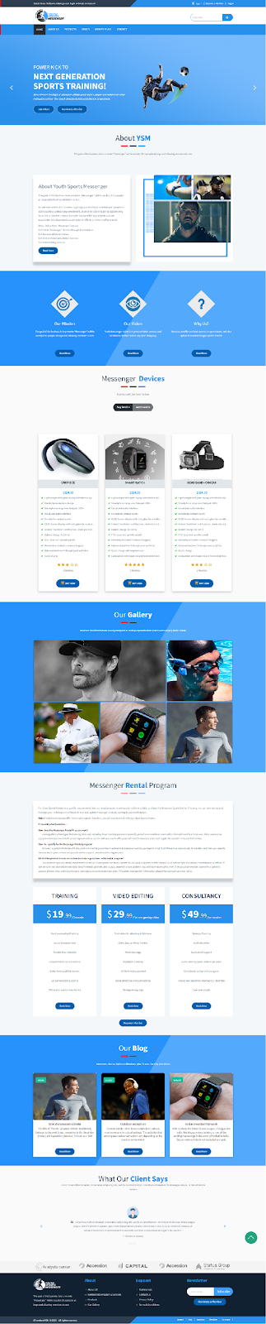

*Figure 1: Website Home Page*

## Purchase or Rent a Device from Purchase Portal

The module describes how a Purchase or Rental for a device is made from the Purchase Portal.

The website gives both options for the user to purchase or rent a device offered by YSM. The checkout process remains similar – while the change is only the plan and pricing for each.

We will brief out each in following sub-sections:

### 2.1 Purchasing a Device:

If we choose any product from BUY Category – the device purchase is made. The purchased device can be used by members until they wish to use. The member gets ownership of device on such a purchase. Only a monthly subscription for using device services is levied at a very low cost.

### 2.2 Purchasing a Device Rental:

When a user clicks on the RENTAL category to purchase a device on RENT from YSM; the user is charged a rent instead of a lump sum amount. A monthly recurring charge is applied on the monthly subscription along with device rental. This is usually higher than the subscription with purchase option.

The following document describes the purchase process in detail (applicable to both Buy/Rent):

<https://docs.google.com/document/d/1LNmdpZAffwZAvlU2PcBOyy2sT-tpsBHW/edit?usp=share_link&ouid=111670019116578694944&rtpof=true&sd=true>

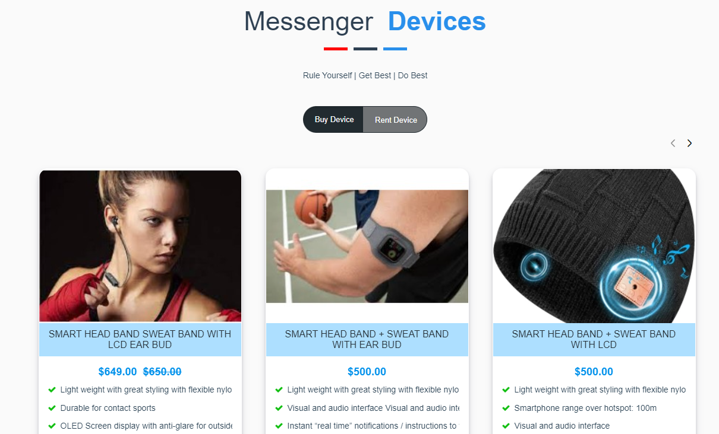

*Figure 2: YSM Device BUY / RENT Selection*

## Cart/Checkout Process

Checkout process is common for all BUY/RENT purchases and other purchases from Marketplace including Trainer Booking, Consultant Booking or Video Editing Service Booking.

The document below describes the Checkout process in detail.

<https://docs.google.com/document/d/1TzTVyQ0_PTDjuLm2hDbvlNAmYzrhWc1B/edit?usp=share_link&ouid=111670019116578694944&rtpof=true&sd=true>

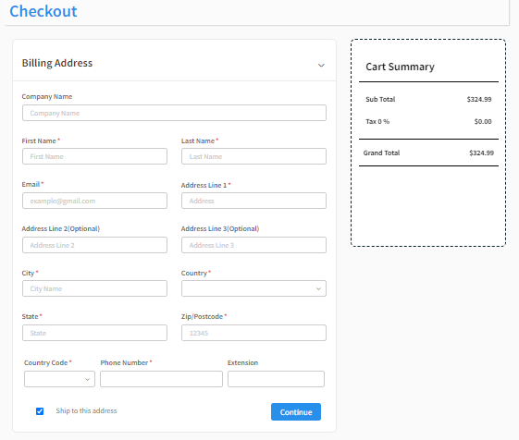

*Figure 3: Checkout process*

# Marketplace Offerings

## Booking a Sports Trainer

Members/Users can find and book a Trainer for physical training nearby their area. The platform offers a marketplace, which has many Trainer profiles specific for sports available near to the users/members. Members can go to find a trainer near their area – in sports of their choice to see the availability of slots and easily book one or more training slots for physical training.

The document below will assist you to navigate the whole process of booking a suitable trainer.

<https://docs.google.com/document/d/15qnXy1Z3G4VuaMe1cjh5VB59iiTW7HQe/edit?usp=share_link&ouid=111670019116578694944&rtpof=true&sd=true>

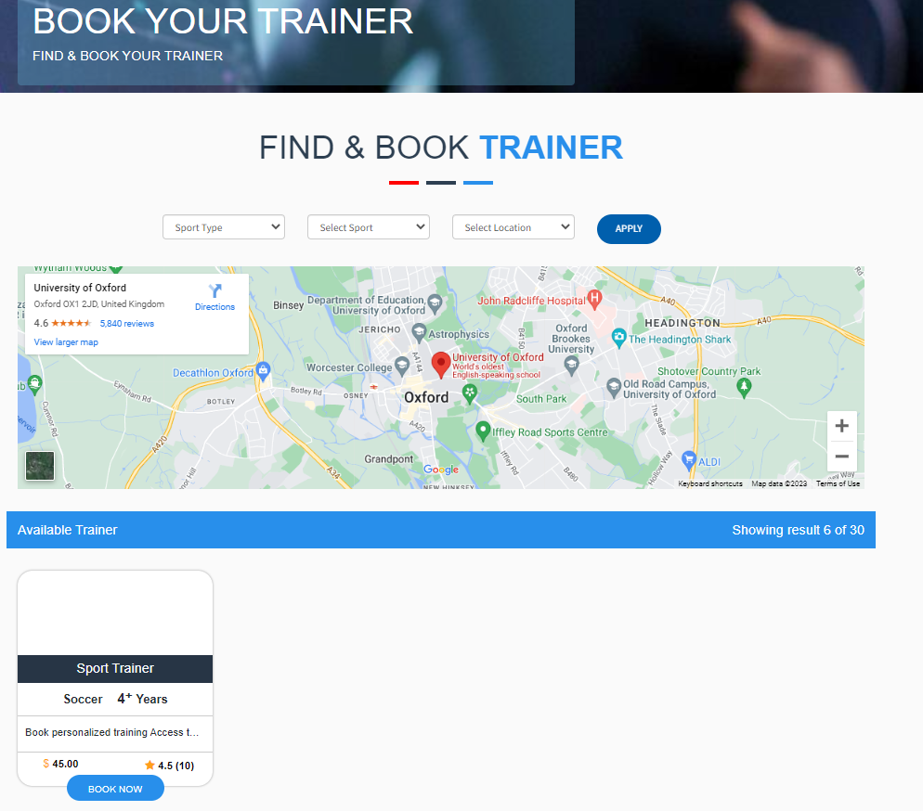

*Figure 4: Book your trainer*

## Booking a Sports Consultation Service

Members/Users can find and book a Sports Consultant on the platform to connect and learn about the different game strategies and improve on their game. They can ask specific questions, get their games analyzed and seek help to improve their game. The consultants empanelled with YSM are highly reputed and experienced sports consultants who help improve sports.

The document below will assist you to navigate the whole process of booking a Consultation Service.

<https://docs.google.com/document/d/1dT-VfYKKZOqu2rNn13Eu_dPSUWfXI-lH/edit?usp=share_link&ouid=111670019116578694944&rtpof=true&sd=true>

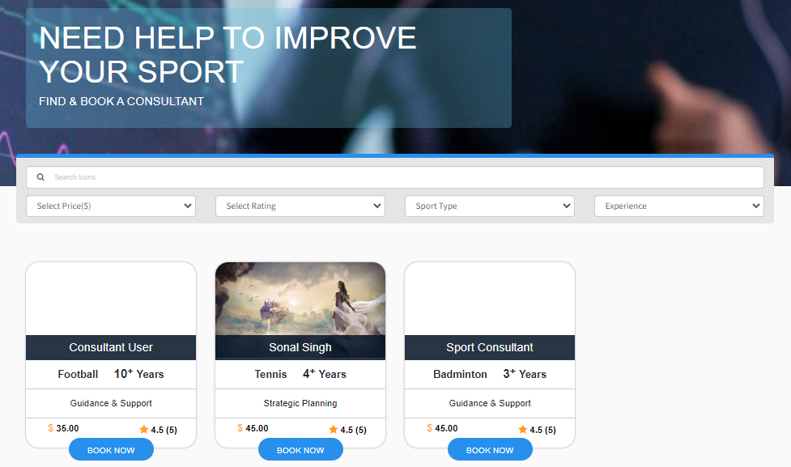

*Figure 5: Sports Consultation Booking*

## Booking a Video Editing Service

YSM offers a unique video breakdown and editing service. It is boring and time taking for players to review their game post matches to identify their mistakes and plan the next strategy. To help down the players and consultants, sports teams – we help them do a smart breakdown analysis for their games. Just purchase and upload your game video link and voila – you will receive a smart breakdown of your game for both attacking and defensive scenarios – drilled down specific to 10 mins for quick recap.

The document below will assist you to navigate the whole process of booking a Video Editing Service.

<https://docs.google.com/document/d/16zCPFPA91REYe8yag9ACS3RsbStdqZSx/edit?usp=share_link&ouid=111670019116578694944&rtpof=true&sd=true>

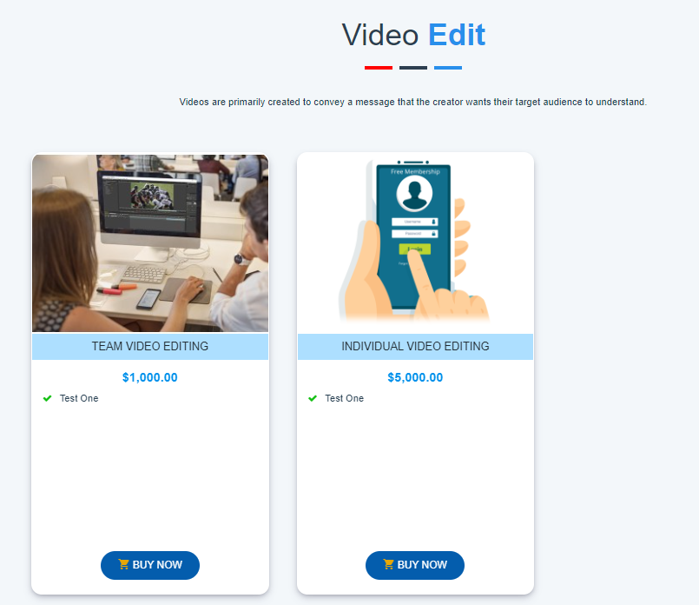

*Figure 6: Video Editing Service*

## Registration/Login/Forgot Password

Members / Users can use the following document to know how to register on the website and use the login to navigate further as a member to take advantage of the number of services offered by YSM.

Registered members get unique benefits and dashboard to get a chance to EARN more thru commissions, referrals, help promote sports and stay active by participating in sports using YSM devices to improve their game and seek help from Trainers and Consultants – all at one place. It is a great utility for aspiring Athletes and Parents who aspire their kids to become a Sports star.

The platform also features a unique referral program that can give you a passive income and help sports teams via fundraiser program.

Following document will help you see how to register and login.

<https://docs.google.com/document/d/1M8-7i5-TflYNQLKGc5AFYP9CADdzqQQV/edit?usp=share_link&ouid=111670019116578694944&rtpof=true&sd=true>

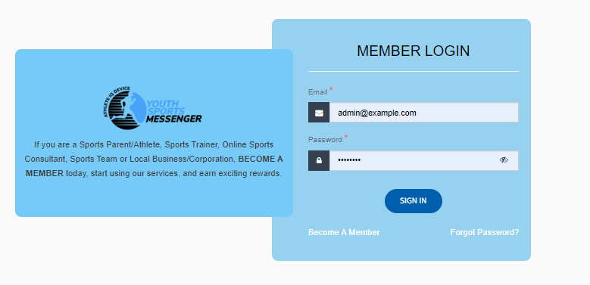

*Figure 7: Login now for more...*

# Member Portal

Members at YSM are provided with a separate navigational portal – through which they can access their services, manage profiles, earn commissions and keep a track.

Following users can access this via login page from main website:

[**https://ysm.demowithme.com/customer/login**](https://ysm.demowithme.com/customer/login)

Members have to login using their email id and password, set at the time of registration.

This section of the help document will help you navigate and learn about the member area and how to use it as a member to take action, check benefits, and more…

## Dashboard

Dashboard shows many reports and charts in a summarized way to the user – with user specific and meaningful data.

This is not fully developed yet – but shows many meaningful insights. Dashboard will further be enriched with more reports, as the portal users grow.

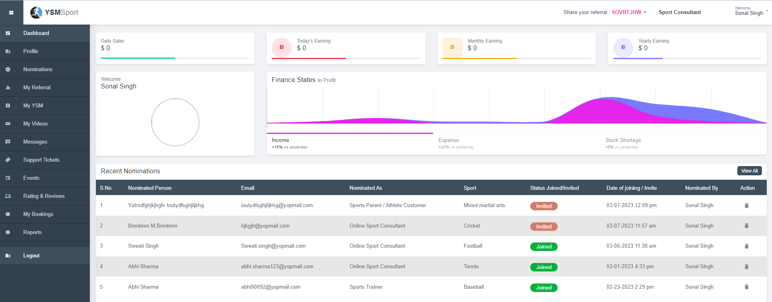

*Figure 8: Member Dashboard*

## My Profile

On YMS, anyone can register himself or herself or they get registered once they made any purchase but they can later update their profile as a Sports Trainer, Online Sports consultant, sport parent, sports team and business/corporation.

### 2.1 My Profile-

Members/Users can see their personal details or their professional profile in this section.

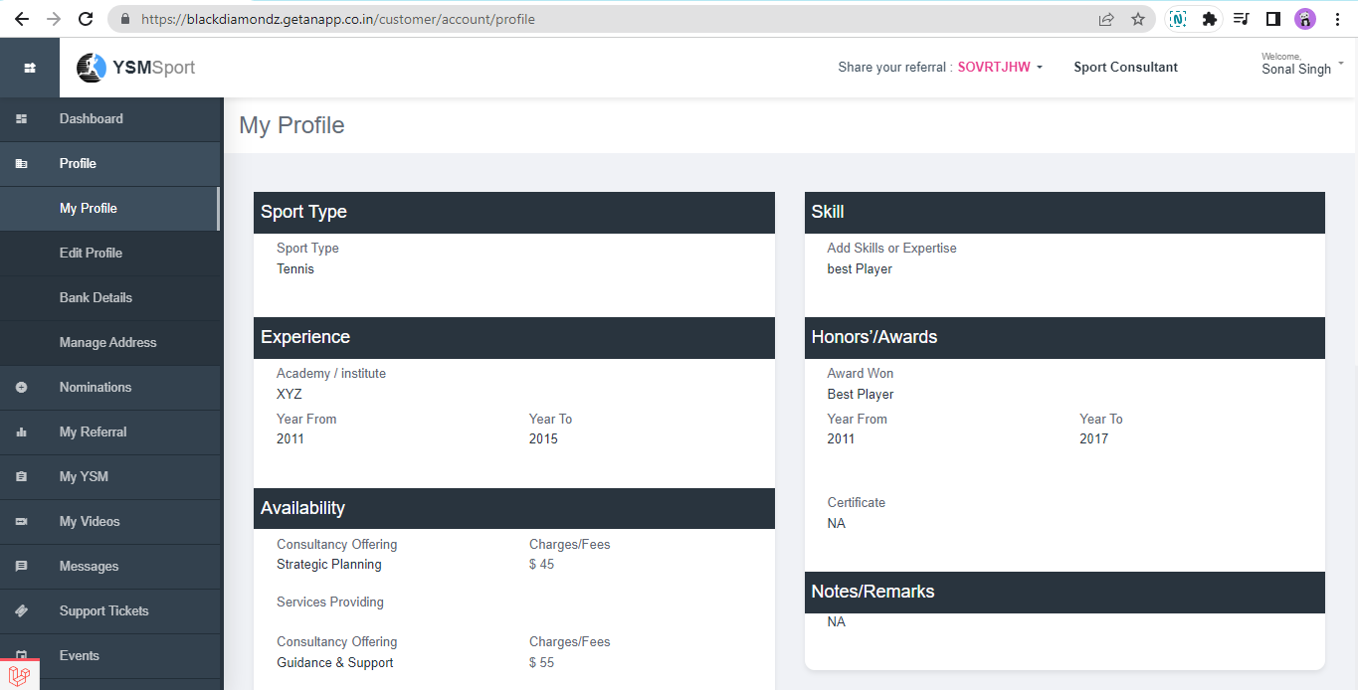

### 2.2 Edit Profile-

Members can edit/update their profile for any given role, and after that it will be approved by admin for that.

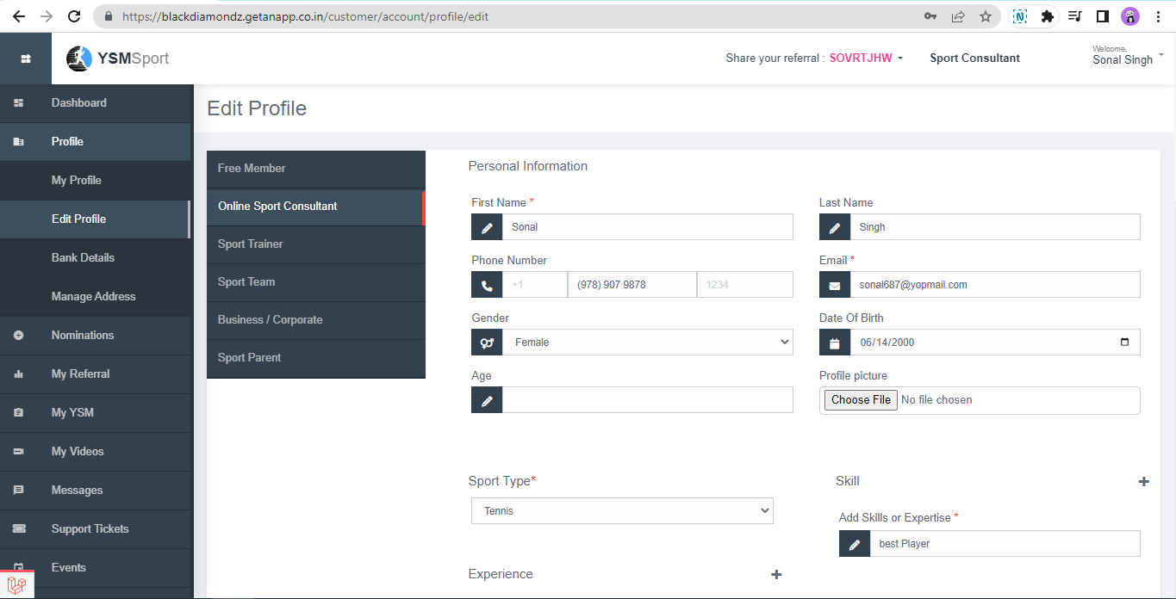

### 2.3 Bank Details-

Members can add their bank details either single or multiple and can also update existing details.

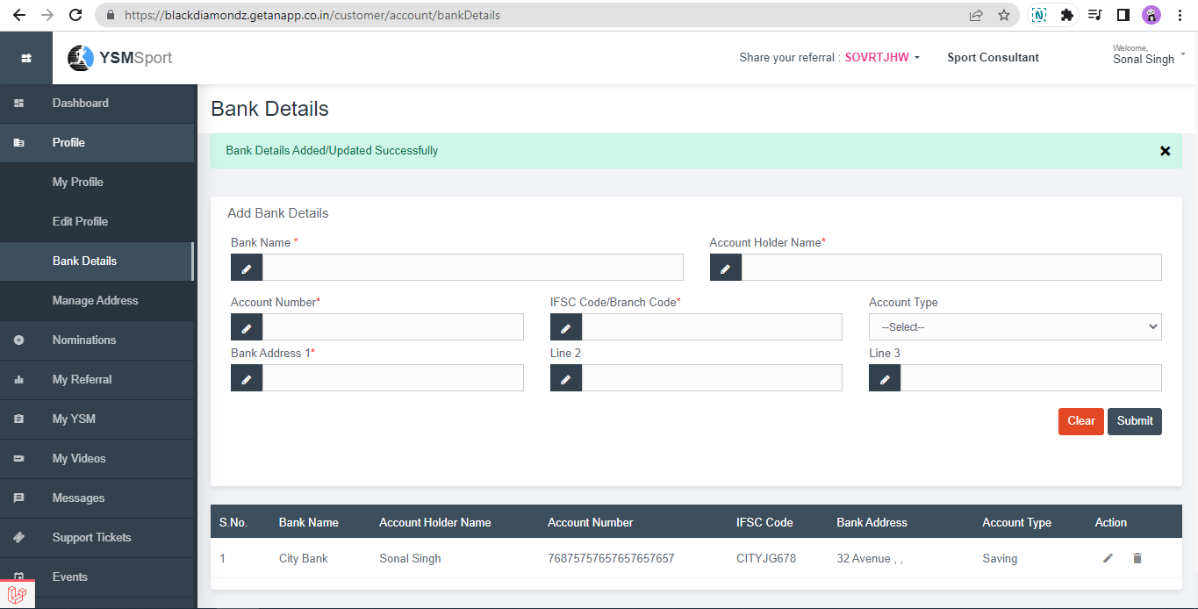

### 2.4 Manage address-

In this section members can add/update their addresses. This becomes handy when purchasing autofill can help them select a shipping address with ease.

## Nominate a Member

Members can nominate and have more members under them to strengthen the YSM team and help YSM reach its marketing reach. This not only helps YSM in getting a stronger network of Free members, sports consultants, trainers, businesses and /or sports team – but also helps any member earn more commission due to a stronger downline.

Any sales that are done by a nominated member, the parent member also receives a portion of commissions / referral earnings. This way - it is win-win for both.

**The usual steps include:**

* Filling of nomination form by any member
* New member receives an email – with link to accept invite and become member by generating a password
* This step makes a new member an active ‘FREE MEMBER’ automatically.
* New member will now have to fill in his/her profile with all correct inputs and details meant for different roles (if selection is for sports trainer/consultant, team or business – then specific profiles be filled)
* In case of profiles of Sports Trainer, Sports Consultant, Sports Team and / or Businesses – the profile activation will be done by ADMIN after necessary verifications.

**Pre-requisite** –

* To nominate someone – you must be a registered user and will need to login – in order to nominate any other member on YSM.
* It is your responsibility to share correct and authenticated information in order to have the nomination confirmed and receive commission incomes.
* Any mis-use or non-authentic information shared on the portal may lead to member deactivation.

**Nomination Form –**

* From front end – user can click on NOMINATE A MEMBER link on footer or on certain pages
* From Member portal – user can click on nominate a member link on side pane to open nomination form

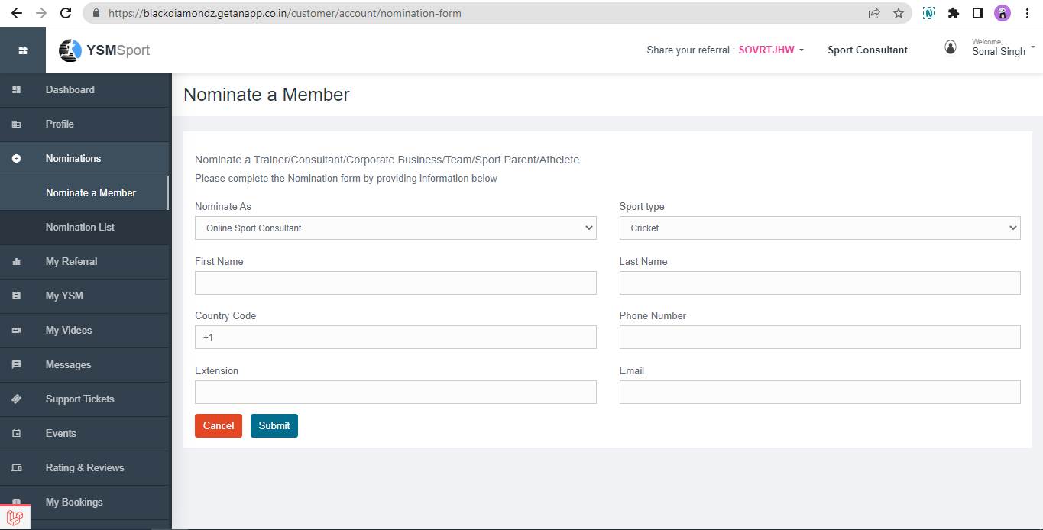

**Email Invitation to NEW User**

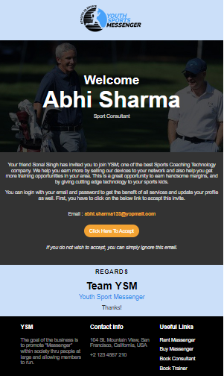

**NEW User Registration & setting up of password**

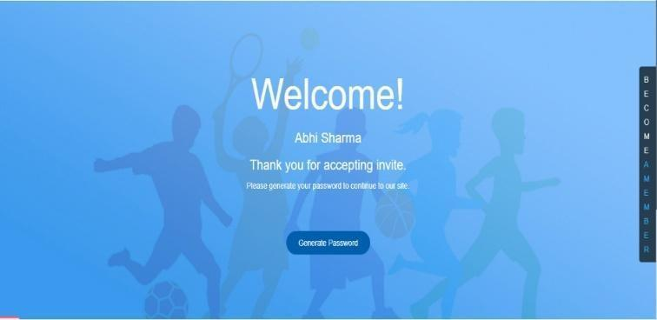

After generating password and logging into account, nominated members can update their profile accordingly.

The new member can now see their referral code.

**Manage Profile:**

New User can now Manage and fill the profile details:

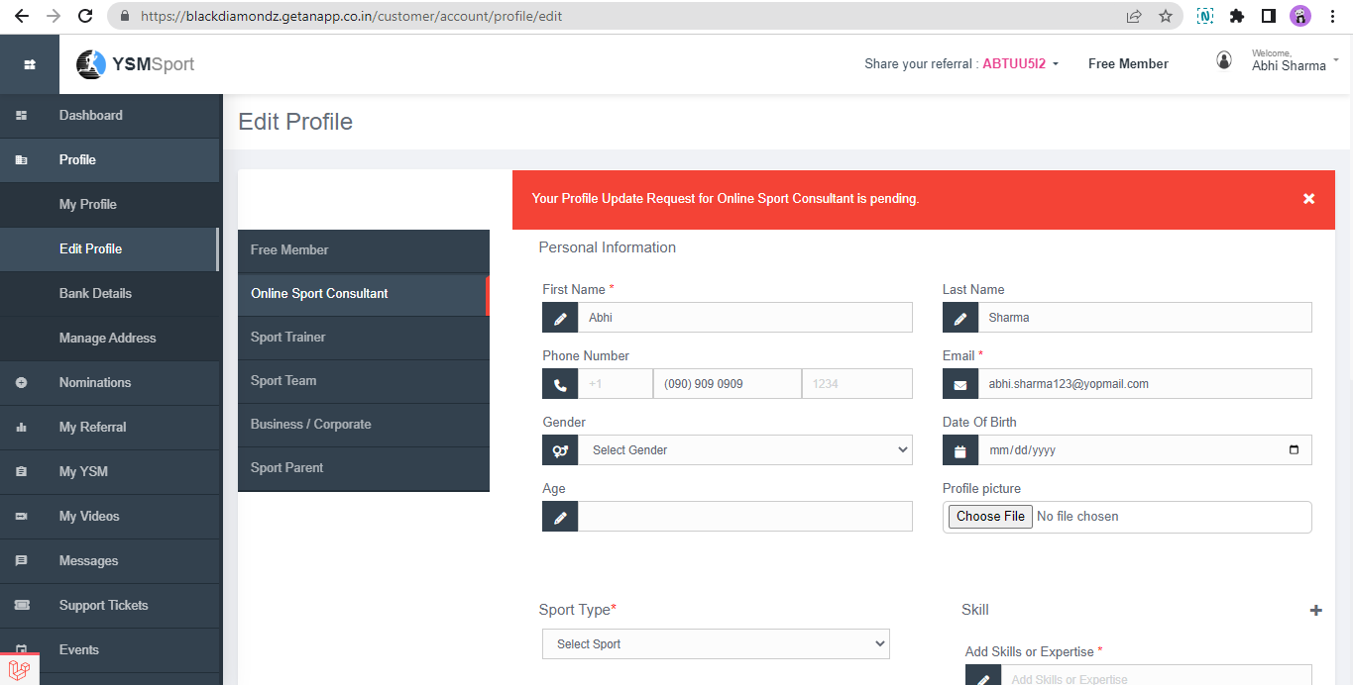

Once they update their profile for whom they have nominated for, admin will then review and approve it, then it will be only visible to others.

**Nomination Lists & Statuses:**

Users can see data of members whom they have nominated for their role and who joined the platform.

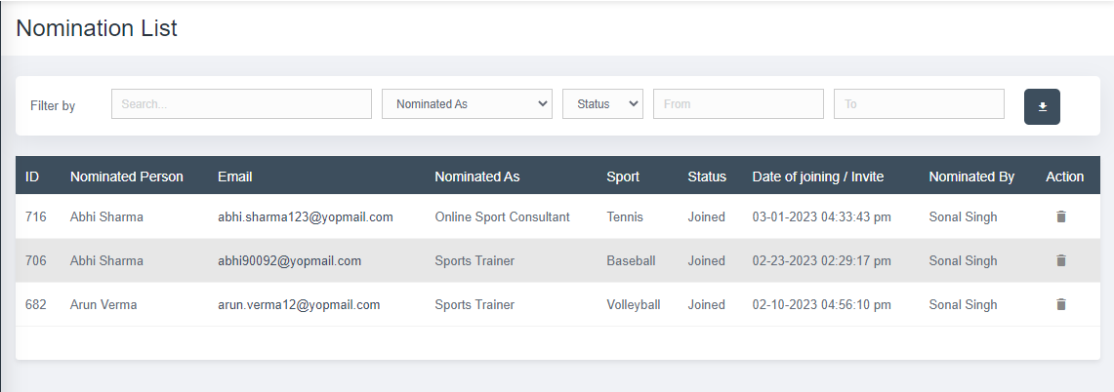

## Referrals, Referral Code, Earnings

All members get a unique Referral code that can be shared to others and any potential buyer can use the referral code to get some discount (if any additional discount coupon code is defined by user) and give benefit of referral commissions to the user.

## **Share Referral Code-**

After successful registration and completing further process every single user gets their own unique referral code to share with other members so that they both get benefits like on using someone’s referral that person gets some discount on their purchase, and the person whose referral is, will earn commission.

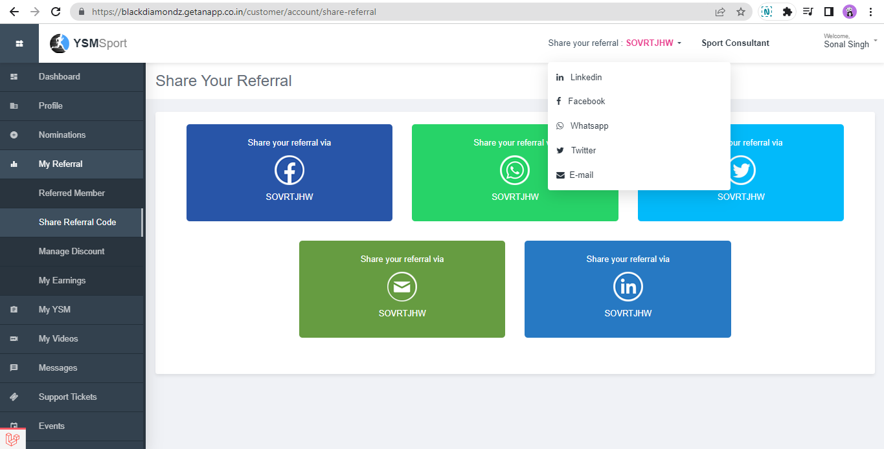

Users can share their referral via different social media platforms like Facebook, WhatsApp, LinkedIn, and Twitter and through Email as well.

For sharing referral just click on any box, that particular page will open where you can choose whom to share referral.

## **Referred Members-**

Members can also see a list of users who used their referral during any purchase under my referral menu.

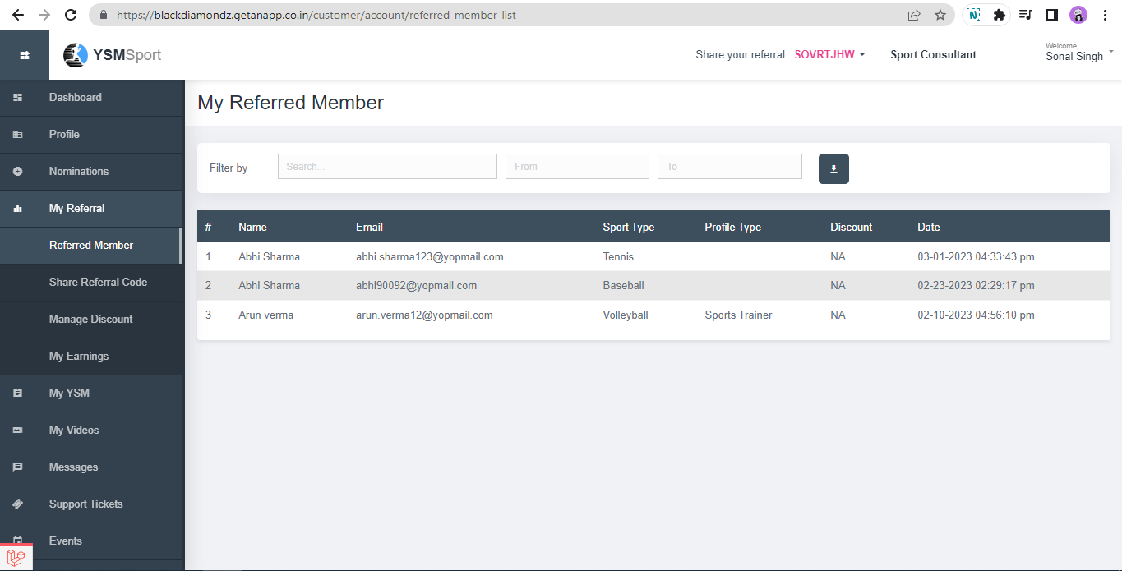

## **Manage Discount-**

Members can manage additional discounts on their referral code to increase purchase from his or her own referral.

(Add how to add additional discount coupon code by members here)

## **My Earnings**

In this section members can see their earnings/commissions from referral, nominations and from events if added by admin as supporter or account manager against any fundraiser event.

The brief of this section is defined in the COMMISSION'S document, how all these three works.

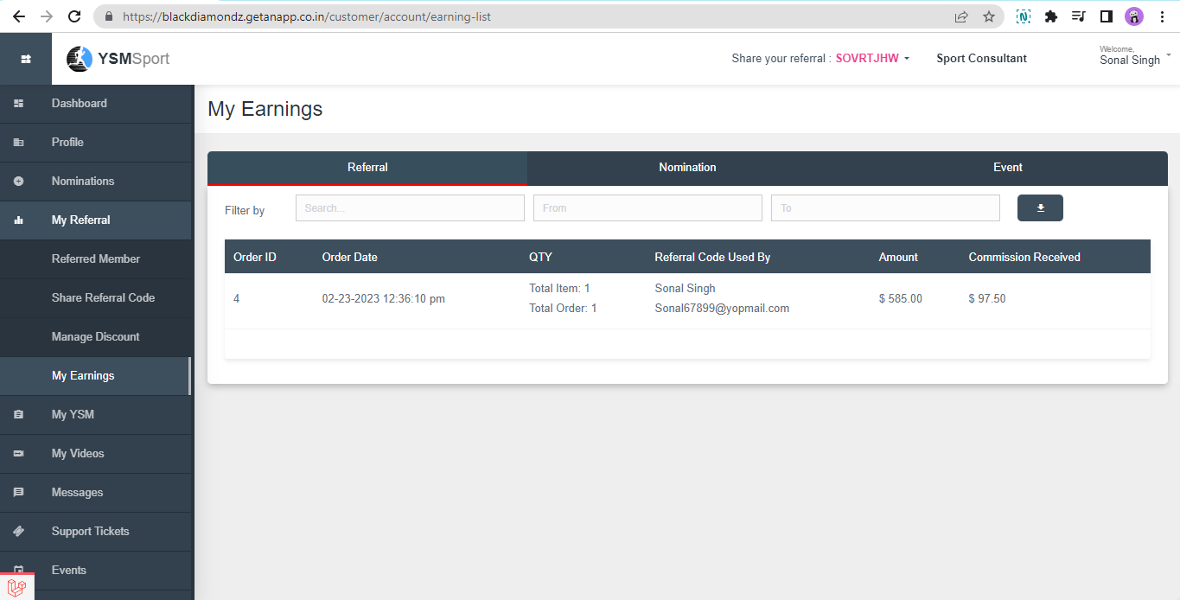

## My YSM (Member’s YSM – all services from Member context)

## **Devices**

This section lists out all devices associated / purchased by the member. Member/User can see details and status of their

* purchased devices
* rented devices

and can activate them once delivered.

*For Device activation process, check in the respective section of the document

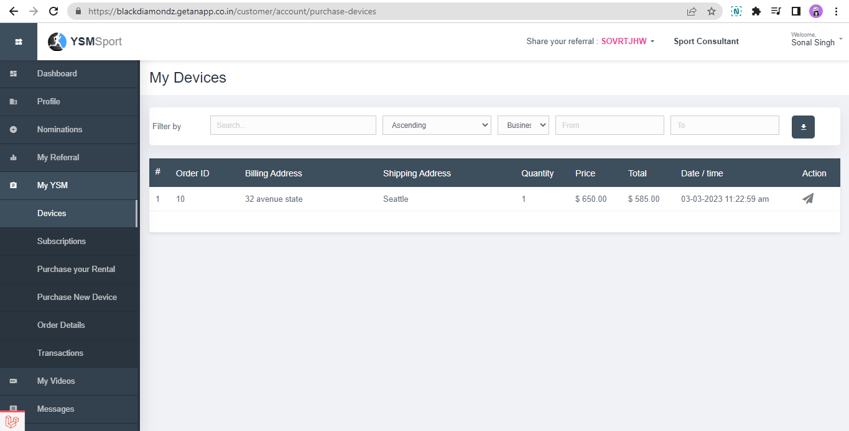

## **Subscription**

This section lists out all active subscriptions associated with purchased or rented devices by the member. Members/Users can see details and pay for any subscription dues from the listings here.

[Add subscription listing, details here]

## **Purchase your Rental**

This section allows members with any active purchased rentals – which they can convert to purchase, and reduce the total rental subscription – to save on long term usage.

By agreeing and purchasing your rental – the member agrees to continue keeping the device and pay a partial upfront fee to change the plan to a purchased device subscription.

This leverages the rental plan conversion by discounting device fee proportionately for the tenure of which is used and thus, overall impacting the fee shown at the checkout for all such purchases. The fee is dynamically calculated.

[Testing in progress, details to be added here]

## **Purchase New device**

On clicking this menu member/user navigates to the purchase portal from there they can buy products or can rent out.

The new device purchase is similar to purchase by any user from the portal. The user have to navigate to

* select any device and ADD to cart
* click on cart to checkout
* on checkout page – prefilled pages for billing and shipping (can be edited) – and summary on right side be validated
* On completing payment process – the order is confirmed

*For buy product, rent product and checkout process refer to the respective sections in this document.

## **Order Details**

Members can see their order details of all BUY or RENT orders and activate devices whose status is DELIVERED.

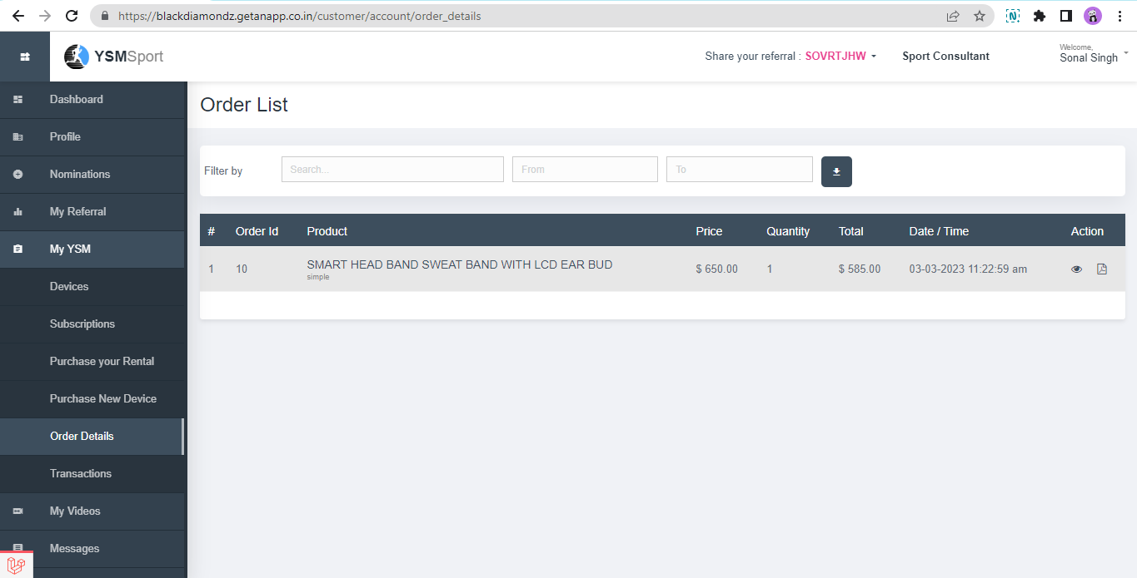

* Refer to the “Device Activation” section to know more.

## **Transactions**

All transactions (payments towards any services) by that member will be listed down here.

[Add transaction listing details here]

## My Videos

This section allows a member to see all orders of Video Editing Services and manage these bookings by uploading videos for editing service in any order or downloading any edited videos from completed orders.

Video editing service is available in the marketplace. Members / users can place the order from available two choices – Video editing of team video or for any specific player.

* The order can be placed from the portal and managed from this section.
* Against any order – members can link / upload videos for editing service.
* Admin can view these orders and videos and process the order
* Members can download / view edited videos uploaded by admin from this section.

**Salient features of Video Editing Service:**

Sports video editing service specializes in creating high-quality highlights, game recaps, player profiles, and other sports-related content.

1. Member/user navigate to marketplace and select Sports video editing.

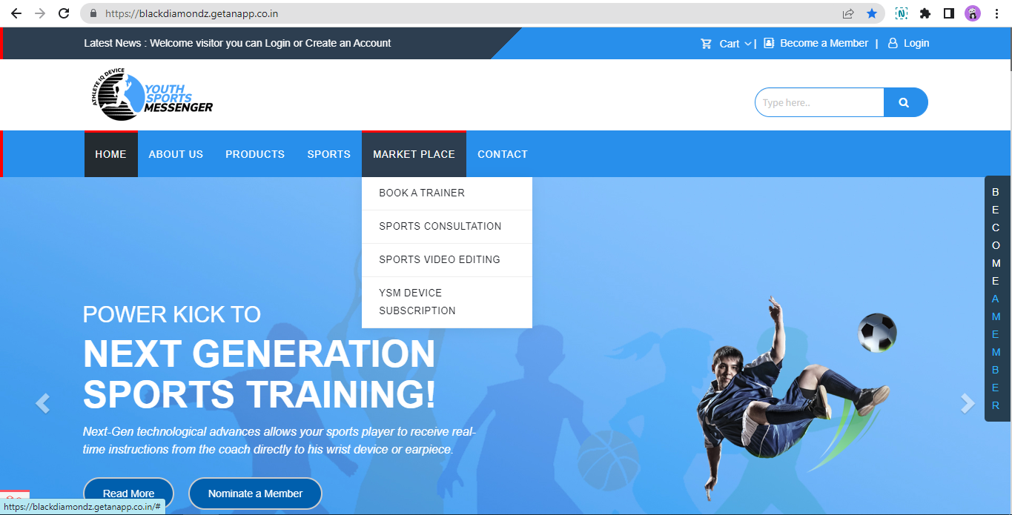

1. Member/user can select any plan either for team or for individual or can choose both

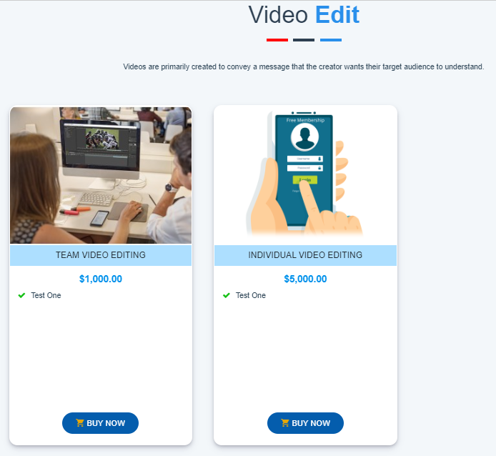

1. After clicking “BUY NOW” the selected item will add in the cart and then the same checkout process will follow.

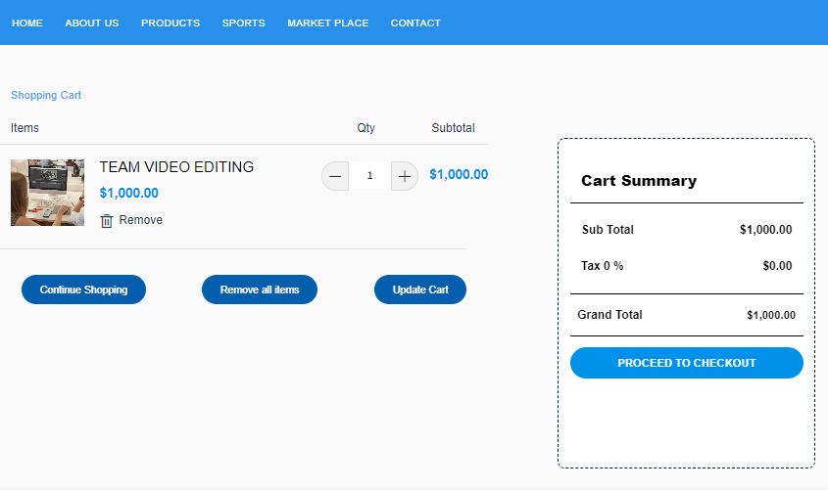

1. Once payment is done members will receive email regarding order confirmation and order.

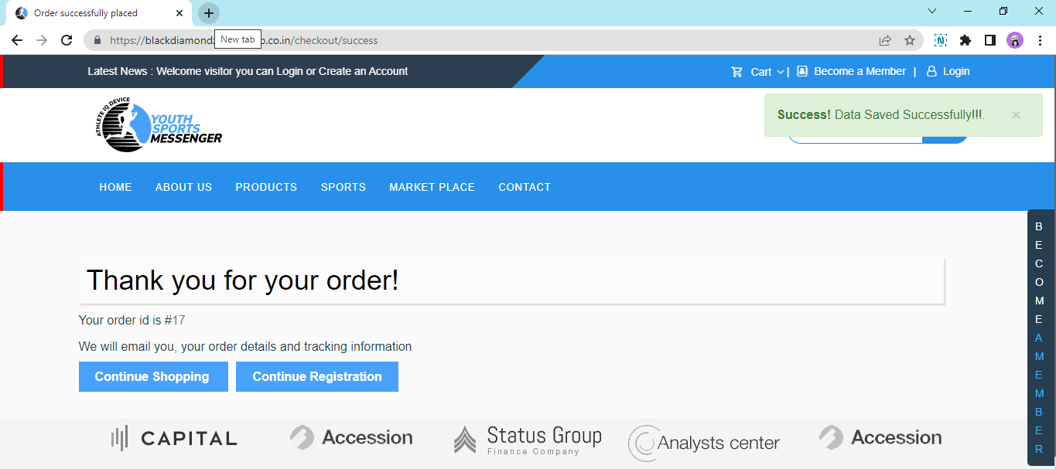

Members/users need to login to their account to upload video links. If a member/user is not registered, the same process will follow of accepting invite and generating password, then members will be able to login to their account.

1. After login in to account navigate to My Videos to upload video, click on the upload icon.

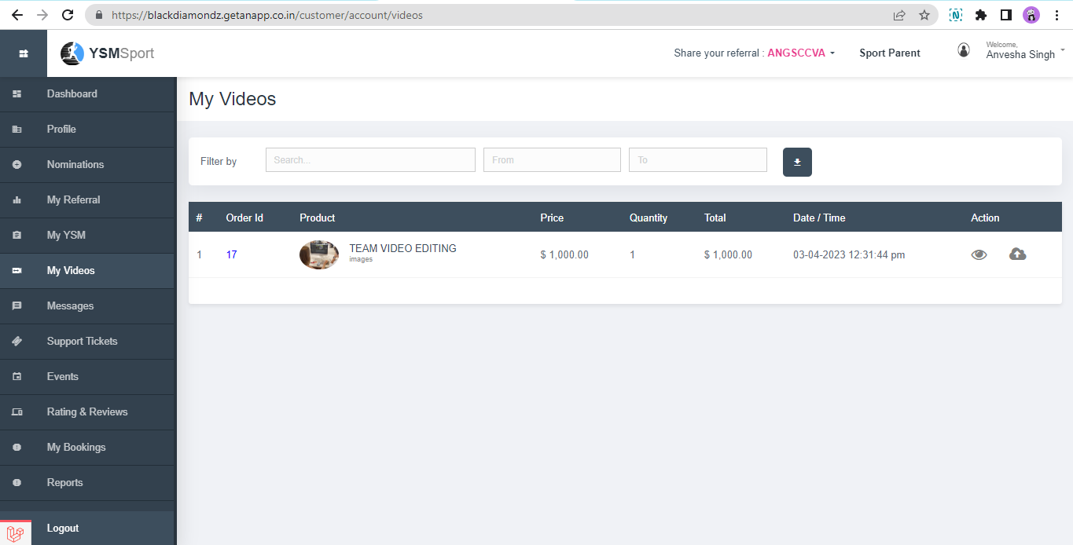

1. Members/users can send footage file sharing services like Dropbox or Google Drive. Please make sure to label your files clearly and provide any specific instructions you have for the final product.

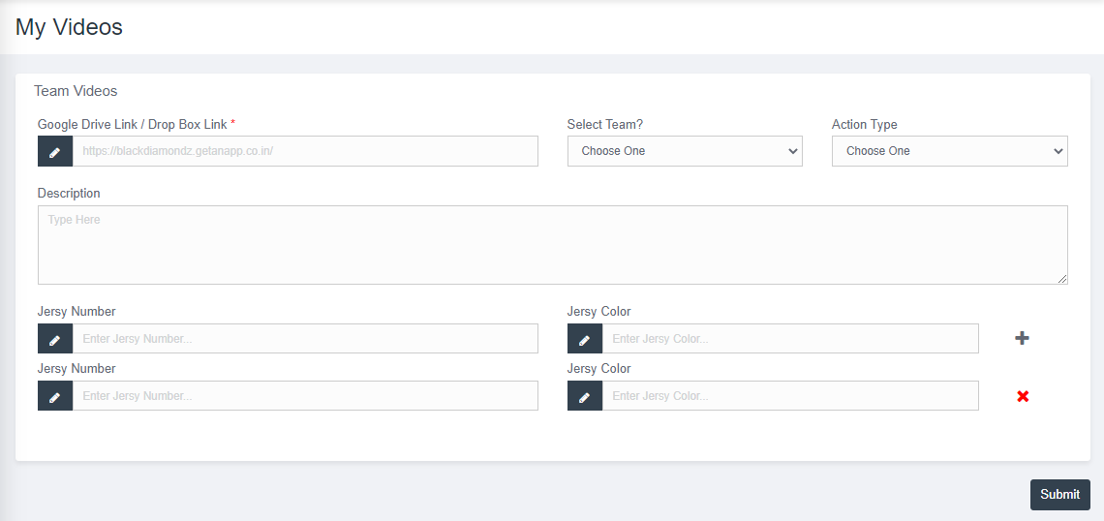

1. Once it is done editing and upload by the service provider, members can see and download.

## Messages

A messaging system is a communication platform integrated inside for use by YSM members at different levels and with different roles; in given use cases. This system allows users to send and receive messages; just like chat / email messages - related to different activities, consultancy and against support tickets. This system’s prime concern is to ease out flow of communication among different stakeholders on YSM platform.

On YSM, popular use cases to initiate chat/message:

1. **Chat among Nominated users:** Member/user can chat with the person whom they have nominated – and network to guide and market the YSM products/services and assist their channel achieve better sales.
2. **Chat to resolve Support Tickets:** Member/User can chat with admin against any support ticket raised by them.
3. **Chat by Sports Consultant against their Orders:** Member/User can chat with the sports consultant whom they have booked for consultancy. The chat is invoked by Consultants to know more about the players and provide consultancy after resolving queries through message.

## **Chat among Nominated users: Send message to nominated member**

System allows only members/users to send messages to a person whom they have nominated to be on YSM. They can help their network to assist them achieve better sales and hence more commissions.

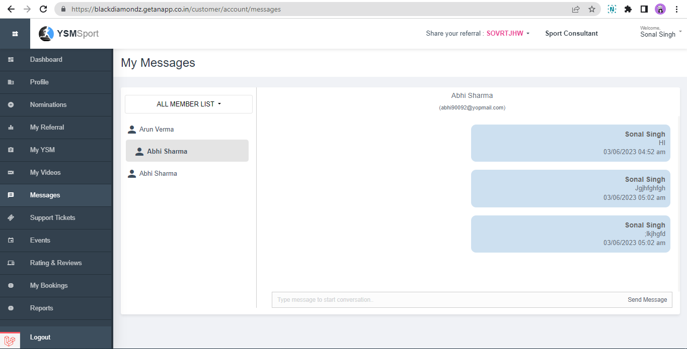

## **Against support ticket**

Members can chat against any pending support tickets. Support tickets initiate a user chat with admin; where admin may interact and take action. Once support ticket marks as closed, the member can’t send a message then.

* To know more refer to the section detailing support tickets.

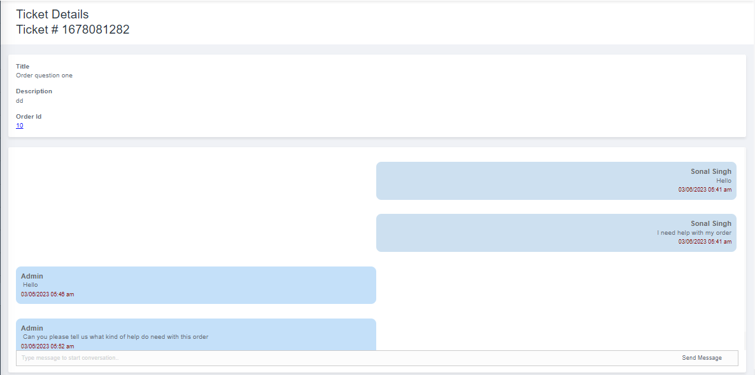

## **Chat with Sports Consultant**

Consultant and customer can chat with each other, against a consultancy order. This is invoked only when the customer has booked the consultation service from the marketplace.

After logging in to the account navigate to my bookings given on the left side menu and click on consultant booking.

Page will open with all booking, click on view to see more details of booking.

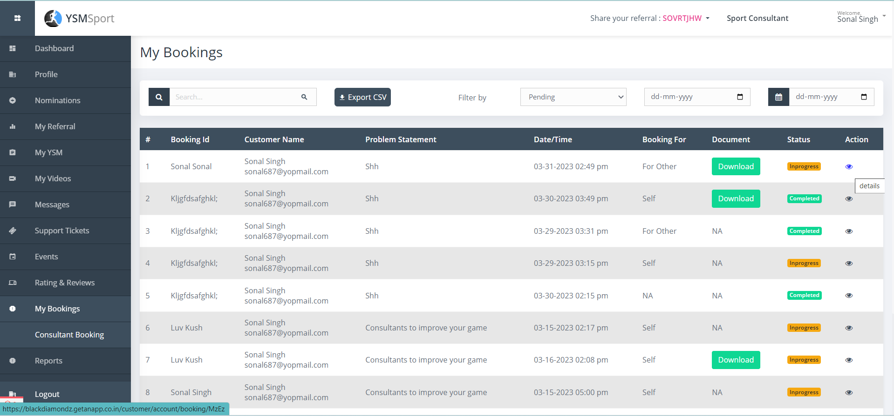

Here all details of consultant booking will show and inbox, members/consultant can chat with each other.

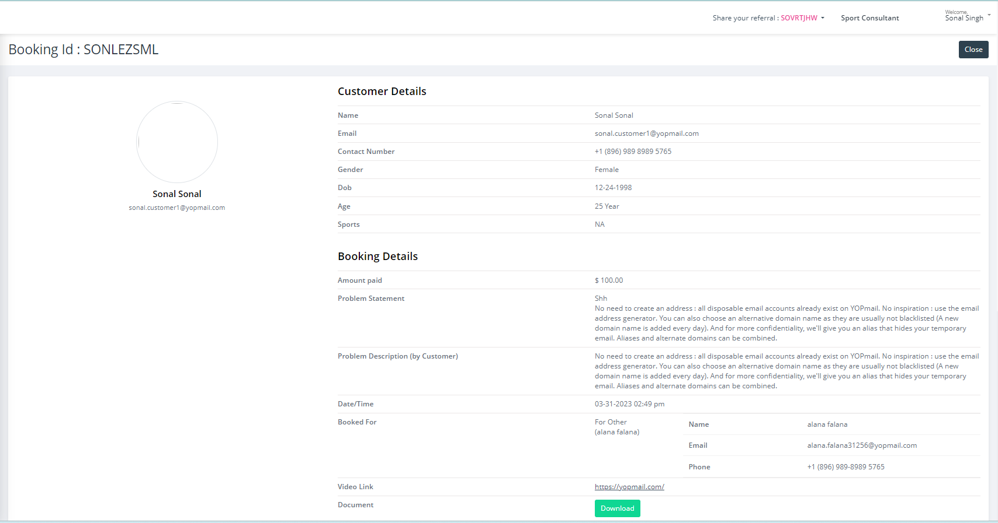

## Support Tickets

A support ticket is a formal request for assistance or resolution of a problem or issue that a customer or user has with a product, service, or system. The ticket typically contains information about the problem, including a description of the issue, any error messages or symptoms, and details about the customer or user who is experiencing the problem.

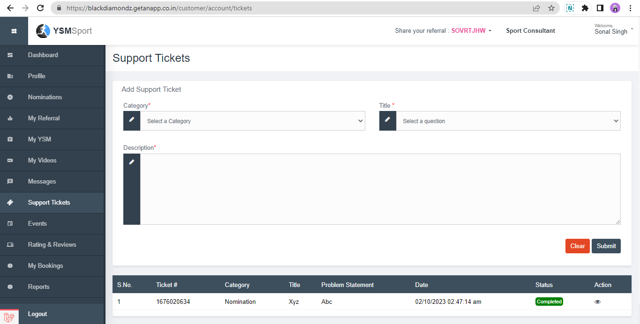

Members can easily log tickets, after logging into account navigates to support tickets given on the left side menu.

## **Select category, title and description of your problem.**

There are different gifts, members can choose from them.

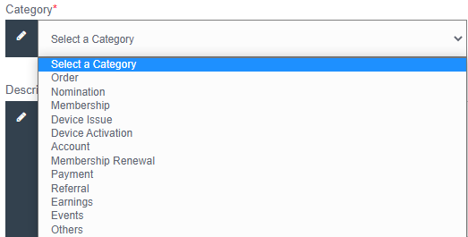

[Please note – admin can have these added in category through backend team, based on use cases]

## **Title – are mapped frequently asked queries**

Once you select a category, title will populate according to the category selected, your order will show members can also select the order on which they need help with and submit it after description.

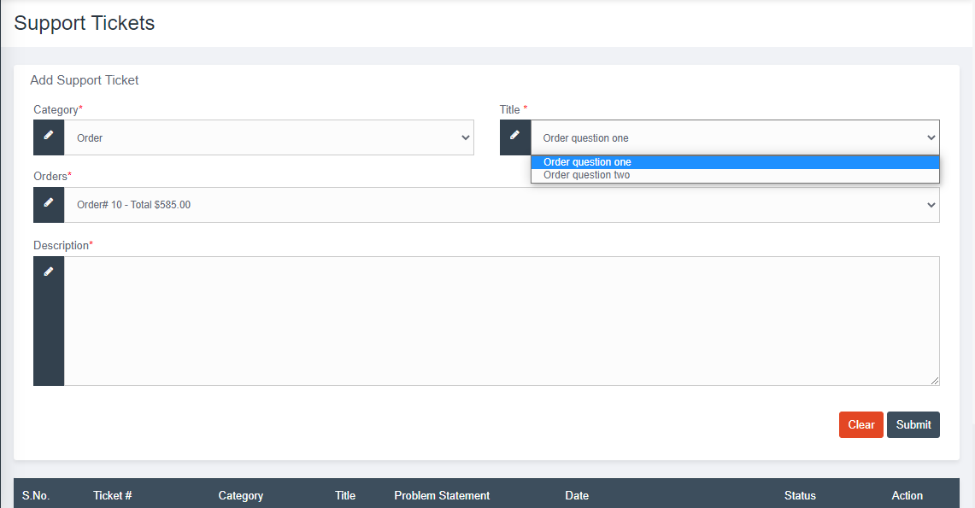

[Admin team can formulate – such questions to be listed against each category in titles for proper ticket subject definition]

List of possible titles

* Orders – Cancel, Refund, Not Delivered, Device Not working
* Nomination – Nomination member not approved, Nomination member not mapped to correct role, nomination member not mapped to member
* Membership – Change role, profile not activated
* Device Issue – Device not working, Device is broken, device has software issue
* Device Activation – Activation code not received, Activation code not working
* Account – Issue with email change, Password Reset, Leave the platform
* Renewals – Renewal not processed, My account is charged but not renewed
* Earnings – Commissions from referral, Level 2 Earnings from Nominated members, Earning from Events
* Events – Event referrals, Event commissions, Fundraiser related
* Others – Open query

## **Unique Support ticket ID:**

When a Member/customer submits a support ticket, it is usually assigned a unique ticket number, which is used to track the progress of the issue and ensure that it is resolved in a timely and effective manner.

**Member chat with Admin/Support team:**

Members / Customers initiate a support ticket to reach out to the admin team / support team. Admin on receiving of tickets – take necessary steps and update / message to members/customers.

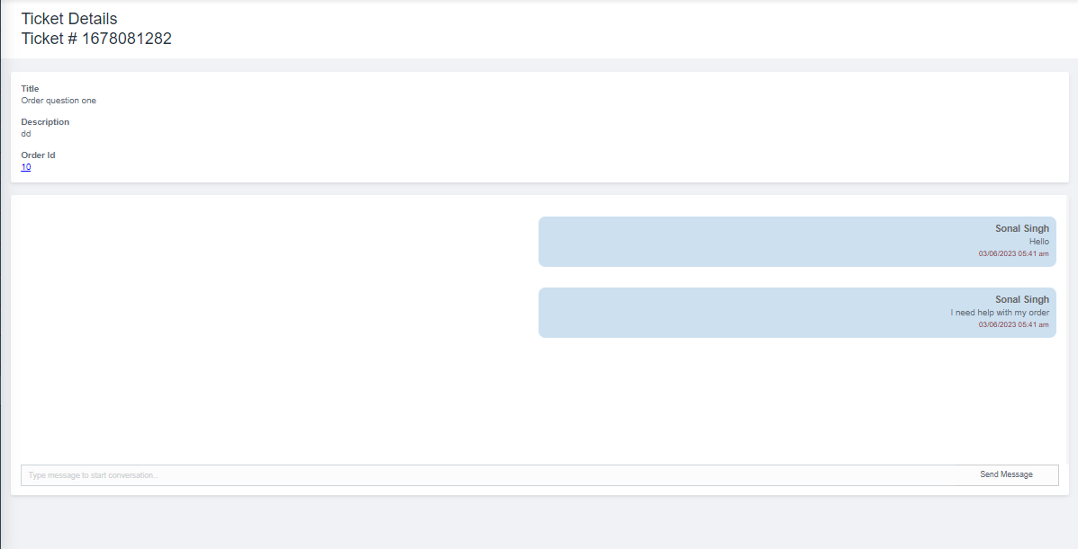

**Responding to tickets by Admin**

Logged in, as admin- Admin will chat with the member/customer to know more about the problem.

In addition, once the member/customer agrees that his/her issue is resolved, then the admin will close the ticket from here.

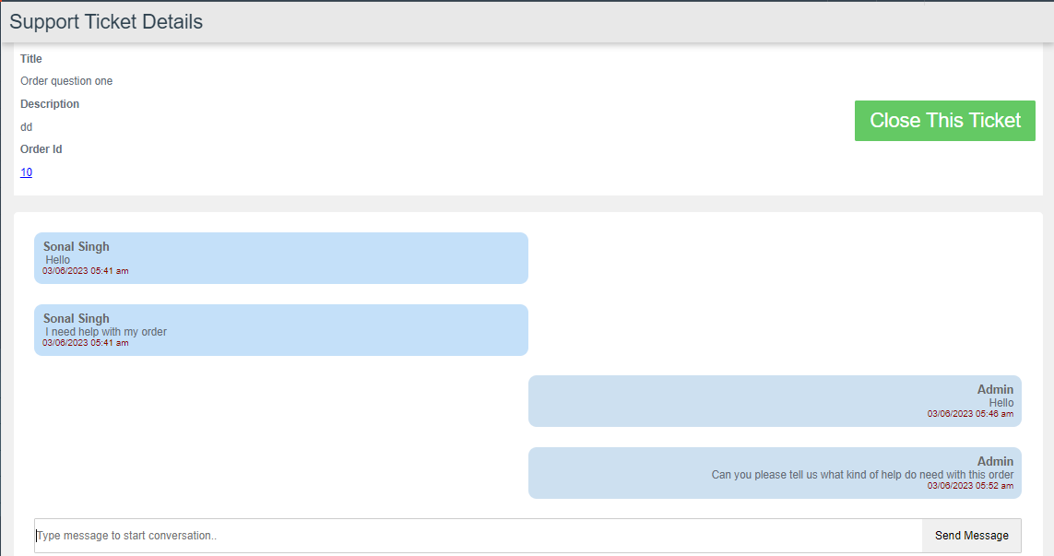

## Events/Events List

Admin will create a fundraiser event and add account managers and supporters against it.

* To know how to create an event, set commissions and add account manager and support, refer to the section that details “Create Event”.

In member/user, login the event will only be visible to those who are added by admin for the event. They can then share event referral code to the public via social media like Facebook, twitter, WhatsApp, email and LinkedIn to purchase devices with this referral and get some amount off.

**Events Calendar view**

After logging in to account as a member, navigate to events given on the side menu click on events. Here on calendar events will show. Members can view events after clicking on the event name.

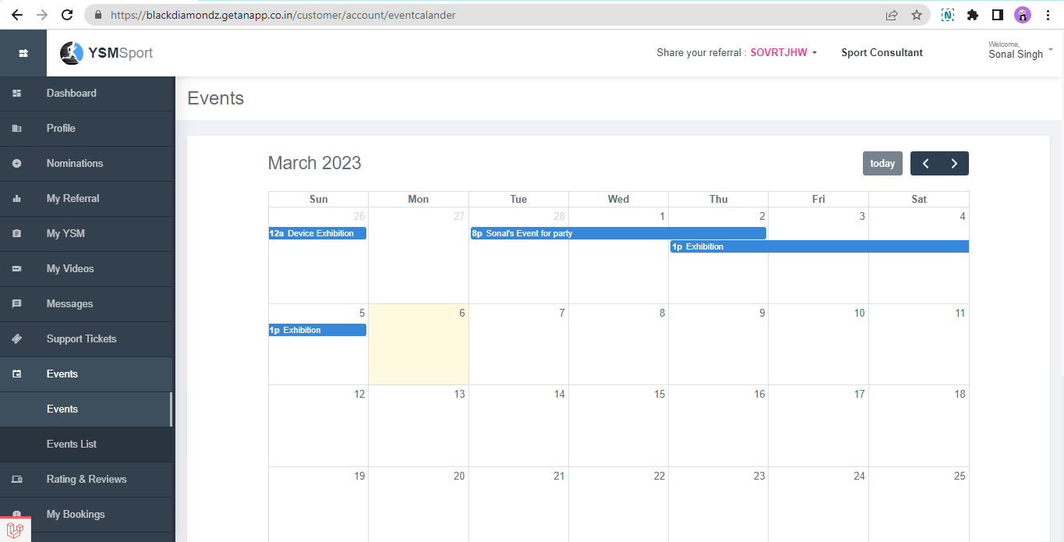

**Events Details view**

On click, members who are associated with events – can view complete details of the event, its fundraiser targets, etc.

This is how the event will show.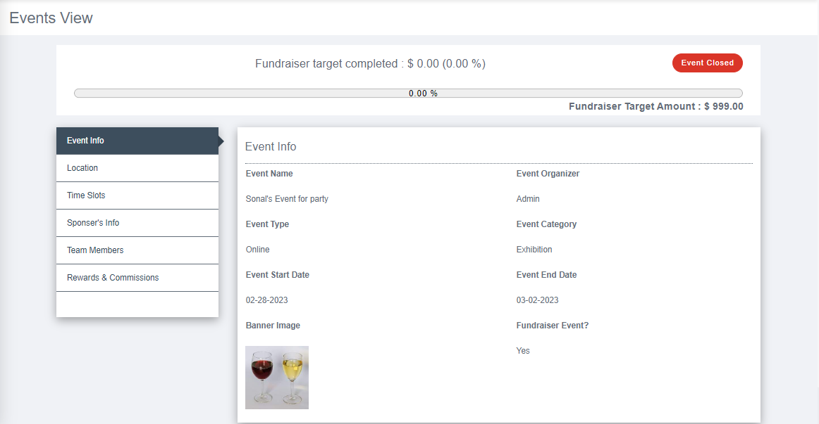

**Events Listing View**

On moving to the second sub menu, the list of all events will show members can also view events from here and share events to others by clicking on the share icon – to market the event and share the referral code – that will record all event sales.

After the event end date it will be closed and can’t be shared.

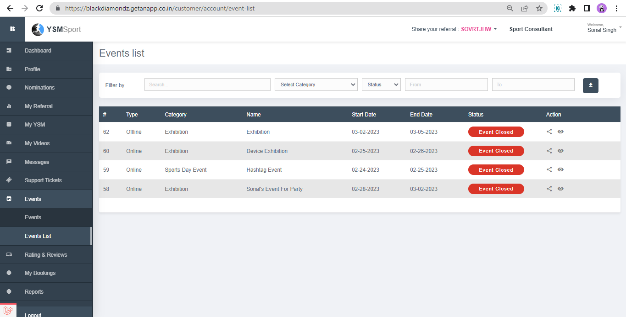

**Referral Code / Event Share**

On sharing a message via email, members can share it with anyone. Then they can use event referral code to purchase any device to get some amount off.

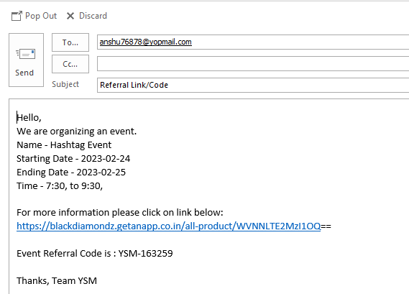

## Ratings & Reviews

Ratings and Reviews can be given at many order interactions by customer members.

Star ratings on order / device / service will contribute to average ratings on a scale of 1 to 5 where 5 means highest satisfaction and 1 means lowest satisfaction.

In addition to the star ratings – the user member can also add up comments/feedback about the order.

These ratings and reviews will show up on respective sales pages of frontend from where anyone can purchase devices, purchase rental devices, book marketplace offerings like trainer service, consultation and video editing booking service.

**This section will detail out ratings for following:**

1. Ratings and feedback on Buy/Rent Orders purchase
2. Ratings and feedback on Training Booking completion
3. Ratings and feedback on Sports Consultancy Order completion
4. Ratings and feedback on Video Editing order completion

**[To be added here]**

## Sports Consultant Booking

11.1 This section will be different for two different users like while the member is a sports consultant /she will see a list of customers who booked consultancy from them and can chat with customers and can also mark consultancy close once done.

Sports consultants can see a list of all customers and their details they have mentioned while booking consultancy.

Sports consultants can download the document uploaded by the customer. And to view the booking details, consultants need to click on the eye icon given under the “Action” column.

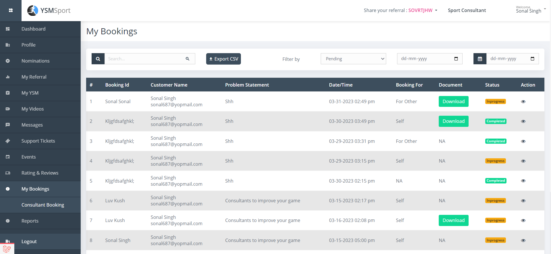

On view, the consultant can see all details of booking and here close the booking.

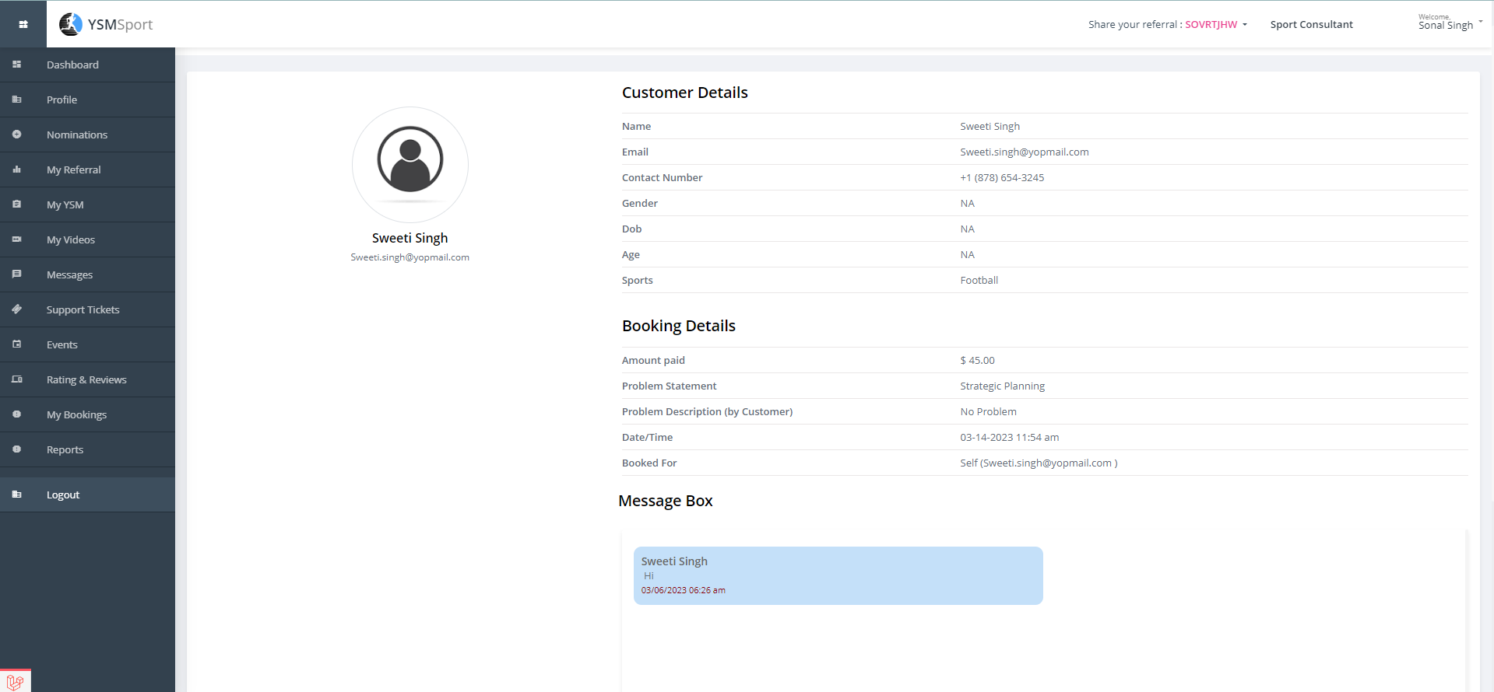

11.2 Second, if a user/member is logging into their account and navigating to the sports consultant booking section they will see the list of consultants whom they have booked for sports consultacy.

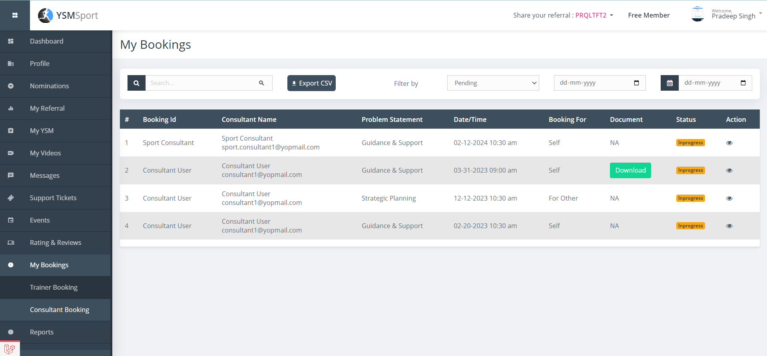

And on clicking the eye icon given under the “Action” column users/members can see all booking details.

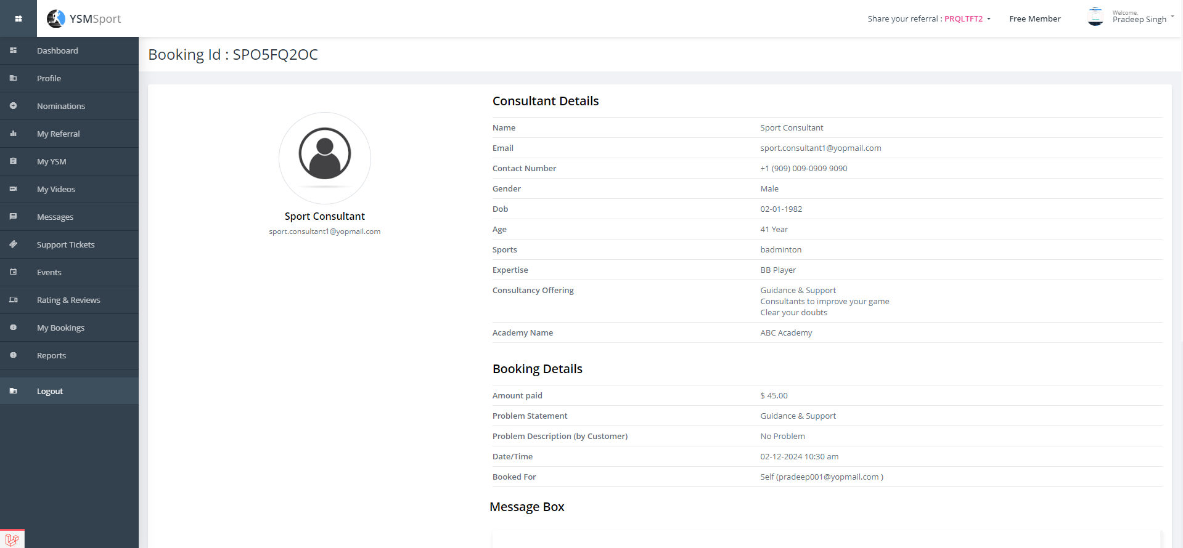

## Trainer Booking

12.1 This section will be different for two different users like while the member is a sports trainer, he/she will see a list of customers who booked slots for training

Sports trainers can see a list of all customers and their details they have mentioned while booking training slots.

Sports Trainer can filter bookings by TODAY’s, CURRENT WEEK, PAST BOOKING and ALL.

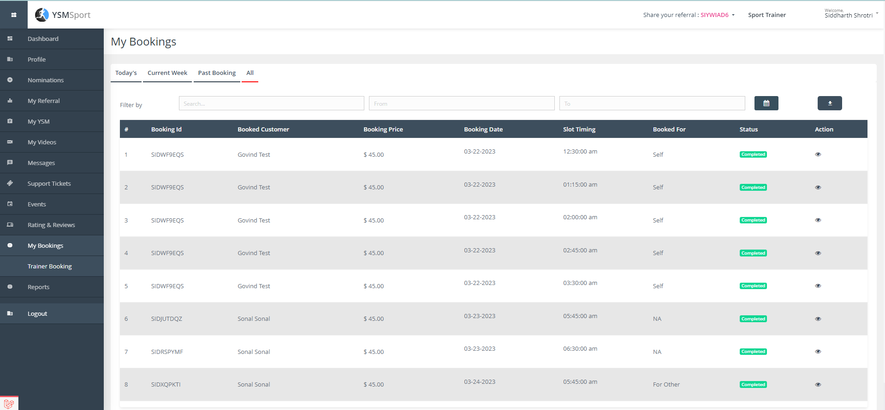

To view details, the trainer needs to click on the eye icon given. Booking will auto close once booking date & time expires.

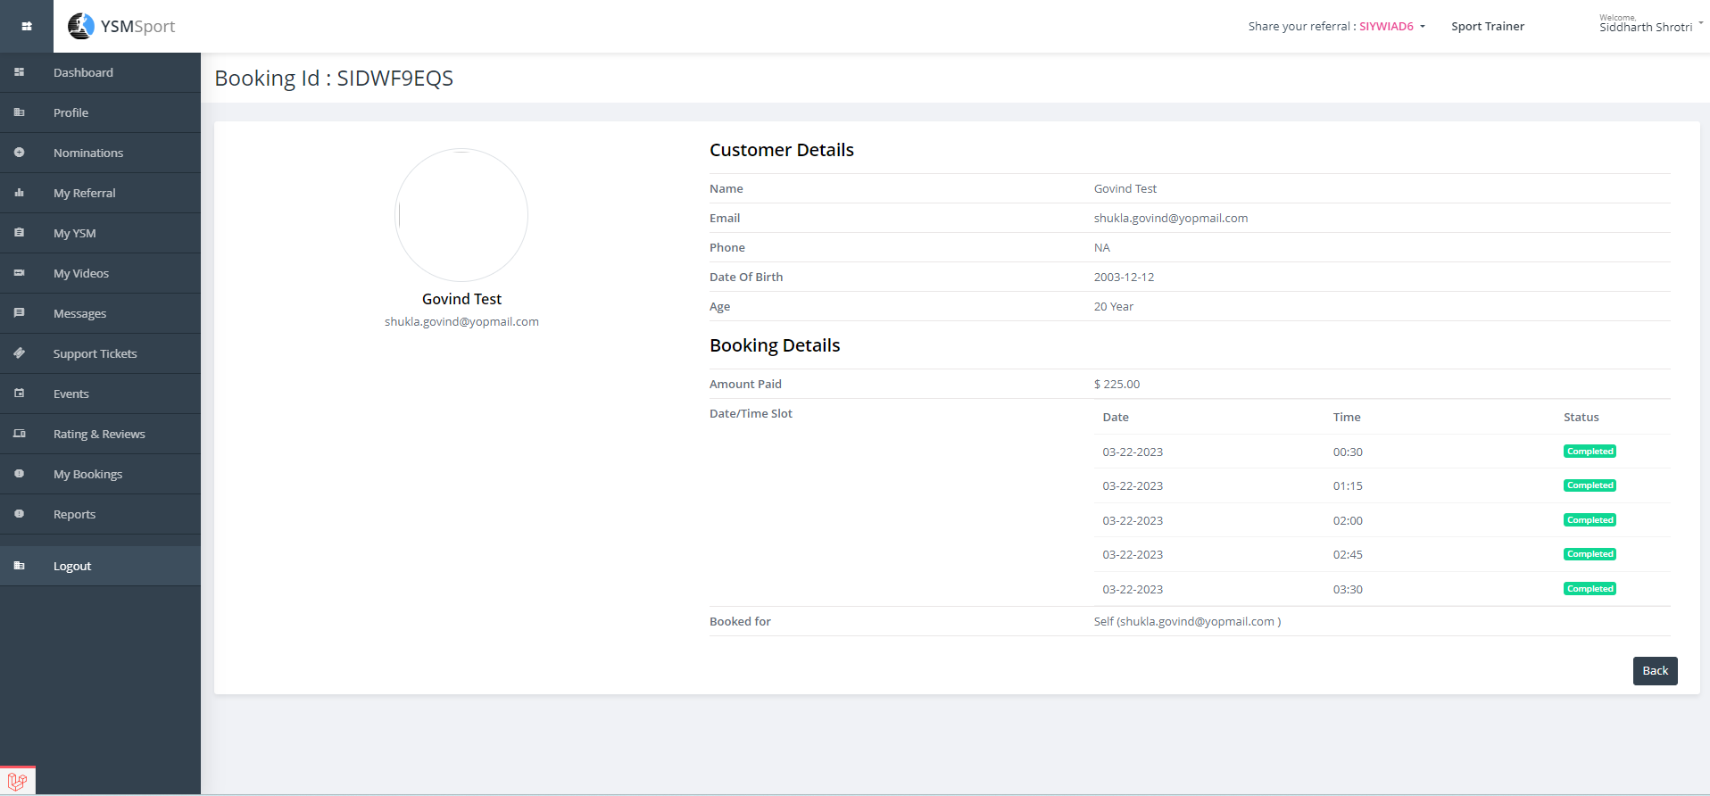

12.2 Second, if a user/member is logging into their account and navigating to the sports trainer booking section they will see the list of trainers whom they have booked for sports training.

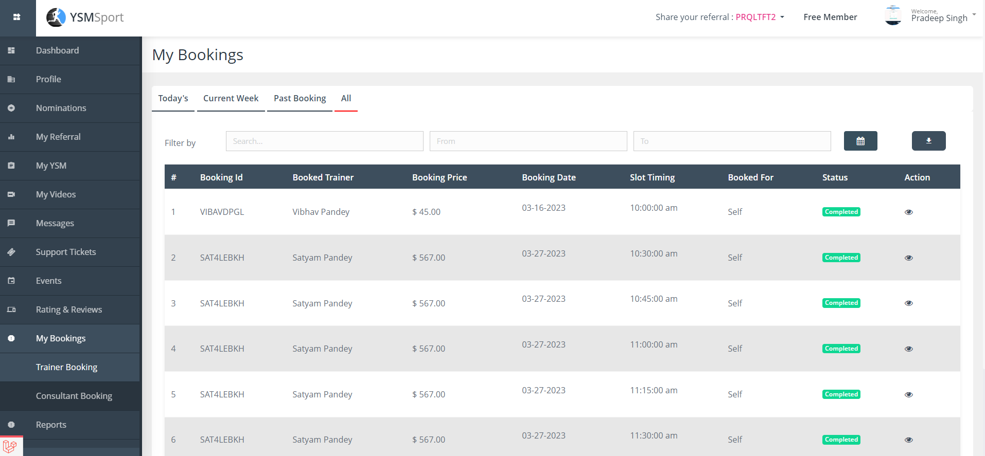

And on clicking the eye icon given under the “Action” column users/members can see all booking details.

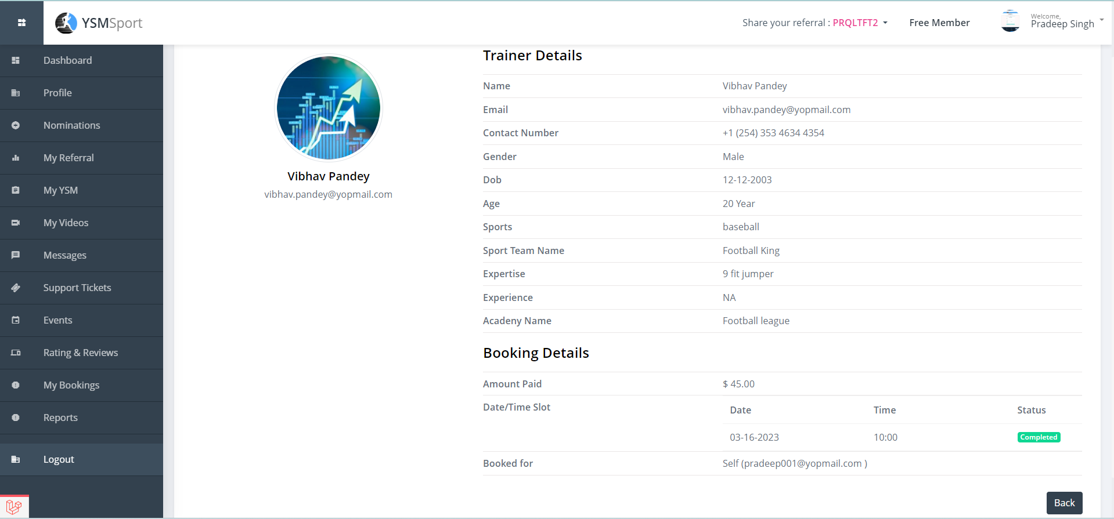

## LogOut

On click of logout – user is logged out from all sessions.

# SUPER ADMIN / ADMIN AREA

This area is solely for users / use cases which describe the admin functionality and help in usual operations of YSM to control and facilitate offerings.

For stakeholders:

* Super Admin user
* Sub-Admin users
* Account Manager users

## Manage Members

On YSM, there are members holding different roles and for registering and updating one specific document, here in this document we will check how listings are shown in admin login, how admin approve/disapprove their roles and admin can also see nominations lists.

To login as admin enter URL-: <https://youthsportsmessenger.com/admin>

Enter login credentials-<Email ID><Password>

Navigate to the “Members” menu given on the left side and in the sub-menu, you will find nominations list, groups and reviews.

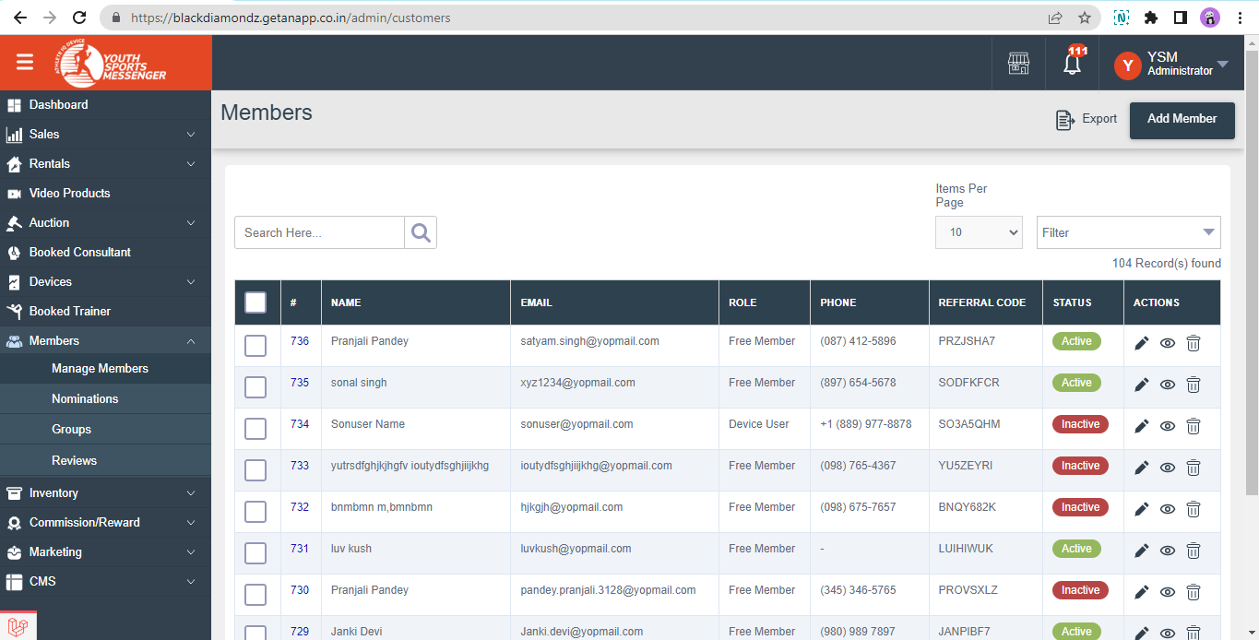

In the above list (Members List), admin can see a list of all members registered on YSM.

On clicking the edit icon-

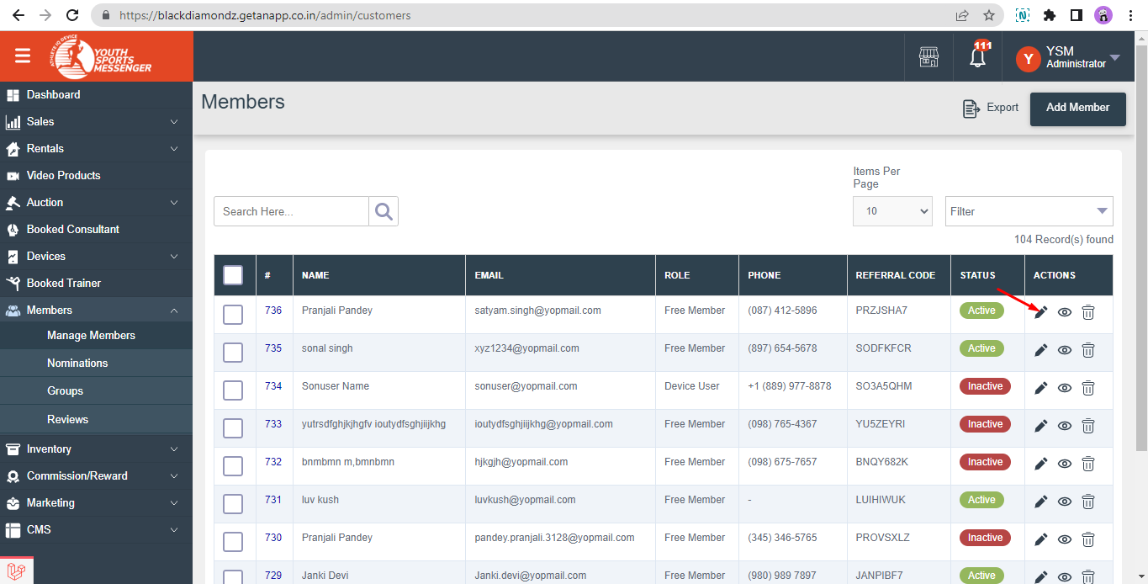

Admin can see all details of that specific user and can make edits and approve/disapprove their role for which they have updated their profile.

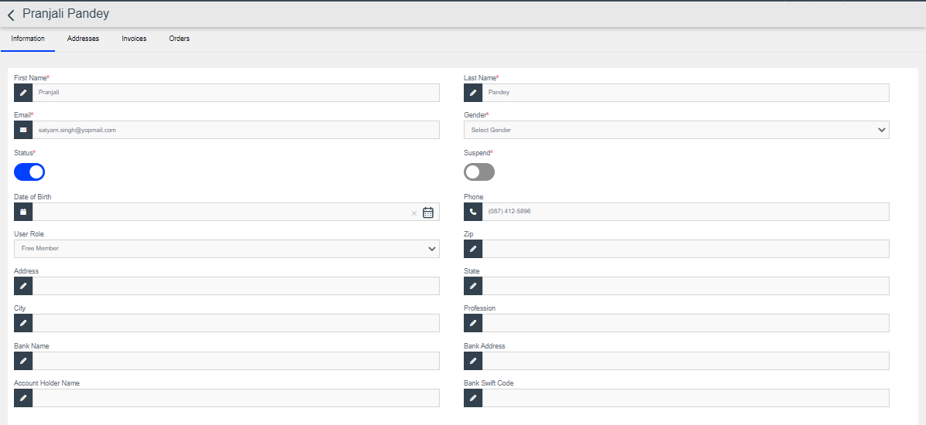

Admin can also see that member’s address, invoice generated and his/her orders.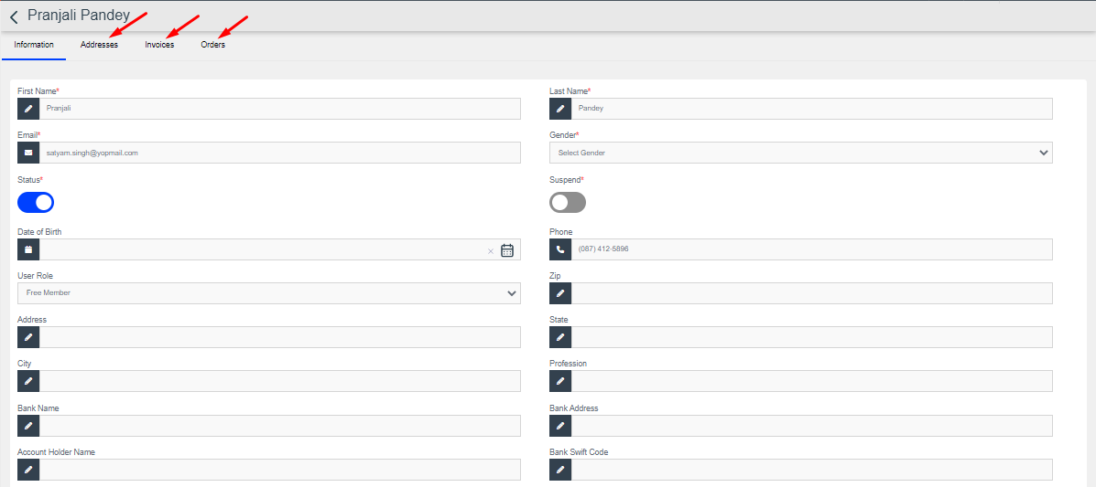

On clicking the eye icon, admin can view details of members.

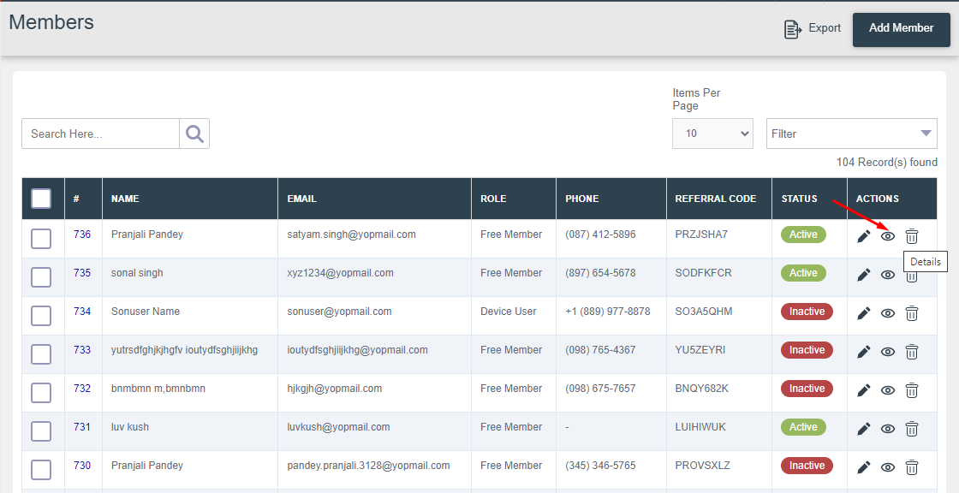

On view member- Member’s profile is given admin can view order’s, nominations, earnings, and product which they have purchased.

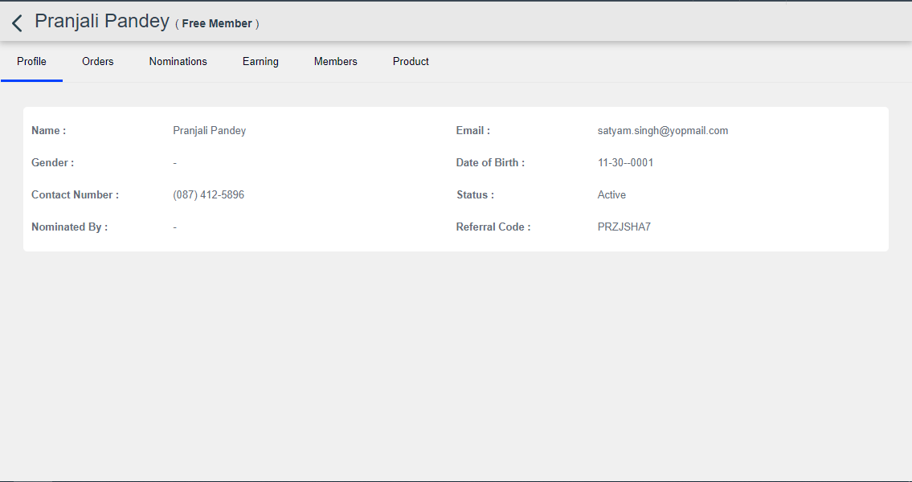

Clicking on the delete icon, will delete the member and all his/her details.

Admin can add members by clicking on the “Add member” button.

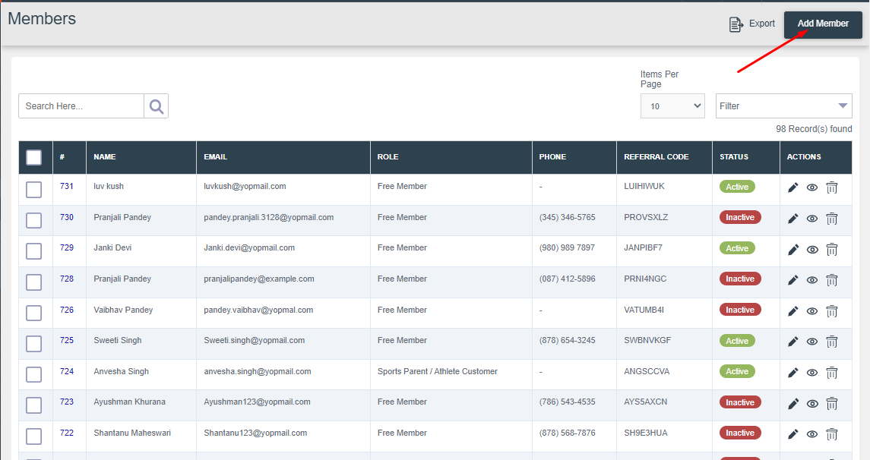

Admin will need to add all details of members to add and save it.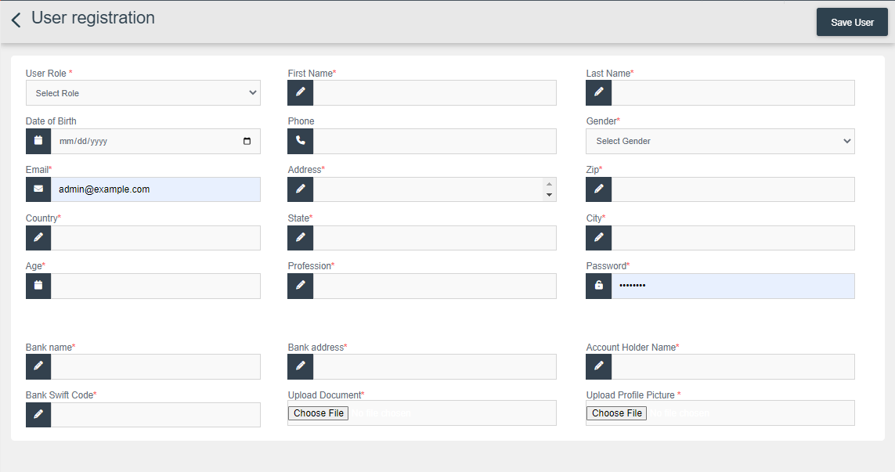

# Nominations

After logging in to account navigate to members menu given on left side and click on sub-menu nominations. Here list of all nominations are showing admin can their details and approve/disapprove their role for which they have nominated for and updated their profile.

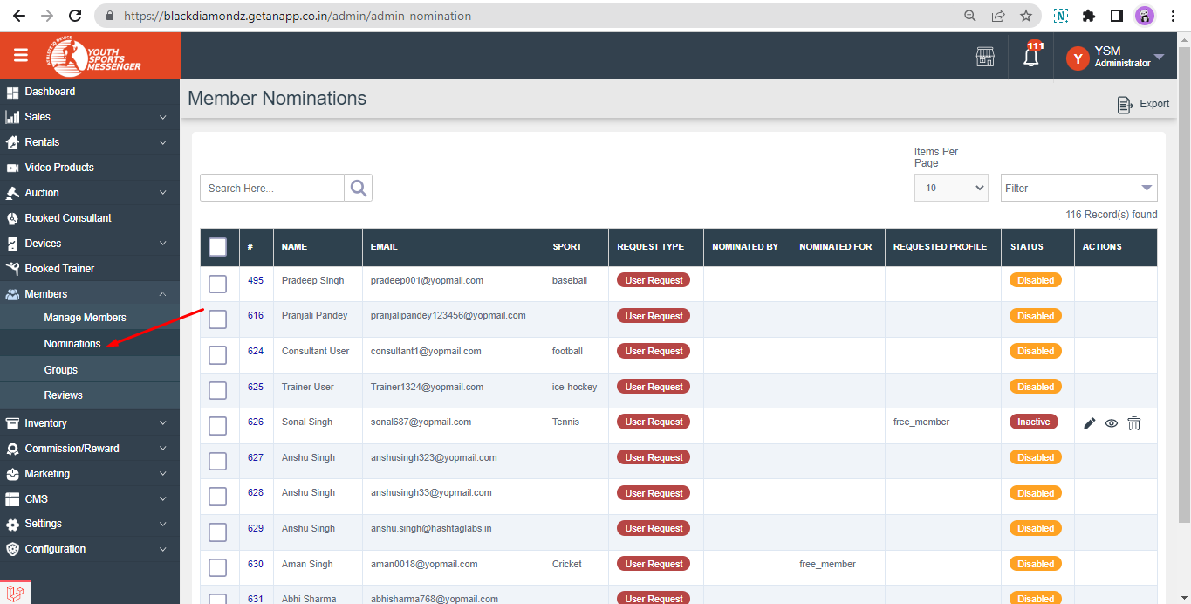

## Manage Orders

Admin have authority to add products to be displayed on purchase portal whether it is for BUY or for RENTAL and can manage orders from there like creating shipments, managing order status and refund.

After logging in to the admin account navigate to “Devices” where all products/devices are listed BUY/RENTAL. To add a new product/device click on the “Add Product” button given.

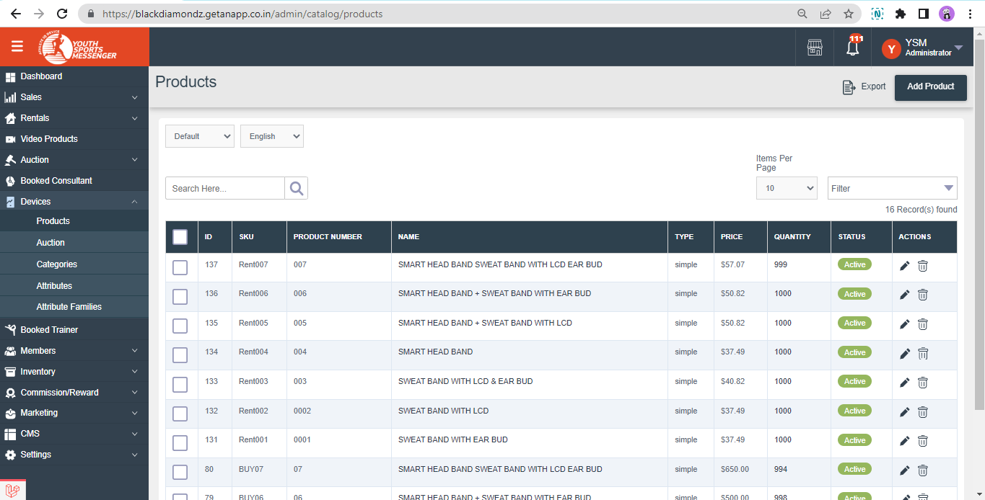

## **ADDING “BUY” PRODUCT & ORDERS**

Add the general information of the product like product type, select simple if you want to create BUY and BOOKING for rental products, attribute family and then add SKU.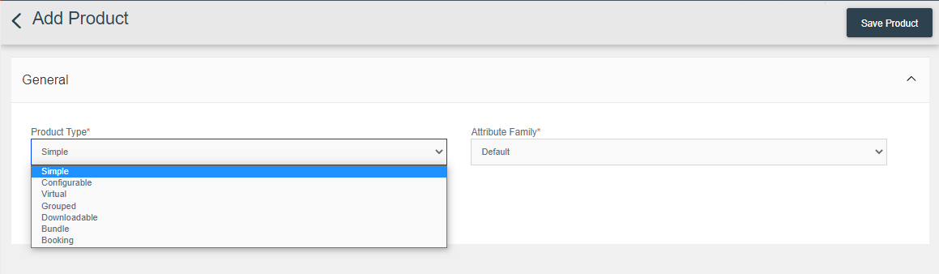

After adding general information this page will where further details will be added about product like specification and in general SKU, Product Number, name, URL key, tax category, and enable toggle of features only.

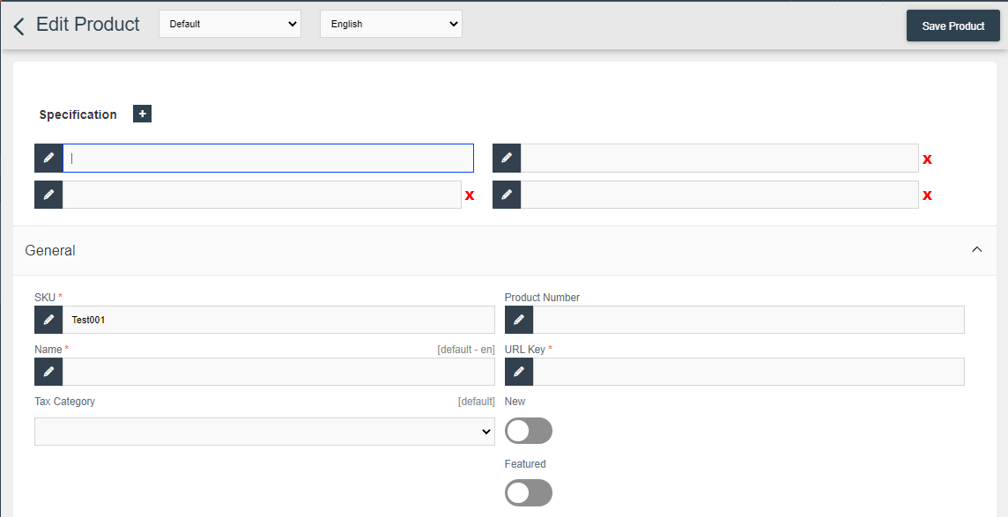

Rest enable all toggles and add data in given fields

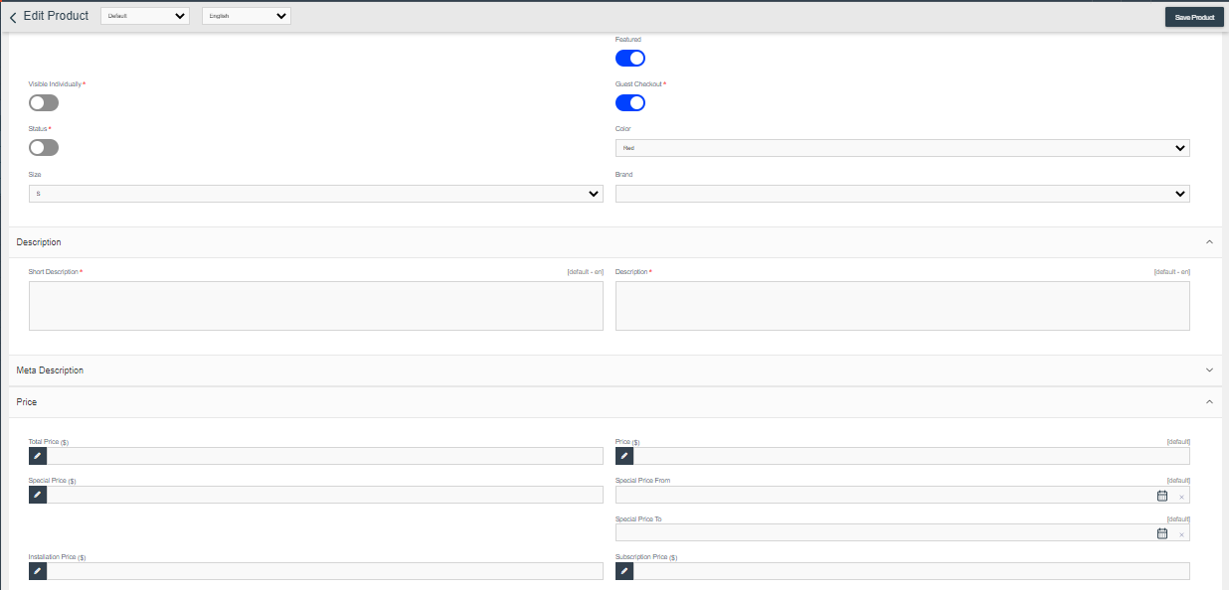

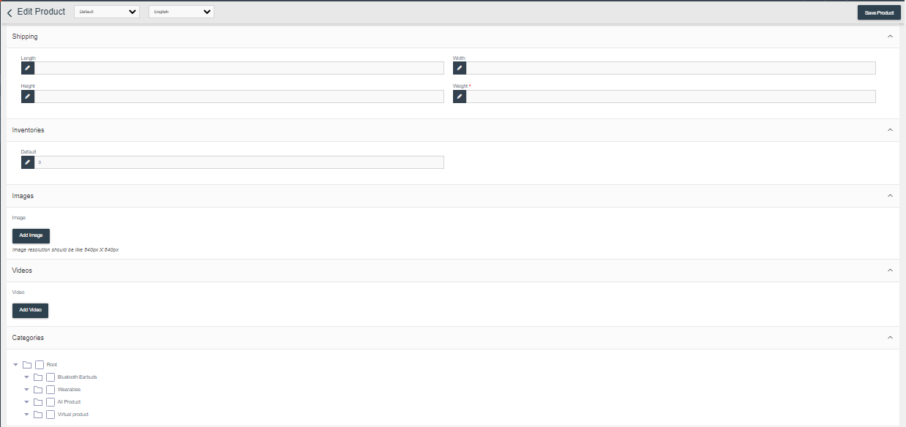

Once product/devices are added, it will display on the purchase portal.

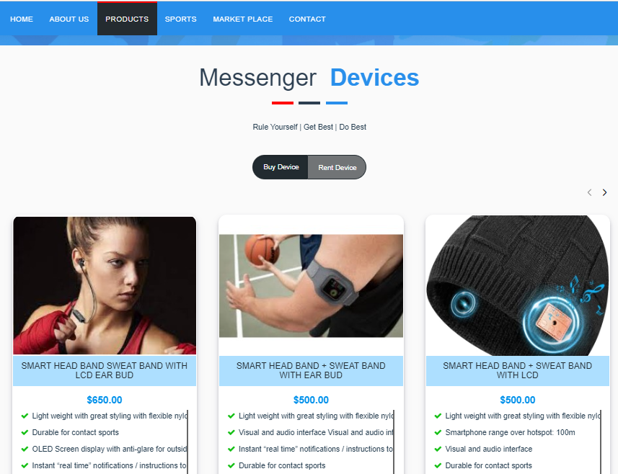

Admin can view orders listing of BUY Products and to view specific orders they can view it by clicking on the eye icon, if order-shipping status is pending, they can create shipment.

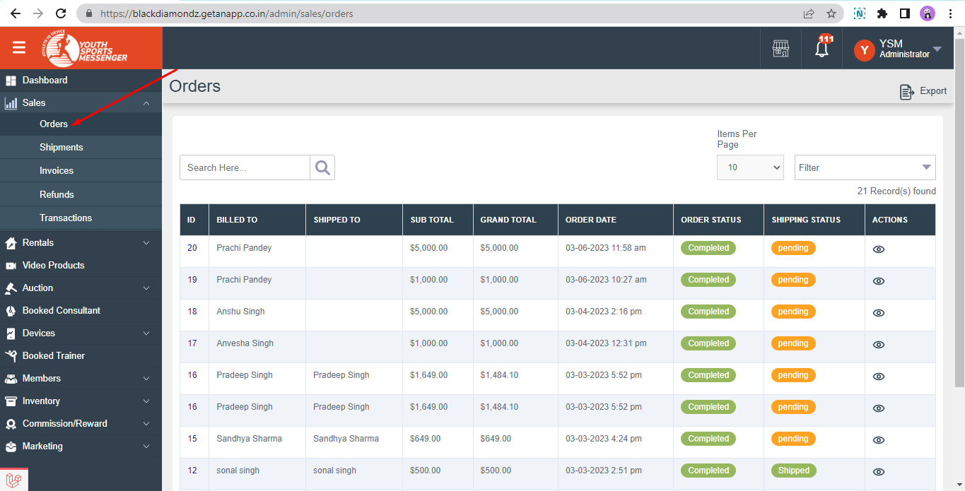

This page will open after clicking on the view; now click on the “SHIP” to create shipment against that specific order.

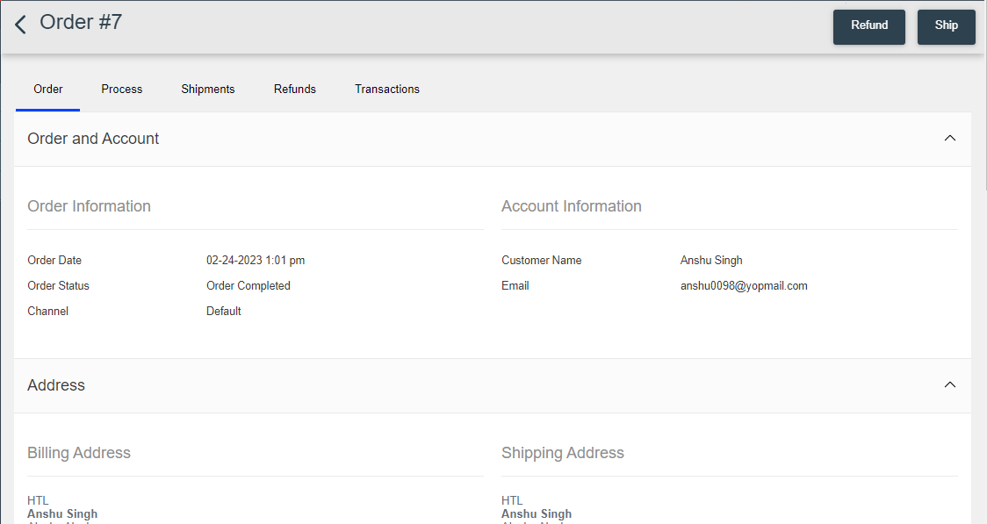

Admin will add tracking number, carrier title/ shipping method and save shipment.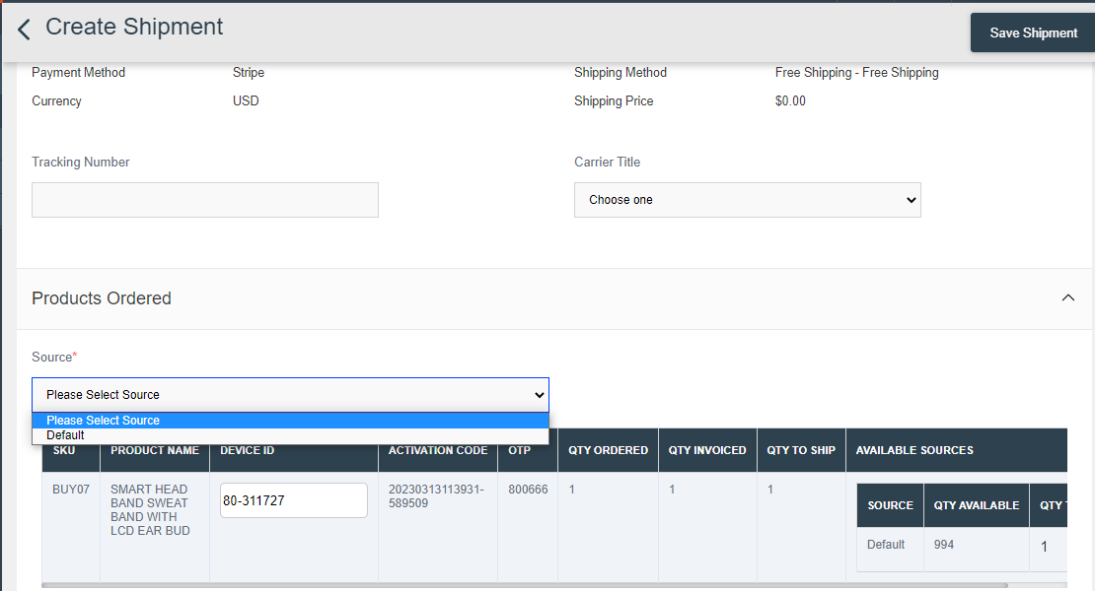

After saving, shipment will be created and members/customers will be notified through, email and get the OTP, which they need to provide at time of delivery to confirm shipment.

Once order status is delivered the member/customer will get the device activation code.

## **ADDING “RENTAL” PRODUCT & ORDERS**

Add the general information of the product like product type, select simple if you want to create BUY and BOOKING for rental products, attribute family and then add SKU.

After adding general information this page will where further details will be added about product like specification and in general, SKU, Product Number, name, URL key, tax category, and enable toggle of “NEW” only not enable featured.



Rest enable all toggles and add data in given fields

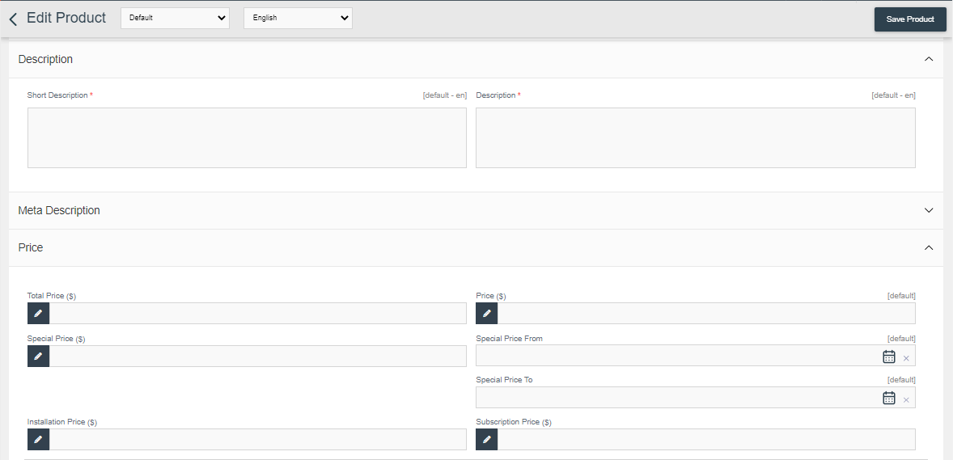

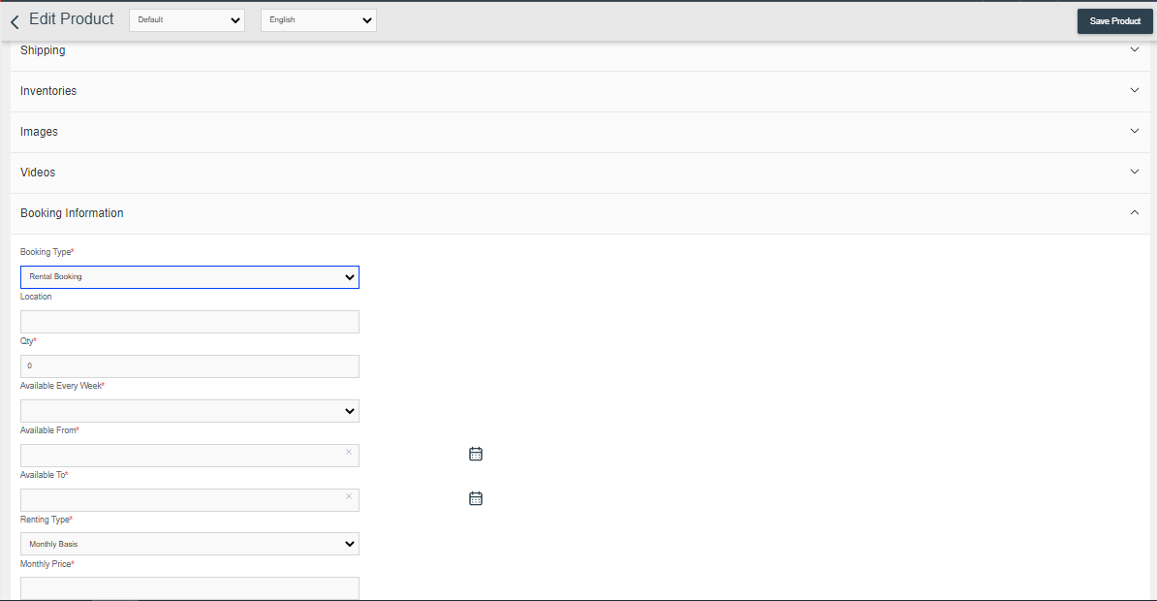

Once product/devices are added, it will display on the purchase portal.

Admin can view orders listing of RENTAL Products and to view specific orders they can view it by clicking on the eye icon, if order-shipping status is pending, they can create shipment.

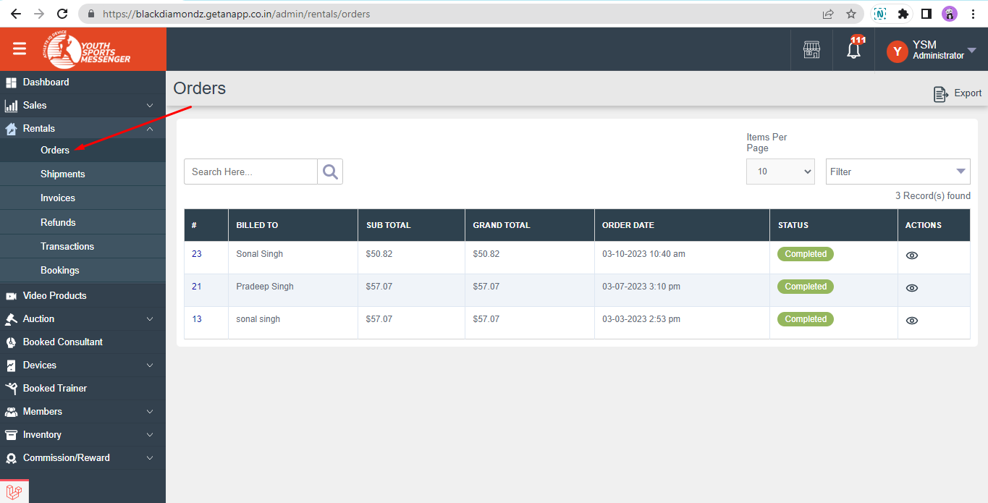

And the same creating shipment, delivery status, sharing activation code process will follow.

## Manage/View Marketplace order listings

# Trainer booking orders

After logging in to the admin account navigates to booked trainers. Here lists of all trainer booking are showing which trainer is booked and booked by whom.

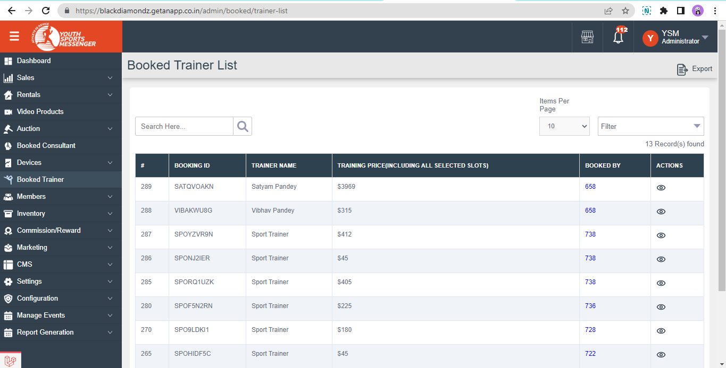

# 

# 

# Consultancy booking orders

After logging in to the admin account navigate to a booked consultant. Here lists of all trainer booking are showing which consultant is booked and booked by whom.

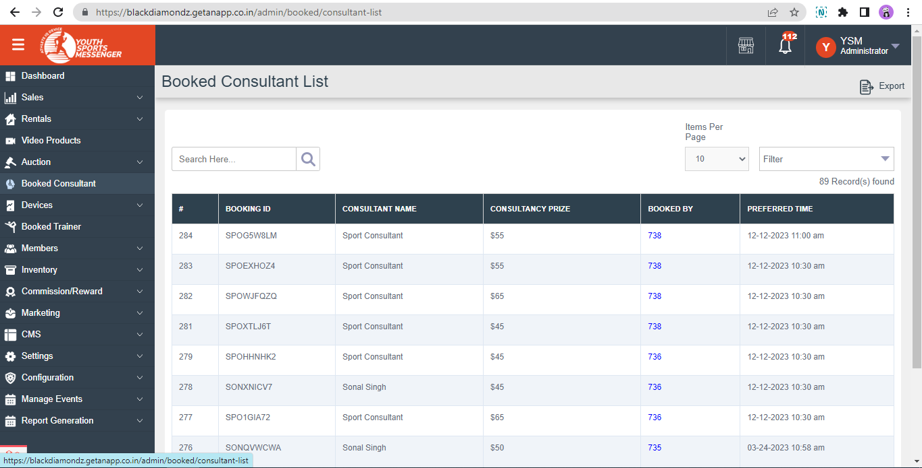

## Manage Video editing booking orders

After logging in to the admin account, navigate to the video products menu given on the left side. Here in this page all orders listing is showing, and on clicking the eye icon admin can view details of that order.

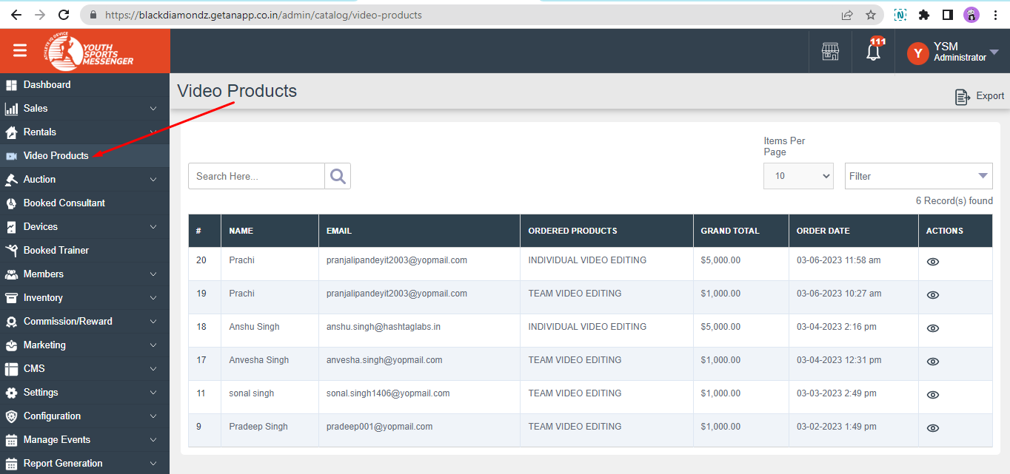

Order details-

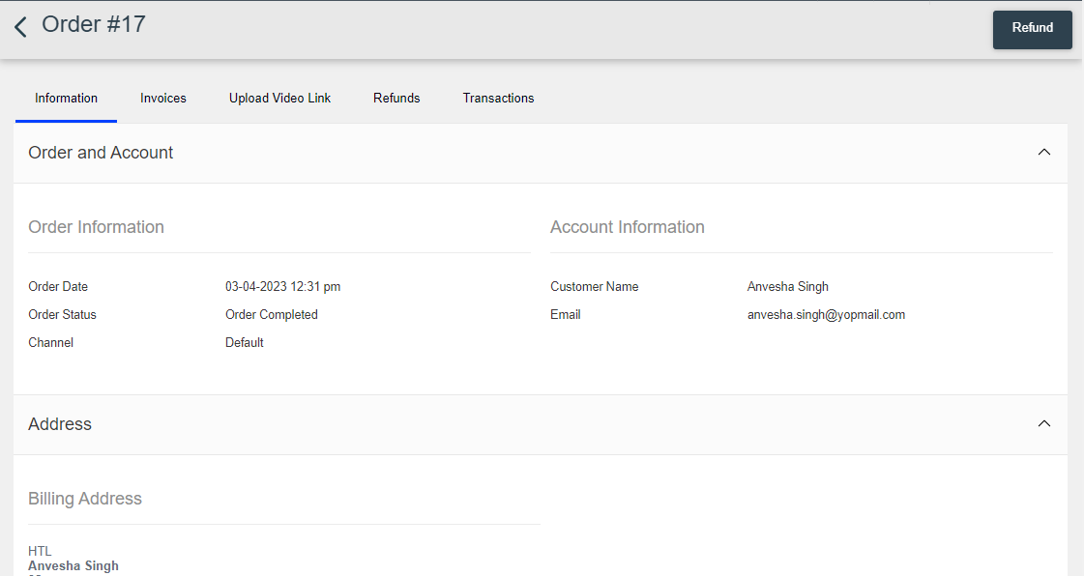

Admin will upload an updated link of the video once work is done.

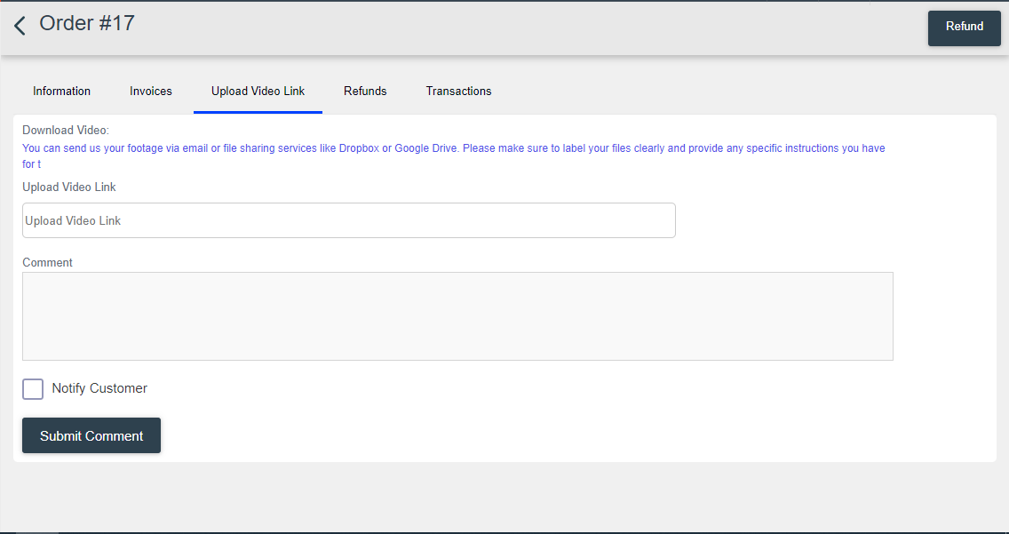

The member/customer will get the updated link and can download it.

*To check the video editing booking service, please refer to that specific document.

## Earnings, Commissions

There are three types of commissions running now.

1. Referral Commission- The person will get this once anyone makes a purchase using their referral code.
2. Nomination’s Commission- The person will get this when the nominated user share their referral with 3rd person and they made any purchase, User (nominated by) will get the nomination commission as set by the admin and whose referral is shared will get respective commissions as set by the admin
3. Event Commission- The person will get this commission when admin includes them as Supporter/Account Manager against an event, they will get this commission when they share event referral and people made purchase using it

To know how it works, please refer to that specific document.

In this document we will get to know how admin creates, set these different commissions

# Referral Commission

After logging in to the admin account navigates to menu settings and sub menu commission, here in this page list of all products are showing both BUY and RENTAL.

Admin will set this and it will be used as referral commission once someone makes any purchase using another member’s referral code, and the member will get commission whose referral is used as set by the admin on product value.

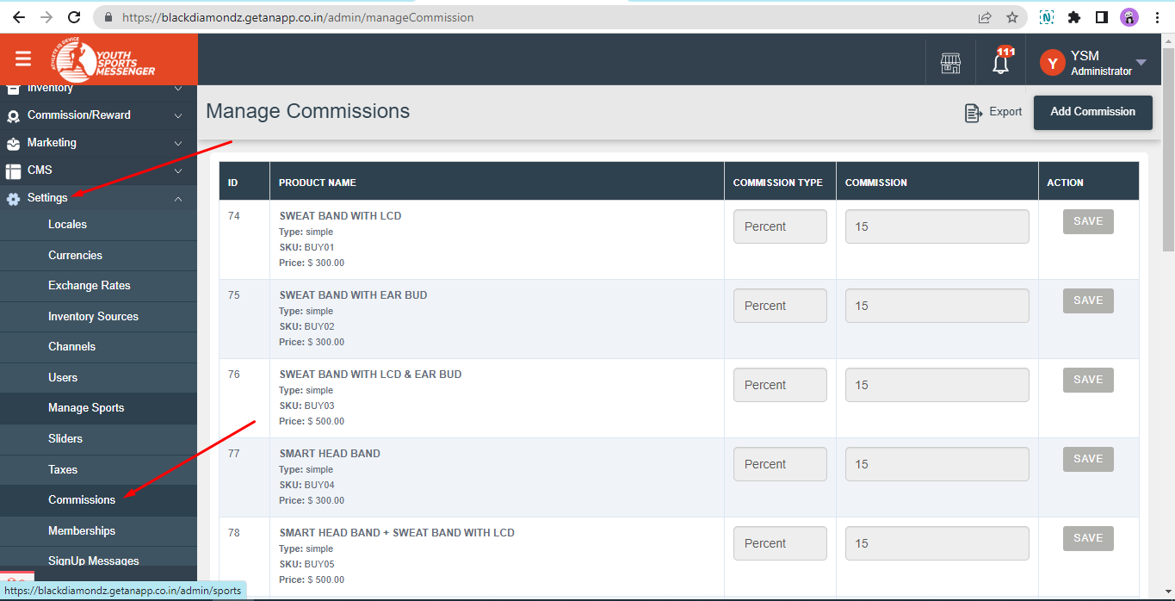

Nominations Commission- To set this commission in admin login, development is still in-progress.

# Event Commissions-

To know how to create a fundraiser event, please refer to that specific document.

To set event commission in admin, navigate to manage events then click on fundraiser events.

Click on the “Create Event” button given on the right side corner.

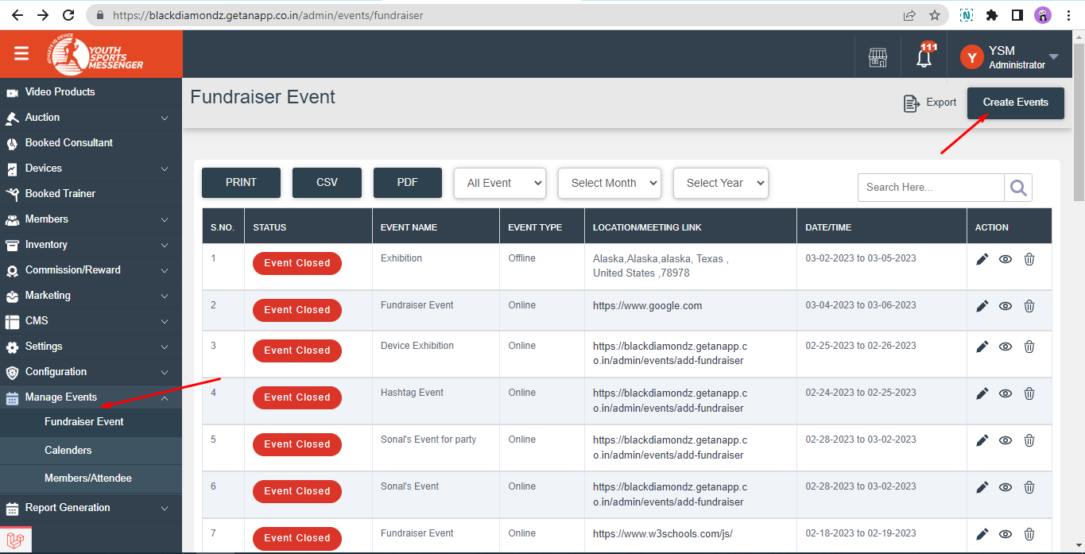

After completing all the following steps of creating an event in this tab admin will set commission for the given member and they will get the amount.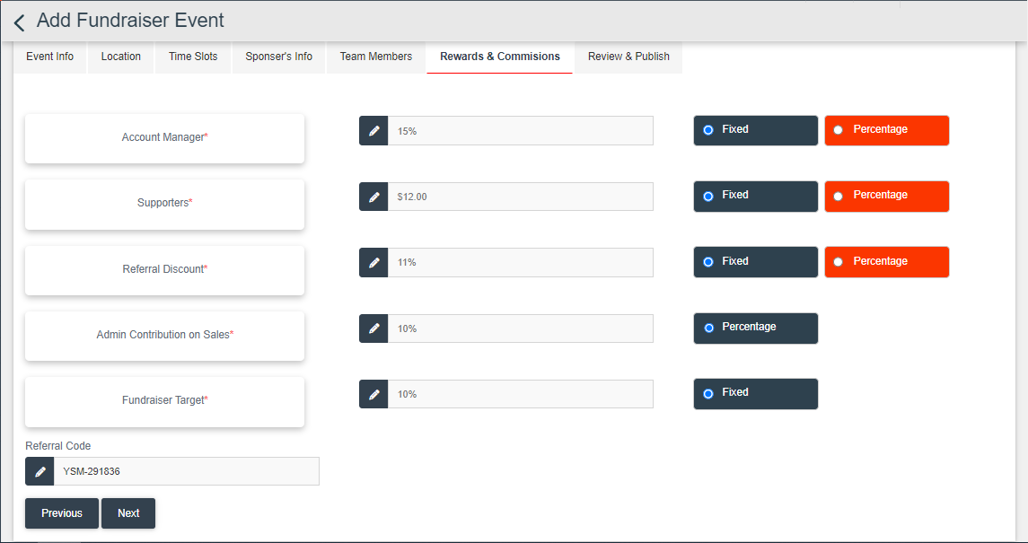

## Support Tickets

A support ticket is a formal request for assistance or resolution of a problem or issue that a customer or user has with a product, service, or system. The ticket typically contains information about the problem, including a description of the issue, any error messages or symptoms, and details about the customer or user who is experiencing the problem.



Members can easily log tickets, after logging into account navigates to support tickets given on the left side menu.

Select category, title and description of your problem.

There are different categories given, members can choose from them.



Once you select a category, title will populate according to the category selected, your order will show members can also select the order on which they need help with and submit it after description.



When a Member/customer submits a support ticket, it is usually assigned a unique ticket number, which is used to track the progress of the issue and ensure that it is resolved in a timely and effective manner.

Members/Customers can chat with the admin if required for further assistance.

Logged in, as admin- Admin will chat with the member/customer to know more about the problem.

In addition, once the member/customer agrees that his/her issue is resolved, then the admin will close the ticket from here.



1. Feedbacks and Review reports
2. Settings
   1. Manage content
   2. Manage Menu headings
   3. Manage email/message content
   4. Manage base url
   5. Manage base email smtp settings
   6. Manage payment gateway settings
      1. Stripe
      2. Paypal
      3. Bank wire transfer

---x---