Rental Purchase

Here is list of products are showing, where user can select whether they want to purchase device or rental device, user just need to switch tabs.

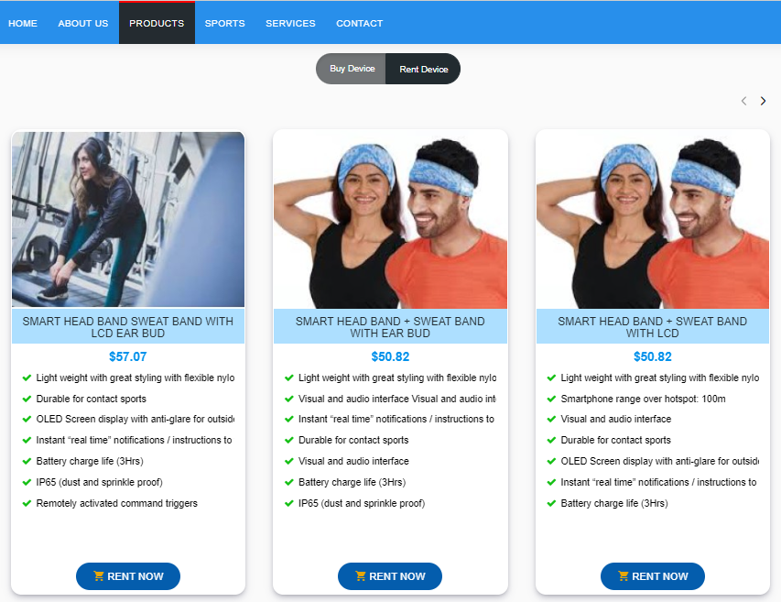

On rental products, user needs to click on the “RENT NOW” button to rent.

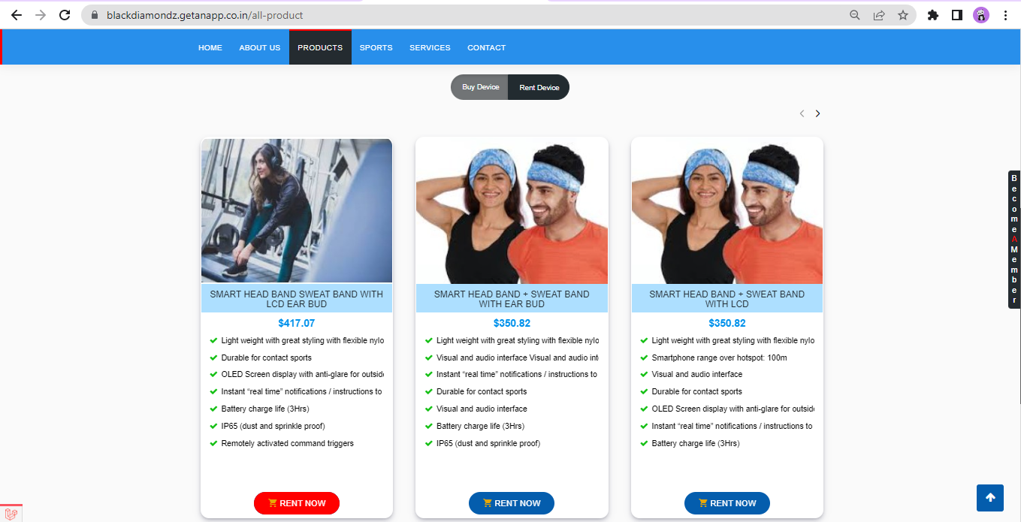

Once user clicks on the “RENT NOW”, the detail page will open of that particular product where user can see more details about product, as features, price breakups.

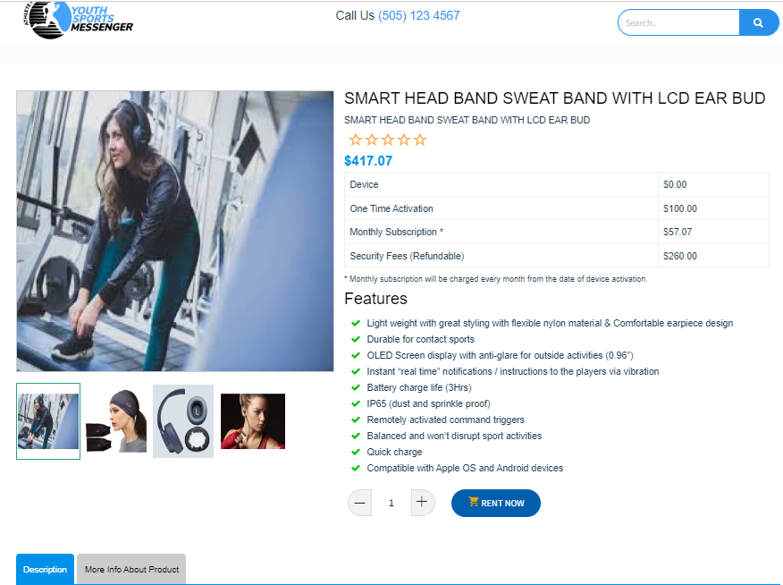

After reading all the details of product and selecting quantity, the following will add in that user’s cart.

After clicking “RENT NOW” the product will add to our cart, we can check our cart and can also make any changes if needed like adding any other product or changes in quantity and will click “PROCEED TO CHECKOUT” or we can directly make checkout from the cart popup top bar.

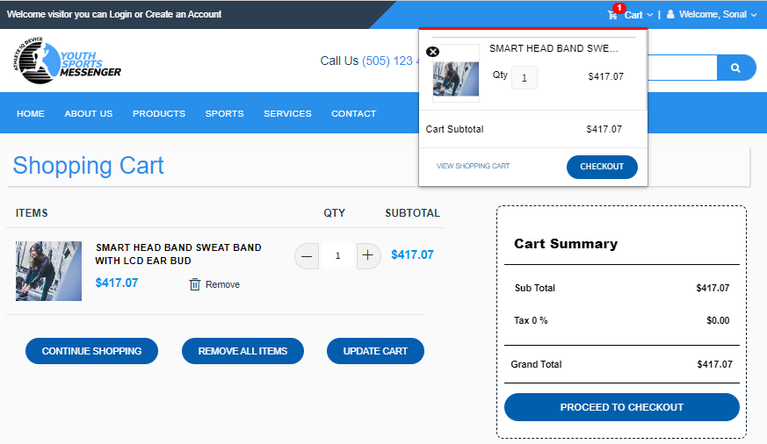

After that same checkout process will follow. The product will be rented for one month from the date of activating device.

\*\*To know more in detail about checkout and device activation workflow do checkout that particular document